Sociological research report:
" Needs of individual communities of Kyiv and Chernihiv regions regarding recovery and reconstruction"

Initiated by NGO "Dobrobat"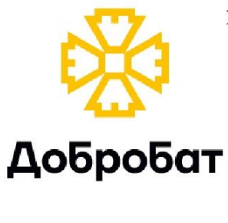
With the support of MF "Renaissance"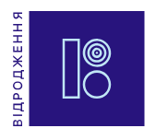

April, 2024
Сontent

General information about the study | 3
General results | 6
The main results of the study
Section 1. Representatives of local self-government bodies and public organizations / charitable foundations | 16
Understanding and perception of the concept of "reconstruction/restoration of the country/community" | 16
Evaluation of reconstruction / restoration projects that were successfully implemented | 23
Actual needs of communities, ability of communities to meet their needs | 32
Dialogue with the residents of the community regarding the restoration / reconstruction process | 37
Willingness of residents / businesses to participate in restoration / rebuilding | 39
Assessment of the level of community capacity | 43
The main obstacles / barriers on the way to recovery / rebuilding | 45
Assessment of overall coordination and communication between participants in the restoration / rebuilding process | 56
Assessment of the existence of a recovery / rebuilding strategy | 58
Needs of public organizations and charitable foundations | 67
Section 2. Business representatives | 68
Interpretation and perception of the concept of "reconstruction / recovery" | 68
Business recovery after damage caused by the full-scale invasion of the Russian Federation | 71
Recovery / reconstruction support programs that are known to business representatives | 74
Conditions necessary for further recovery and development | 76
Plans to move out of the community | 76
Actual business problems (except for the consequences and challenges of a full-scale war with the Russian Federation) | 78
Assessment of the level of feeling of business security | 80
Vision strategy / support programs for businesses affected by a full-scale Russian invasion | 80
Assessment of the problem of corruption | 83
Restoration of communities and current needs | 85
Assessment of the level of readiness of community residents and businesses to join the recovery/reconstruction process. Assessment of community and business capacity | 87
Assessment of existing communication between all parties in the recovery / rebuilding process. Assessment of the country/community recovery strategy. | 89
The assessment of the state program is Recovery | 91
Chapter 3. Residents of communities | 93
Interpretation and vision of the restoration / reconstruction process | 93
The main obstacles to reconstruction. Manifestations of corruption in the process of reconstruction / recovery | 97
Assessment of the existence of a defined reconstruction / restoration strategy. The level of readiness to participate in the development of a strategy for the reconstruction of the country / community | 100
Evaluation of reconstruction initiatives and measures that have already been implemented in communities | 101
Current needs of communities | 106
Damage to respondents' property. Assessment of what has already been rebuilt / restored | 107
Sources of information on recovery / rebuilding | 112
Willingness to participate in the recovery / reconstruction process | 114
Portrait of respondents (community residents) | 116

General information about the study

Purpose: to study the needs of certain communities in Kyiv and Chernihiv regions.
General tasks:
- Learning to understand and interpret the recovery/rebuilding process.
- Evaluation of the restoration / rebuilding process.
- Assessment of interaction / communication, the level of involvement of various target categories, in particular population categories, in the process of restoration / reconstruction.
- Assessment of the main existing needs of target communities.
- Study of the main barriers/obstacles to the recovery/reconstruction process.
- Studying the vision of the main principles of recovery / reconstruction, basic expectations.
Geography of the study: 10 communities - 5 communities each in Kyiv and Chernihiv regions.
Kyiv region | Chernihiv region
Gostomelska village | Kiinska village
Irpinska city | Chernihiv city
Borodyansk village | Kiselivska village
Dymer village | Ivanovska village
Makarivska village | Novobilouska village

Methodology: a combination of two methodological components - qualitative (GI with representatives of three target categories) and quantitative (telephone survey of residents of certain communities using a structured interactive questionnaire).
Number:
- Qualitative component – 30 in-depth interviews, online format using the Zoom platform.
- Quantitative component – 600 respondents.
Dates of the field stage:
- Quality component - 29.02-22.04.2024
- Quantitative component - 01.04-15.04.2024

Distribution of target categories of the quality component:
Description of target categories | Number
Representatives of local self-government bodies in 10 designated communities of Kyiv and Chernihiv regions | 10
Representatives of the State Administration of Kyiv and Chernihiv Oblasts | 2
Representatives of businesses that suffered as a result of the full-scale invasion of the Russian Federation in certain communities | 10
Representatives of public organizations and charitable foundations that implemented projects in certain communities of Kyiv and Chernihiv regions | 8
IN GENERAL: | 30

Level of GI respondents:
- Representatives of local governments and regional councils: heads of communities (the majority of respondents), deputy heads of communities, deputy directors / heads of departments / departments and chief specialists (department of international relations and investments, Department / department of regional development, housing and communal services management).
- Business representatives: owners / co-owners, directors, financial directors, chief accountant.
- Representatives of NGOs / BF: heads of NGOs / presidents of BF, project coordinators, manager.
Quantitative component sampling design:
The sample is combined — uniform at the stage of distribution of regions and target communities (slightly increased sample proportions for the city of Chernihiv), random at the stage of respondent selection, at the same time there is screening for the gender and age of respondents according to the calculated sex-age quotas. The sample represents the adult population aged 18 and older in the Kyiv and Chernihiv regions . The statistical error for one-dimensional distributions in the total array of received data with a probability of 0.95 does not exceed 4.08% (without taking into account the design effect).
Name of the community | 18-35 years old |  | 36-54 years old |  | 55 years and older |  | Total:
Name of the community | Ch | J | Ch | J | Ch | J | Total:
Kiinska village | 1.00% | 1.00% | 1.17% | 1.17% | 1.50% | 2.50% | 8.33%
Chernihiv city | 2.00% | 2.00% | 3.00% | 3.17% | 2.33% | 4.17% | 16.67%
Kiselivska village | 1.00% | 1.00% | 1.17% | 1.17% | 1.50% | 2.50% | 8.33%
Ivanovska village | 1.00% | 1.00% | 1.17% | 1.17% | 1.50% | 2.50% | 8.33%
Novobilouska village | 1.00% | 1.00% | 1.17% | 1.17% | 1.50% | 2.50% | 8.33%
Gostomelska village | 1.33% | 1.33% | 1.83% | 2.00% | 1.33% | 2.17% | 10.00%
Irpinska city | 1.33% | 1.33% | 1.83% | 2.00% | 1.33% | 2.17% | 10.00%
Borodyansk village | 1.33% | 1.33% | 1.83% | 2.00% | 1.33% | 2.17% | 10.00%
Dymer village | 1.33% | 1.33% | 1.83% | 2.00% | 1.33% | 2.17% | 10.00%
Makarivska village | 1.33% | 1.50% | 1.67% | 1.67% | 1.50% | 2.33% | 10.00%
Total: | 12.67% | 12.83% | 16.67% | 17.50% | 15.17% | 25.17% | 100.00%

Quotations from respondents who participated in in-depth interviews are given verbatim in the language of the respondents and highlighted in italics
Glossary of abbreviations used in the report:
GI is an in-depth interview
LGUs are local self-government bodies
NGOs are public organizations
BF - charitable funds

General results

- Representatives of local self-government bodies of communities and representatives of public organizations / charitable foundations who were involved in the research have a deep and comprehensive understanding of the "concept of restoration / reconstruction". They emphasize that it is worth not only to restore to the pre-war level, but also to implement certain qualitative improvements in each of the affected areas. The vast majority of respondents of both categories (representatives of local government and NGOs / BFs) emphasized that it is difficult to identify priority areas in relation to restoration / rebuilding - parallel restoration of both critical infrastructure and communications facilities, as well as social infrastructure, business and housing stock should take place . Business representatives put, first of all, the recovery of the economy, the reconstruction of enterprises and the restoration of business activities in the concept of "restoration / reconstruction of the country". At the same time, housing of citizens and objects of the social sphere must be rebuilt. Roads and bomb shelters/shelters were also noted as priority areas/objects for reconstruction. Spontaneously, 57% of research participants from the category of "community residents" invest, first of all, in the reconstruction of citizens' housing in the process of "restoration / reconstruction" - this is the most common answer. With a hint, among the spheres that need to be restored/reconstructed in the first place, the answer options "citizen's housing" (68%) and social sphere objects (schools, kindergartens, hospitals) (63%) are leading.
- Choosing between the two proposed theses: "to rebuild as much as possible everything damaged that can be restored" or "to build a new one instead of the damaged one as much as possible" - the vast majority of representatives of local government, NGOs / BF and business emphasized that an individual approach should work in each individual case, which will be based on on the principle of economic expediency. In contrast to key informants from the category of representatives of local government, NGOs / BF and business, respondents from the category of "community residents" preferred the approach of "as much as possible to build new instead of damaged" - this option was supported by 55% of respondents.
- The vast majority of respondents to in-depth interviews supported the thesis that "reconstruction should take place gradually, as far as possible", but the reconstruction should take place now, and not after the end of the war. This position is also supported by the majority of respondents (68%) from the "community residents" category.
- Among the objects that are impractical to restore at this time, the key informants of the quality component more often noted: completely destroyed buildings; houses of culture; objects of the social sphere in settlements from which a significant number of the population left; individual objects in border and front-line settlements, which are constantly under fire. 67% of respondents from the category of "residents of communities" noted that it is impractical to rebuild some objects. Among the objects that are currently impractical to rebuild, the following were mentioned more often than others: cultural institutions (22%); objects in which there is generally no urgent need (20%); objects that are completely destroyed (14%).
- The communities that were involved in the study suffered significant damage as a result of the full-scale invasion of the Russian Federation: the housing of residents, educational and medical facilities, communications, administrative buildings, business / enterprises, etc. were destroyed or damaged. In all communities, a powerful process of recovery / reconstruction is taking place, the main sources of funds for this process are recorded: assistance from public organizations, charitable foundations, individual patrons, religious and commercial organizations; the state program is Recovery; programs / projects / initiatives financed from the state, regional and local budgets.
- All respondents from the categories "local government representatives" and "GO / BF representatives" noted a high level of success of implemented projects, the main indicator of this success is that residents have already returned and continue to return to communities. Representatives of local government and NGOs / BF did not give examples of inappropriate reconstruction of individual objects. The respondents from the "business representatives" category also positively evaluate the recovery/reconstruction processes that have already taken place in the communities, but they do not have detailed information about these projects. The vast majority of respondents from the "business representatives" category do not remember specific names of organizations/institutions that were engaged in restoration in their communities.
- Among the things that have already been built in communities, respondents from the category "residents of communities" more often mentioned residential buildings (64%), bridges (55%), educational institutions (54%), gas, water, electricity supply (41%), hospitals , FAPs (36%), kindergartens (35%). To an open question (without suggested answer options) - At whose expense was the restoration / reconstruction of various community facilities? - 39% of respondents could not provide an answer. At the same time, 35% of the participants noted that the restoration took place with the funds of various public organizations and charitable foundations, but they do not remember the specific name. In general, it can be assumed that the respondents have rather insufficient information about the sources of funds for the restoration / reconstruction of objects in their communities, or are not interested in this information, do not remember the names of institutions and organizations. The level of success of implemented reconstruction projects is quite high, according to respondents from the category of "community residents", so 7% of survey participants called the implementation of reconstruction / restoration projects "completely successful", 64% - "rather successful", 20% - "rather unsuccessful", only 4% - "completely unsuccessful", 5% - could not decide on the answer to this question.
- All categories of key informants of the qualitative component are marked by international public organizations and charitable foundations as more powerful in terms of recovery / reconstruction. Reasons: greater financial capacity, better organization of work, involvement of highly professional and highly qualified personnel, strict reporting, strict control of subcontractors. Among the disadvantages of cooperation with large and powerful NGOs / BFs, a large number of respondents noted the long duration of consideration and implementation of projects (we are talking about larger- scale projects, targeted assistance to people is provided promptly). Some representatives of local government were marked as the most powerful Fund for liquidation of the consequences of armed aggression and regional councils, which finance a significant number of projects related to restoration / reconstruction. Private patrons (businessmen, people's deputies) also provided powerful assistance. In turn, 71% of respondents from the category "community residents" could not decide on the answer regarding which institutions / organizations are the most powerful in terms of restoration / reconstruction; 11% of participants indicated that charitable foundations and public organizations were the most powerful, but did not specify specific names. Respondents noted international charitable funds and public organizations as the most effective in terms of restoration/rebuilding in communities, Ukrainian national charitable funds and public organizations occupy the conditional second position in terms of effectiveness; the third - representatives of local authorities.
- The main problematic aspects regarding the restoration/reconstruction process in the process of communication with community residents were noted by local government representatives: lack of understanding among community residents that it is impossible to restore/rebuild everything at once; lack of perception by the residents of the community of the presence of certain requirements and criteria for donors who allocate money for restoration / reconstruction; low level of population activity regarding independent participation in projects, recovery/reconstruction programs, expectation that representatives of local authorities should solve all their current problems; misunderstanding on the part of residents of communities that NGOs / BF provide targeted assistance and it is simply impossible to spend this money on the needs of the Armed Forces. Separate problematic aspects in cooperation with NGOs / BFs, which were also noted by representatives of local government: the target orientation of donor reconstruction projects, which may not coincide with the needs of the community; in some cases, lack of communication between the representatives of the local government and the NGO / BF that provided assistance for restoration / reconstruction, which may cause duplication of assistance to one affected household, while the other will not receive anything.
- Key informants from the "representatives of local government" category noted that a large part of the businesses in their communities were damaged, and a separate part was very badly damaged. At the same time, a significant number of businesses that did not leave the communities have already recovered or are on the way to recovery. It was also noted that the vast majority of businesses recovered / are recovering exclusively with their own funds, access to support programs, both state and non-state, is quite low or completely absent. Loans for recovery are not profitable, business representatives do not dare to use credit funds, so as not to acquire additional financial obligations, the fulfillment of which in the existing conditions is extremely difficult or impossible at all. Among the urgent business needs, the representatives of local government noted: lack of support programs for restoration / reconstruction; labor shortage; lack of tax benefits for the affected business; decrease in purchasing power of citizens.
- Business representatives who took part in the study noted that their businesses / enterprises suffered a significant degree of damage as a result of the full-scale invasion of the Russian Federation. All participants of the study, representatives of the affected business, noted that the restoration of their enterprise / business took place mainly at the expense of their own funds (savings). Three respondents used grant programs, some respondents also applied for loans. Some of the participants recovered by almost 100%, some participants noted that they still have not been able to recover to the pre-war level, although the vast majority of profits are invested in further recovery / reconstruction. A low level of awareness of available support programs for business recovery/rebuilding among respondents from the "business representatives" category was recorded. The majority of business representatives did not participate in any of the recovery/rebuilding support programs for businesses. Among the main conditions necessary for further recovery and development, the following were noted: finances (including at the expense of loans), personnel. Key informants from the "business representatives" category have no plans to move out of the community, they noted that they see prospects for development in their own communities. The most urgent business problems at the moment: a significant tax burden, a shortage of personnel, a significant decrease in the purchasing power of citizens, as well as a lack of dialogue with local and state authorities, lack of access to support programs. Most of the respondents noted that they do not feel that their business is currently protected.
- 63% of respondents from the category of "residents of communities" noted that as a result of the full-scale invasion of the Russian Federation, their housing (private house or apartment) was damaged, 7% - business premises. 35% of survey participants noted that no property was damaged. 60% of respondents from those whose property was damaged as a result of the full-scale invasion of the Russian Federation received one or another assistance. The respondents who received it noted money as the most common option for obtaining assistance for restoration / reconstruction, in second place - turnkey works (36%), in third place - construction materials (33%). 23% of respondents among those who received assistance for the restoration/reconstruction of damaged housing/real estate used the eRecovery program, 18% received funds from charitable foundations and public organizations, and 13% received funds from the local community budget. A high level of satisfaction with the assistance received by the respondents for restoration / reconstruction was recorded, so 48% of the participants are completely satisfied, another 42% are rather satisfied.
- Among the urgent needs for restoration / reconstruction, the representatives of local government and NGOs / BFs most often noted: housing fund; shelters / bomb shelters; objects of critical infrastructure and communication; educational institutions; less often - medical facilities, roads / bridges. The existing need for the creation of veteran spaces and hubs has also been recorded. Among the objects that currently require priority restoration/reconstruction in their communities, business representatives noted: housing for community residents, bomb shelters, roads ("patching" repairs, investing in major repairs is still impractical), also for some communities, the need is urgent regarding the restoration / reconstruction of the kindergarten. Among the objects in need of priority restoration / rebuilding, 60% of respondents from the category "community residents" indicated residential buildings, 27% - roads, 17% - schools / lyceums / gymnasiums, 12% - critical infrastructure objects, 11% – kindergartens, 9% – businesses/enterprises, 9% – hospitals, FAPs, 7% – bridges, 6% – gas, water, electricity supply, only 4% – houses of culture. A different rating of the needs for priority reconstruction / restoration in individual communities was recorded.
- Representatives of local government and NGOs / BF note that they are open to dialogue with residents and businesses of the community, and also provide constant information through Internet resources: the community website, pages in social networks and messengers; and also with the help of print media. The public is involved in various working groups, during which the priority directions for the restoration and development of the community are determined. Open discussions and surveys are held in communities to understand the opinions of community residents. Businesses are informed about existing support programs for recovery/reconstruction through the community website, at the same time it is worth noting that respondents from the "business representatives" category have a low level of awareness of existing support programs/grants, it may be appropriate to establish other channels of communication and information delivery. 40% of survey participants, residents included in the community research, noted that residents of their community take part in decision-making, what exactly needs to be restored / rebuilt, at the same time, 41% of respondents noted that residents do not participate in these processes, 19% - could not decide on the answer to this question. Top 5 sources of information regarding what has already been rebuilt and what is planned to be rebuilt / restored: local groups in Telegram, Viber, Facebook (not from local authorities) (32%); Facebook, Instagram, Twitter of local authorities (30%); information from relatives, friends, colleagues, acquaintances (27%); Telegram of local authorities (24%); see personally (19%). 18% of respondents from the category of "community residents" noted that the local government informs quite sufficiently about the process of recovery / reconstruction of the community, 34% - rather enough, 29% - rather not enough, 15% - not enough at all, 4% - could not decide the answer
- Some of the key informants from the categories "representatives of local government" and "representatives of NGOs / BF" noted a decrease in the level of activity of community residents - people are mentally and physically tired, and the general level of activity has also decreased due to the fact that young people and people of active age have left the communities, and men are currently protect the country. At the same time, a fairly significant share of ordinary citizens are active, trying not only to restore / rebuild their own property, but also to help others - physically, materially or financially. They positively noted the fact that new public organizations are being created in the communities, which are writing projects for the restoration of the community and attracting donors on their own. Some of the respondents from the "business representatives" category noted the low level of willingness of community residents to participate in the recovery/reconstruction processes, primarily due to the fact that the active population left the communities (especially rural communities), leaving behind people of retirement age who have poor health. Also, the level of willingness to participate in various initiatives has decreased compared to the first year of the full-scale war, as people are tired, in despair, embittered, and therefore withdrawn.
- Respondents, representatives of local government and NGOs / BFs, noted that business representatives were quite actively involved and continue to be involved in various reconstruction / recovery initiatives, at the same time, at the moment, the activity is somewhat lower, since the business is being restored mainly at its own expense, therefore the level of ability to help the community with recovery / rebuilding decreased. Business representatives noted that they are ready to join the recovery / rebuilding processes in their communities to the extent of their capabilities, and already have such experience. At the same time, some respondents from the category of "business representatives" noted that they currently do not have the financial resources to participate in the reconstruction of the community, but are ready to participate in other formats of activities that may be useful for the restoration of the community. 75% of respondents from the category of "residents of communities" are ready to join the process of restoration / reconstruction of the community. Among the formats in which they are ready to participate in the process of restoration / rebuilding of the community, physical assistance leads (49%). Also, 14% of respondents are ready to participate financially or by discussing projects/plans, voting. Lack of physical and moral strength (54%), lack of time (32%), as well as the position that they should do this dominate among the reasons for not being ready to join (among those who are not ready to join the process of restoration/rebuilding of the community) authorities and builders (29%).
- All respondents from the category "representative of local government" and "representatives of NGOs / BF" noted that currently the capacity of the communities is quite low, their own funds are sufficient only to cover urgent needs and support the life activities of the community. Restoration / rebuilding is possible only at the expense of attracting external assistance. Evaluating the community's ability to meet existing needs, the vast majority of respondents from the "business representatives" category also assumed that the current level of community capacity is quite low, so they can meet the community's needs for recovery/reconstruction only with external assistance. The situation is similar with the affected business - comprehensive recovery / rebuilding of business (especially medium and large) is possible only under the condition of external support.
- The main obstacles to the restoration/reconstruction process as a whole, which were noted by the representatives of the local government and NGOs/BF: direct full-scale war and shelling, lack of funding, lack of labor, bureaucracy, long-term preparation of project and estimate documentation, long process of implementation of reconstruction projects.
- The vast majority of respondents, representatives of the categories of local government and NGOs / BF, noted that they did not encounter cases of corruption in the process of restoration / reconstruction - everything is transparent, legal and open. Safeguards of possible corruption manifestations: digitization / digitization (Diya application, isRecovery program, Prozorro platform); independence of commissions in the process of registration of damage / destruction; engagement of qualified certified experts for damage assessment; providing assistance to the directly affected; in general, the transparency of projects (including the DREAM platform contributes to this).
- Business representatives who took part in the study, on the contrary, noted the urgency of the problem of corruption, the manifestations of which have a negative impact on the process of rebuilding the country and on their activities. Among the manifestations of corruption related to reconstruction, a significant overestimation of the cost of construction materials was noted. Manifestations of corruption in the conduct of business include monopolization and non-transparent holding of tenders. At the same time, in recent years, the vast majority of respondents have not encountered cases of extortion of bribes by representatives of state bodies or self-governing municipalities. The vast majority of key informants from the category of "community residents" identified corruption as the main obstacle on the way to reconstruction/restoration (besides war/shelling) - this was the answer given by 82% of respondents. Also, 45% of the survey participants noted the lack of finances as an obstacle on the way to rebuilding/restoration. 65% of respondents consider the problem of corruption to be very relevant in the process of restoration / reconstruction, another 25% - rather relevant, 6% - rather or not at all relevant, 4% - could not decide on the answer to the question about the relevance of corruption in the process of reconstruction / reconstruction. All proposed possible options for manifestations of corruption in the process of reconstruction/restoration received almost the same number of responses, but the first place with 69% of responses is occupied by the option - "overestimation of the cost of construction materials". "Kickbacks" and dishonest conduct of tenders as manifestations of corruption were noted by 64% of respondents; overestimation of the cost of construction works - 62%.
- Respondents of all categories note a low level of trust in government representatives at any level, while a high level of trust in international NGOs / BF. At the same time, the representatives of local government and NGOs / BF noted that the most optimal distribution of funds for reconstruction / restoration is the receipt of funds directly for a specific project to the budget of a separate community or the affected household. The optimal scheme for the distribution of funds for restoration / reconstruction according to key informants from the category of "business representatives" is as follows: funds are allocated for targeted projects directly to the community, funds are managed by representatives of local government, at the same time there is control by representatives of NGOs / BF, or the public (residents and businesses of the community ). Digitization / digitalization of all processes increases the efficiency of the management of funds and minimizes the possibility of corruption risks, the majority of key informants of the qualitative component emphasizes. The highest level of trust among business representatives regarding the disposition / distribution of funds for reconstruction is recorded in charitable funds and public organizations (especially international), the lowest level of trust is in representatives of the central government. A fairly high level of trust in representatives of local community authorities was also recorded. 66% of respondents from the category of "community residents" trust international non-governmental organizations and charitable foundations to manage/allocate funds for restoration/reconstruction - this is the most popular answer. A fairly significant part of respondents in this category are ready to entrust the distribution of funds for reconstruction to representatives of local authorities (39%) and Ukrainian public organizations and charitable foundations (21%).
- Separately, it is worth noting the high degree of positive perception of the state program Recovery is an effective, transparent, effective program. But problematic aspects of this program were also recorded, which were mostly noted by representatives of local government: lack of access to the program if people have destroyed documents, while restoring documents is a long-term and rather complicated process, and quite expensive at the same time; lack of access to the program for people who did not enter residential objects in the State Register of Property Rights after 2013. Key informants from the category "representatives of NGOs / BFs" additionally noted the following problematic aspects regarding the Restoration program: the accrued amounts are not enough for full restoration / reconstruction; after the launch of the program, the cost of housing and building materials has increased several times. State control of these aspects is necessary. Separately, respondents noted difficulties in accessing the state program isRecovery for older people: in general, it is difficult for them to understand electronic services and platforms (perhaps it is necessary to provide such people with the opportunity to submit documents in paper form); the lack of properly executed documents is more often observed in older people.
- The representatives of local government and most of the representatives from the "GO / BF" category noted that the general communication and coordination between all participants in the reconstruction / recovery process is established and does not require changes, at this time the interaction is generally close and effective. Regarding the presence of stable and well-established communication between all parties involved in the recovery / reconstruction process, most business representatives noted that such communication is rather absent. In particular, there is no communication with representatives of the affected business. They note the expediency of creating a single resource coordination center for business (perhaps for the public as well), which will advise on available support programs, identify urgent business problems and try to offer ways to solve them.
- Respondents from the "representatives of local government" category noted that there are recovery plans at the state, oblast, and community levels, appropriate recovery and development strategies are being developed that take into account the specifics of regions and individual communities. Also, the vast majority of respondents from the "representatives of local government" category are ready to participate in the development of a recovery strategy in one form or another, to share their experience, and to offer their ideas. They note that the strategy should be 7-10 years in advance and should include not only the processes of recovery / reconstruction, but also development - first of all, the development of the economy. Some of the respondents, representatives of NGOs / BF, are not informed whether there is a general strategy for recovery and development at the level of the state, region, they assume that there are elaborate plans and programs. At the same time, most representatives of NGOs / BF are ready to join the development of such a strategy: to offer their ideas, share their own experience, take part in discussions. A significant part of the respondents, representatives of local government and NGOs / BF, noted that strategies for recovery and development should be created at the level of communities in the first place - this is the most rational and expedient approach. The vast majority of respondents from the "business representatives" category noted that they do not see the existence of a general recovery / reconstruction strategy at the level of the country or region. There is also a lack of comprehensive understanding of business/enterprise loss and damage, and having this data is critical to building an effective recovery strategy. It was emphasized that it is more expedient to develop recovery/reconstruction strategies, starting from the level of the community, or at least the district. Respondents from the "business representatives" category also demonstrated a high level of readiness to participate in the development of a recovery / rebuilding strategy. 33% of survey participants from the category of "community residents" noted that there is no reconstruction / restoration strategy, while 24% of respondents noted that there is a reconstruction strategy at the country level. A fairly high level of readiness to participate in the development of a recovery / rebuilding strategy among respondents was recorded: 59% are ready to participate in online voting and choose the best projects; 39% are ready to join the strategy discussion online; 29% are ready to join the strategy discussion live; 21% are ready to offer their ideas. Only 23% of respondents are not ready to participate in the development of a recovery / rebuilding strategy.
- The main thesis of the strategy for the recovery of the affected business concerns the provision of access to "cheap" lending, noted key informants from the "business representatives" category. Various grant programs and tax benefits for those businesses that have suffered significant damage are also effective, according to some of the survey participants of various categories. An important aspect in the business recovery / rebuilding strategy is proper information about the existing business support programs, currently the level of information is insufficient. The representatives of the business noted the local government of the community as the optimal source of conveying such information.
- Among options for possible support for writing a recovery and development strategy at the community level, respondents from the category "representatives of local government" noted: material, technical and financial support; round tables / discussion sessions; attracting additional highly professional personnel.
- Additional proposals from key informants from the category "representatives of local government": development by the Ministry of Justice of certain schemes for simplified entry of data on residential objects into the State Register of Property Rights for those whose property is damaged or destroyed; reducing the number of paper reports; development of typical projects for reconstruction of social sphere objects; creation of a single database in which all assistance provided to citizens by the state, NGOs / BF, etc. will be entered, this database should also contain data on all damaged objects and current needs of the community (this proposal is also supported by representatives of GO / BF); clearer control over the filling of the register of destroyed and damaged property.
- Additional suggestions from key informants from the category "representatives of NGOs / BFs": at the state level, change the approach of working with donors in order to have a greater influence on the selection of objects that will be restored; to simplify the requirements for the preparation of project and estimate documentation, it should not be written on dozens of pages.
- Also, during the research, an example of effective organization of work was recorded in one of the communities: creation and maintenance of its own damage database and graphic geo-portal - this tool should be distributed in other communities, as its use optimizes and facilitates certain processes related to restoration / rebuilding.

The main results of the study

Section 1. Representatives of local self-government bodies and public organizations / charitable foundations
Understanding and perception of the concept of "rebuilding/restoration of the country/community".
Representatives of local self-government bodies of communities and representatives of public organizations / charitable foundations who were involved in the research have a deep and comprehensive understanding of the "concept of restoration / reconstruction". They emphasize that it is necessary not only to restore to the pre-war level, but also to implement certain qualitative improvements in each of the affected areas, that is, a clear attitude towards development is followed. A very apt message from one of the respondents was recorded, which accurately demonstrates the interpretation of the concept of "restoration / rebuilding" - "Restoration, development, security". Unfortunately, at this time there are not always enough financial opportunities to ensure the development component in each reconstruction / restoration project.
Look, during the de-occupation period, such a slogan appeared in our community. This is "Recovery, development, security". Three concepts, three understandings, which have become basic for us, and we use them, in principle, when we tell the president about the communities, then in three words there is understanding. (GI_OMS_Chernihivska)
In the concept of recovery, I put what is done better than it was. (GI_OMS_Chernihivska)
We would like to invest in something more extensive than the restoration of existing objects in their old boundaries with their confederation, with their functional purpose, and we would like to rebuild everything in a modern way according to new requirements and standards, but the reality is that we are simply restoring the old now. (GI_OMS_Kyivska)
For me, reconstruction is development, it is building a new society. In a new country. (GI_GO/BF)
Restoration, in my opinion, is the restoration of life in the community in general, that is, it is not only the restoration of housing, medical, educational, and transport infrastructure. This is the reconstruction, and sometimes it can actually be the construction from the very beginning of such a social atmosphere, the social fabric of the community. Therefore, everything must be rebuilt, and then it must be developed, because it suffered and it must be developed anew, because the economic situation has changed, and the directions of development have changed, that is, this is a very complex and almost philosophical aspect. (GI_GO/BF)
In my opinion, restoration and rebuilding is not only the restoration of housing and some kind of business. This is the restoration of people's lives. The restoration of people's lives is the return of the displaced, well, not the displaced, the return of those who left, the restoration of mental health, the restoration of the infrastructure because it was also damaged. We can also say the restoration of families and a normal way of life. (GI_GO/BF)
The vast majority of respondents of both categories (representatives of local government and NGOs / BFs) emphasized that it is difficult to identify priority areas in relation to restoration / rebuilding - parallel restoration of both critical infrastructure and communications facilities, as well as social infrastructure, business and housing stock should take place . Only a comprehensive approach will ensure positive results and contribute to the recovery / development of affected communities.
Therefore, I do not think that it is possible to talk about any priority here. It is all subject to restoration and it should be done systematically, in principle, as we tried to do. (GI_OMS_Kyivska)
You see, in order for kindergartens and schools to be filled, people need somewhere to live. Do you understand? These two processes of social infrastructure, together with the restoration of housing, went in parallel. There was no such thing as first this and then that. It was like everything else. The work was very big. We have an education department that deals with these issues themselves. Medicine deals with its own issues. That is, the people who are responsible for the directions are engaged in them. We defined priorities and continued to move on them. (GI_OMS_Kyivska)
At the same time, the following areas, which must be restored / rebuilt first of all, were recorded:
- Electricity, water, gas supply, as well as television and Internet communications.
- Objects of critical infrastructure.
- Dwelling.
- Objects of the social sphere.
- Business and enterprises.
- Psychoemotional state of community residents.
- Shelters, bomb shelters and fortifications.
This is energy supply, this is gas, water, electricity - first of all, to be able to move and do something. This is exactly the first. And then - yes, start hospitals and schools. Home renovation will depend on whether there is electricity, whether there is water, whether there is gas. Internet. This is the most important thing. And in parallel already housing and social facilities. (GI_OMS_Chernihivska)
These are energy structures, this is light, this is gas supply. We have gas supply, it worries us more in winter, but electricity supply - unfortunately, now our entire civilization is tied to electricity, our whole life is tied to electricity. Therefore, the first priority is electricity supply. Another thing, I believe that these are, after all, ways. These are roads - railways and highways. Because if we can't get anywhere, we'll have to drive through the mud, then it won't be anything either. (GI_Vlada_Chernihivska)
That is, such objects, most likely, which provide heat, which provide electricity, should be restored as a matter of priority. The same hospitals, kindergartens, they are also needed, but the hospital, if anything, can be moved to some other premises. And a power plant or a heating plant, or some premises that provide heat, you can't just move them anywhere. (GI_GO/BF)
The priority is housing, because approximately 14,000 of our residents are left homeless. This is approximately, because not everyone registers, official data. On the second plan is the restoration of the infrastructure, because we need to supply water, we need to have gas, we need to have electricity, we need to find where to buy bread, essential products, because after the liberation, for example, not a single store, of course, did not work . Therefore, it was also very important and even more important than the first priority, because if a person comes to the city, there should be water, gas, electricity, sewage, there should be a minimum infrastructure to ensure life. These should be working shops so that people can buy the most necessary goods. Next comes the restoration of business, the restoration of industrial capacities in order for taxes to flow, to be able to accumulate the city budget and carry out restoration with this budget. In addition, it is very important to restore the social infrastructure. A person must send his child to school or kindergarten, and first of all, medicine must work, that is, the restoration of medical facilities was first of all - these are our polyclinics, these are our hospitals, because it is objectively impossible to live in the city without medical services. In addition, the restoration of the city's security characteristics and aspects. We had the police station in the city and the base of the emergency services completely destroyed, because these are fires, there may be debris, it may just be domestic fires. (GI_OMS_Kyivska)
Well, first of all, this return of people to their homes is the first thing. The second is the development of the territory of communities in terms of social and cultural significance and direction of spatial and housing in the future. Now the question is to restore a part, most of the housing, at least to give some development vector. That is, whether it will be some kind of ecosystem there, or it will be some kind of agrarian system there, or there will be some other industrial projects implemented on the territory of these settlements. (GI_GO/BF)
First of all, these are houses for the population, that is, what was damaged, because people have nowhere to live. They also have the opportunity to live in MCP and MTP. But this is all temporary. And I believe that, first of all, it is necessary to restore, arrange, perhaps for those whose houses are not subject to restoration. Further, it is also the education sector, the medical sector. You know, we are now, everything is not over yet, we are now in the process of war. And the more houses we could build and the more people could return home, first of all these are busy jobs. (GI_GO/BF)
Social spheres, since if we do not rebuild schools, kindergartens, families will not be able to return to their homes with their children. If medical facilities are not rebuilt, there will be no place to provide medical services. Residents will not be able to fully receive their legitimate service one hundred percent. (GI_OMS_Kyivska)
I believe that, let's say, it is important to rebuild not only housing, but also, let's say, public infrastructure. Because, let's say, we are rebuilding housing, people return, and again, children return with adults, and these children also have to go to schools, kindergartens, and so on. That is, the emphasis should be not only on housing, but also on, say, public buildings, there infrastructure and so on. Schools, kindergartens, hospitals. (GI_Vlada_Kyivska)
Well, usually people who come back to the place, the first thing they say is we don't have a roof over our heads. That is, if there is an air raid or explosions, they all run to one place. That is, it turns out that it is so very important exactly, well, this is also what we talk about with people when we communicate with them, that is, it seems to me that the shelter... Security must be now. Beauty - after the end of the war. (GI_GO/BF)
Well, not restoration, but, apparently, an increase in the defense capability of our regions. And fortifications. Currently only fortifications. Defense, I think that's a very big rebuilding priority as well. Because if people feel insecure, they will not return to their seats. (GI_GO/BF)
It is worth noting that the representatives of the NGO / BF put more emphasis on the need to restore the cultural sphere and sports, as this will contribute to the fact that young people will stay in communities, and cultural hubs will be able to provide services for IDPs and local residents, whose psycho-emotional state needs improvement. At the same time, it is very important to implement programs to provide psychological assistance to the population.
This is exactly what we hear from the communities. There is also a request for the arrangement of some cultural type of spaces. Since these are IDPs who want to gather somewhere. Since there are people who have suffered, they need somewhere to unload their emotional, psycho-emotional, in order to have the opportunity to spend time somewhere. And if we take for 100% the houses that we have rebuilt, then 50 percent, 60 percent have a need and 50 percent turn to it, to psychological help. Well, if at the beginning they did not apply, especially people from the rural population, that the psychologist is some kind of magician, now they are very actively applying. They actively apply and there is a very considerable demand, especially people who have been injured, who I have in recovery, almost always apply. (GI_GO/BF)
The word "reconstruction" would be more appropriate here, but "restoration". Restoration of not only something physical, but also moral and psychological. (GI_GO/BF)
The maximum reconstruction of the damaged or the construction of a new one - none of the theses is complete, it is necessary to apply an individual approach, noted the representatives of local government and NGOs / BF. But still a more expedient thesis is to rebuild what is possible as much as possible, since the construction of a new one requires the involvement of significant funds and time costs (including the development and preparation of project and estimate documentation), and this is currently irrational. At the same time, the restoration of the damaged takes place according to modern technologies, modern materials are used, as well as new approaches that take into account the challenges of today.
What is damaged is a different degree of damage. If it is normal there and it can be done, then it is better to restore, and not to build a new one again. And what is it - will it stand broken? There is no logic in this. (GI_OMS_Chernihivska)
If it was really damaged and the cost of that restoration is even a little less than the construction of a new one, then there is nothing to talk about here. Economically, you have to look at these components and see what kind of object it is. (GI_OMS_Kyivska)
Everything is very individual, and I told you that I would like to rebuild everything differently and do it differently, but the main issue is time. People will need somewhere to live, somewhere to teach their children, to treat their parents, to go to work over some bridge and to buy food somewhere. And building from scratch is, as a rule, time and money, and here it is different. (GI_OMS_Kyivska)
You understand, after all, it is an old building. Come on, in order for you to build something new, you need to do all the documentation. This is a big process and it can drag on for six months or a year - only the preparation of the project itself. We take old buildings and renovate them - the first building, then the second - take turns and let's restore what is there. It can be better then. (GI_Vlada_Chernihivska)
Well, what has already been completely destroyed, no one will restore it, I told you about the dormitory that was in Novoselivka, we, thanking our military, dismantled it for their needs. There was already, let's put it this way, a technical report, where specialists stipulated that it is not subject to reconstruction and rebuilding. It was demolished. Well, look, for each object that is destroyed, we have engaged an architect with a license, he conducts all this survey, and then makes a technical license report. He has a license, he is responsible for it. And there at the end of this report is written subject to restoration or not subject to restoration. That is what we are focusing on. If it is subject, then it is subject to restoration, if it is completely destroyed, and he wrote that it is not subject, well, then what is the point of rebuilding it, if everything is damaged there. (GI_OMS_Chernihivska)
We have already moved away from simply covering two sheets of slate there, covering where there was a crack. So we are already trying to replace with modern materials in order to move away from this. Likewise, windows and doors. We try to change for the better, let's say. (GI_OMS_Kyivska)
This includes new approaches, taking into account the challenges of today and taking into account the martial law, that now every building, every kindergarten, it has additionally designed and made shelters where children can hide during air raids. Accordingly, it is a complete rethinking that these places should be equipped with ventilation and bathrooms, and cots for children to lie there. Likewise, additional anti-radiation shelters are being built in schools and educational institutions, as well as in medicine. (GI_OMS_Kyivska)
I think, yes, new, modern is better. But the problem is that these are different financial costs – rebuilding what was there and building a new modern one. If we have an inexhaustible list of funds, then build a new, modern one. But, if there is a choice between building 5 new modern ones or rebuilding 50, then it is better to rebuild 50. (ГИ_ГО/БФ)
All interviewed representatives of local government and NGOs / BF noted that reconstruction / restoration should take place already: no one knows how long the war will last, and people should have the opportunity to live a normal life in their communities. Also, recovery/reconstruction processes are a driving force for revitalizing the economic sphere in communities: in the process of reconstruction, new jobs are created in communities.
We do not understand the extent of this war. Let's say, thank God, Chernihiv Oblast is not affected much now, only under the border. Everything must be rebuilt, because if we don't rebuild, people will go abroad and then we simply won't bring them back. And due to the fact that yes, we started reconstruction, people started to return, and today we have to rebuild. (GI_OMS_Chernihivska)
Therefore, we return to life, despite all the troubles, continue to live, somehow develop the city, because we love it. (GI_OMS_Chernihivska)
Well, I think that it is necessary to gradually rebuild. Although we are not far from the border with Belarus and Russia, thank God, so far we have not been touched for the second year. Well, but gradually it is necessary to recover. The community must live. And what to do? Life does not end there. Do you understand? You need to live, you need to develop, you need to work with children. (GI_OMS_Chernihivska)
My position is to rebuild right now. I understand, if I look at my community, I see that it needs to be done now. If we look at the border, then here I will say that - no. What are we going to rebuild now, for example, in those settlements where there is almost nothing left from that village and people are constantly flying there. Well, there is no point in rebuilding there yet. There you have to wait for the end of the war. And if the community is alive, people, 90% of residents already live in the community, have returned, then of course people need to live, people need to rebuild right now. We cannot resettle all the residents abroad and say: "Wait, there is a war." (GI_OMS_Chernihivska)
Because life goes on. Because people need to eat, children need to be left in kindergartens and schools to go to work, because the economy needs to be restored, because all the people who returned home, returned to their city, they have the necessary infrastructure, the most necessary for life. They work, they pay taxes, they work for our economy and, accordingly, they all provide for the budget, the country's budget. (GI_OMS_Kyivska)
Yes, it is necessary to approach carefully. Because maybe somewhere - for example, in the border area, we probably shouldn't restore everything. Yes, very high risk. And so, for example, does the energy sector need to be restored? Need. Are the risks great? Big ones. And we have no other way out. Therefore, everything must be done carefully. You can't say like that, let's give after the war. What is "after the war" if we need it now? Well, that's the wrong approach. (GI_Vlada_Chernihivska)
If we're going to rebuild housing, if we're going to rebuild infrastructure, then in my opinion, let's say that, it will encourage people to come back, let's say that. Undoubtedly, the army should be helped. The lion's share of the funds should definitely go to the armed forces. But the country also needs to be rebuilt, so to speak. (GI_Vlada_Kyivska)
First of all, these are funds for the economy, these are jobs, and this is an opportunity for those people who are here to feed themselves, help the armed forces, and the opportunity to return their family from abroad, who left and were evacuated there, because many people now do not return, for example, from abroad, because their place where they worked is destroyed, for example. But they can find themselves on the construction site, work here and live in their own settlement. It seems to me that if we do not build, how will the local economy and everything else live. It's a big boost and a big boost, and it can give anyone a job. (GI_OMS_Kyivska)
Here we have an example - modular towns are places where people live compactly, temporary structures, people live in them. You see, people who have lived all their lives in their house, in their yard with their household, it is very difficult to live in these, let's say, dormitories of general accommodation. Another year is nothing. And it's been a year and a half... Social tension is growing, that is, people want to go home. What are 22 rooms 40 meters long. Well, the module is 22 rooms, 88 people. That is, they are used to it, I say. That is, they must now be rebuilt, sent home, settled - their psychological state will immediately change and their health will improve. Because they will not be able to live there for long. And they, and social tension is growing, and despair that something can improve in life. And in order not to lose this faith in the best and for people to have a normal psychological state, it is necessary to rebuild and resettle them back home. And the sooner it is done, the better. (GI_GO/BF)
I believe that it is necessary to restore. People just need somewhere to live. People need somewhere to be treated, somewhere to study. Well, you can't put life on hold and wait until the war is over to start rebuilding later. It is impossible to do so. Therefore, I believe that it is necessary to rebuild. (GI_GO/BF)
If a person will wait for this turn for a new restoration for five, seven years, then this is very bad. Because she will simply go to put down roots in another place. And then our large regions will remain simply empty until something is rebuilt there. And this will be a very big problem. Therefore, I think that here it is necessary to look in both directions, and as long as a person agrees to live in his house, he should be helped with this. (GI_GO/BF)

Among the objects that are impractical to restore, the following are recorded:
- Those objects that are destroyed completely - it is more expedient to design new hospitals / schools and build them from scratch.
- Cultural buildings in villages that have suffered significant destruction are usually large buildings and quite old, the reconstruction of which requires significant financial investments.
- Social objects in the villages, from which a large part of the population left, were heavily damaged. It is cheaper to equip smaller premises for the provision of social services.
- Damaged housing that has not been restored in 2 years and its condition is closer to destroyed.
- Objects in border and front-line settlements that are constantly under fire.
Well, as of now, for example, we have the premises of a children's dental hospital, which was destroyed by a direct hit. It cannot be restored. Plus, we have, again, completely destroyed two schools. Surveys, all this was carried out, and there is an understanding that it is absolutely impractical to restore it, because it will cost much more, well, and it is impossible to do it in fact. There is an understanding that it is necessary to disassemble these rubbles, and already do, build, design a new school. That is, a completely new school. But, again, we set aside some budget to develop the documentation. But the construction of a new school is also not a small sum, and when we can implement it all, we will look at it all in the future. (GI_OMS_Chernihivska)
If we see a large cultural center in the village of Anisiv, which is very badly damaged and in a state of emergency now, and it will cost a lot of money, millions of money, that's why we don't see the expediency of restoring it now. There is a small room, where one of the organizations also undertook to restore it, and it will really be enough for the youth, for the people of this village. Yes, of course, people would like to preserve the sturdy building and everything, but people understand that the priorities are different now. (GI_OMS_Chernihivska)
We have, including before the war, a number of large Houses of Culture, six hundred to one thousand square meters, which no one visits. And when you arrive, you ask the librarian to open the library for you, she looks for the key to the lock for half an hour, then we understand how it works. And there are cobwebs on that castle. Well, we are trying to optimize, put the school premises somewhere in one building - we stopped heating them and so on. Well, such objects actually exist. And now including, but there should be state policy. And it is already being followed, and we clearly understand that when we join the European Union, there will not be schools with small numbers of forty children, where the education of one child costs seventy thousand hryvnias per year, because for forty children, for two hundred children, a guard is needed, we need a doctor, we need a psychologist, we need this, that, that and that, that it is easier to take a child every day by taxi to Kyiv to school to study for this money, than to study in some village, where she is alone in a class, and she simply socializes and goes wild (GI_OMS_Kyivska)
In our country, for example, these are cultural institutions. Where, first of all, there are small villages and they are badly damaged, people understand that it is impractical to restore them and we have to wait until everything stabilizes in the country and we can build new ones that are much better and much newer, let's say that they could be used in a new way, not only, for example, as a club, but as an opportunity to receive income, that is, for business in the future. (GI_OMS_Kyivska)
Evaluation of reconstruction / restoration projects that were successfully implemented.
The communities that were involved in the study suffered significant damage as a result of the full-scale invasion of the Russian Federation: the housing of residents, educational and medical facilities, communications, administrative buildings, business / enterprises, etc. were destroyed or damaged.
All communities are undergoing a powerful recovery/reconstruction process, the main sources of funds for this process are as follows:
- Assistance from public organizations and charitable foundations. The biggest help came from foreign NGOs / BF.
- Patrons and sponsors, both Ukrainian and foreign (both specific individuals and commercial companies).
- The state program is Restoration.
- Religious organizations and churches.
- Various state programs.
- Programs that were financed with the funds of the regional authorities or with state funds.
- Projects that were financed / co-financed at the expense of the community's own funds.
Below is a list of institutions, charitable foundations, public organizations, individual benefactors (in random order) that implemented projects related to restoration / reconstruction in communities. It is worth noting that this list is not exhaustive: 1) the purpose of the study was not to collect statistical data on all institutions / organizations that participated in the restoration / reconstruction of communities; 2) the number of institutions/organizations is very large, so the main ones that were mentioned more often are given (at the same time, during all the interviews, the respondents constantly expressed their gratitude to all those who provided any assistance to the communities):
Name | Initiatives
Acted | Windows in the lyceum, windows for the population, shelters and bathrooms in schools (including with the aim of increasing the level of inclusiveness), grants for business
Chemonics International | Restoration of FAPs
DECIDE | Educational spaces, shelters
DRC | Housing fund (completely renovated roof, replaced windows, entrance doors)
New Way | Overlaying of the school roof, repair of FAPs, restoration of water towers, water pipes
NRC | Housing
Open Door Ukraine | New houses
United24 | Housing
USAID | Energy and heat supply
ZOA | Housing stock (roofing, replacement of windows, entrance doors, heating systems)
Rebirth of the nation | Kindergarten storage
Dell Loy Hansen | Houses for residents
The state program is Restoration | Housing
DESPRO | Housing
Gem (Howard Buffett Foundation) | windows
JI ZET | Modular hospital
Help from Poland | Modular towns
To Ukraine with love | Houses for residents
Dorobat | Sorting of debris
DTEK | Restoration of communications
European Investment Bank | A number of projects
Initiatives of local government organizations of communities | Various initiatives
Caritas | Roofs, windows, doors
Kyiv National University named after T. G. Shevchenko | Various initiatives
Republic of Latvia | Modular houses, furniture for kindergartens, reconstruction of the lyceum
Leroy Merlin | Building materials
Doctors without borders | Housing fund, medical facilities
A man is in trouble | Various initiatives
Kyiv on the initiative of the mayor | Funds for current repairs
International Medical Corps | Outpatient clinic
Twin cities (Riga, Cascais, Milwaukee, Miami) | Buses, reconstruction of a kindergarten
IOM | Grants for business
People's deputies (O. Vasylevska-Smaglyuk) | Various initiatives
NEFCO | Restoration of communications
Oxfam | Housing fund, grants for business
Programs of the regional council (OVA) | Various projects
UNDP | Various initiatives (in particular: dismantling, reconstruction of the school, etc.)
Rokada | Various initiatives
Save the children | Shelter
Sokar | Restoration of school
UNHCR | Various initiatives
Ukrzaliznytsia | windows
Government of Poland | A modular town for IDPs
Swiss government | Drilling a well
Government of Japan | A garbage truck was provided
Foundation "Partnership for a strong Ukraine" | Windows in various social facilities
Fund for liquidation of the consequences of armed aggression | Various projects
Red Cross | A modular town for IDPs, water pipes, building materials
Chernihivvodokanal | Reconstruction of wells, pumping stations
UNESCO | Waterman
UNICEF | Shelter in schools / lyceums, bathrooms, etc

All respondents from the category of "local government representatives" and "GO / BF representatives" noted a high level of success of implemented projects, the main indicator of this success is that residents have already returned and continue to return to communities.
First of all, after that, we need to return people, we need to return children, restoration of education. People returned to the city, because no matter how efficient or successful the restoration was, people probably would not have returned so actively. Therefore, the fact that we were able to open schools on the first of September played a role. Likewise with critical infrastructure. We restored, a lot of networks were interrupted. With the return of people came the return of business. The same coffee shops began to open, life returned to the city, which gave a sign, and so now all these businesses - they replenish the economy, replenish the local budget. (GI_OMS_Chernihivska)
These are educational institutions, first of all, because children are our future. These are bomb shelters for children for ours, for kindergarten. We have almost 600 children studying in the community. True, many have left, but they are returning quietly. Well, that's the only thing so that help, it's for us for the reconstruction of all sewage treatment plants and the KNS. Because it's ecology, you see, it's the future for children, and it's the future for residents. (GI_OMS_Chernihivska)
If there were no such processes, no one would return here. The more work is done, the more people come back here. There is still a lot of work to do. Enough. But it is expedient, let's say so. (GI_OMS_Kyivska)
All that has been done is all successful. There were no such failures, collapses. Thanks to charitable foundations, really, very big. Because our community is, let's say, agro. More is tied to agro-industry, on agricultural land. And those objects that were there before the full-scale invasion, that were budget-generating, shops there, shopping malls, gas stations, other industrial ones there, they were all bombed. That is, the budget part, it is not filled, as for a full-scale one. Therefore, it is not enough to do what you want. And thanks to charitable foundations, yes, this is such a good argument. And thank them for helping. (GI_GO/BF)
There were also no recorded examples of inappropriate reconstruction of individual objects.
The question regarding the level of power of the BF / NGO turned out to be difficult, the respondents sincerely could not distinguish which organizations are more powerful, but in general they noted that it is foreign BF / GO that can still be called more powerful, reasons:
- Greater financial opportunities.
- More advanced logistics.
- A higher level of efficiency of process organization.
- A higher level of efficiency in providing assistance to people (if it is targeted assistance to the population).
- Qualified and highly professional personnel.
- Rigorous and detailed reporting.
- Strict control of subcontractors.
So it's a little difficult to tell you, because everyone is in their own direction. The state helps people in its direction, benefactors help in their direction. Even if we take Dobrobat, they also help in their direction. Every help is invaluable. It is very difficult to single out someone, someone more, someone less. (GI_OMS_Kyivska)
I think that it is support, probably, after all, and, well, support is, well, funds, yes, international funds, definitely. Well, and perhaps they were able to adjust their work here precisely as a coordination one. Because coordination work is, well, it is, in my opinion, seventy percent of success. Your communication with people, communication with local communities. (GI_GO/BF)
Well, I said again, the staff who work, qualified specialists, the number of volunteers who are involved in these funds. (GI_GO/BF)
Most often, among the powerful NGOs / BFs that provided assistance for recovery / reconstruction, the following were noted: DRC, NRC, ZOA, Acted, USAID, CIVIC (Center for Civilians in Conflict), UNDP, JI ZET, UNICEF, NEFCO, Man in Trouble, International Medical Corps, Partnership for a Strong Ukraine Foundation, New Way, Red Cross, Rokada, Caritas, Dobrobat, Gem, UNHCR, Open Door Ukraine, Doctors Without Borders, DESPRO, etc.
In terms of housing, the two most powerful are: ZOA and DRC. What helped the most, the most people. The sums there are simply huge. ZOA distributed more than 30 million hryvnias to people. DRC - more than 20. We simply don't have and never had such funds in our budget. And they helped us. As for social objects, the "Partnership for a Strong Ukraine" fund helped a lot. In terms of medicine, it is the International Medical Corps, they restored the dispensary, they provided a new car for the dispensary. Then in terms of institutions - UNICEF, there are more than ten million hryvnias for storage in Kiinka. To everyone with whom we cooperated - thank you all for your help. (GI_OMS_Chernihivska)
Some representatives of local government were marked as the most powerful Fund for liquidation of the consequences of armed aggression and regional councils, which finance a significant number of projects related to restoration / reconstruction. Private patrons (businessmen, people's deputies) also provided powerful assistance.
Fund for liquidation of the consequences of armed aggression. Indeed, let's say, those needs, the need that we provided, to us there in the vast majority, let's say, those projects were supported, and they are now in the process of restoration. So, in my opinion, it was the most effective fund. It was, it is, let's say, because in the current year we were again given funds for the completion of these facilities. (GI_Vlada_Kyivska)
At the same time, the respondents noted that the authorities of Ukraine at all levels (and especially at the community level) have shown their effectiveness: representatives of authorities at all levels are constantly in a state of searching for new reconstruction / recovery programs, try to attract new donors, constantly prepare project and estimate documentation - this process takes place continuously, at the same time it is quite complex and requires significant time, financial and human costs.
First of all, if the local government, again, did not look for these opportunities, did not look for these resources, well, it is unlikely that anything much would have been done. Therefore, of course, local self-government played a very big role in this issue. But, again, the local self-government bodies, on their own, would not have done all this work and would not have been able to cover it, because they did not have, there were not so many resources in the city at that time and as of today. Therefore, together, it is always thanks to the negotiations, thanks to some contacts with international organizations, with what we show them when they come, we show them the painful points, we show them what happened here. And they, well, really get into this story and are ready to help us. (GI_OMS_Chernihivska)
Among the disadvantages of cooperation with large and powerful NGOs / BFs, a significant number of respondents noted the long duration of consideration and implementation of projects (we are talking about larger-scale projects, targeted assistance to people is provided promptly).
Of course, there are such monsters and giants as the UN, Red Cross, Caritas - they have their advantages, because they have big budgets and they are powerful. But they have very big disadvantages: because of their structure and scale, they are slow. Priority measures: tarpaulins, slates, windows - it was quick, several months. If something more complex requires analysis, preparation of cost documentation, identification of a contractor, they may have nine months, they may have a year. (GI_OMS_Kyivska)
In one of the communities, they found a format of cooperation with large NGOs / BFs in order to increase the level of efficiency of project implementation, namely: a local charity fund was created, which offered various donors to act as an executive organization. At the same time, this local foundation did not claim payment for its services (administrative costs – transport, fuel, premises, employee wages). Under such conditions, the first project was involved, which was implemented in a shorter time than planned. At the same time, a larger amount of assistance was provided within the framework of the incoming budget.
In order to check our reputation, they gave us a certain amount of money - I don't remember exactly, we had the task of installing a hundred windows, and we were given three months to do it. We installed one hundred and fifty windows in two weeks - they were impressed. And then they just gave us money, gave-give-give - we didn't spend a single penny on administration, we spent exclusively on assistance, and we already have the fourth or fifth tranche with them - this is the most successful example of the implementation of such work.
Among the important aspects of interaction with BF / NGOs, which are based on the experience gained, some representatives of local government organizations noted the following:
- The reputation of the community and the positive experience of cooperation with donors are important, new donors pay significant attention to these aspects and are more likely to provide assistance.
- The need to constantly prepare / write project and estimate documentation, to have ready-made projects, and not to verbally tell donors about actual needs, this also increases the willingness of donors to provide assistance.
- The ability of the community to independently co-finance a part of the project also has a positive effect on the decision of donors to provide assistance.
- Filling out the profile of the community on the DREAM platform helps to attract donor assistance.
- The need in some cases for deeper communication with donors, detailed reporting of information about the most urgent needs - this can have a positive effect, the donor can review his requirements / conditions for providing assistance and go to the community to close the urgent need.
I don't ask a person: "How can you help?" - and they ask me. And when I'm not asking the question, "How can you help?" - and I will tell you what the community needs first of all, there are benefactors who say: "No, we do not, for example, make administrative premises. Give us schools." And I also have priorities in schools. Somewhere, first of all, it was necessary to make a shelter, and somewhere, first of all, it was necessary to install windows. And we first of all made these priorities, developed project documentation where it was needed. And we could ask benefactors. We showed what we needed, and did not just verbally say: "Here, look, help in whatever way you can." (GI_OMS_Chernihivska)
They need the result before and after. And that it was a beautiful picture. because again, foundations report to donors. Donor, not every donor will come here, yes, thank God, donors came to us, they visited the educational institution, which they financed for us to replace the windows, replace the heating. The community made the interior decoration of the slopes, behind the batteries, the doors, and the foliage. The foundation came, looked at everything, and, well, that is, the donor himself. The donor himself, a German, came, looked at it all, asked there what the community did, what he paid. And after that he says, I want to help you with three more objects on the same topic. I start - you finish. (GI_OMS_Chernihivska)
We had one within the framework of UNDP, by the way, about UNDP, they also help us quite significantly, and now we have a dialogue - educational institutions. They provide help, we passed the multi-round selection, and it was proposed to repair the premises inside this school. Yes, it is definitely needed there, but it is not so much a priority. You know, we refused. First, there is 20% co-financing. We refused because our priority was the construction of a food block. We went there and we basically changed their approach to working on these programs. Listen, it makes sense for us to do repairs if we are now, by and large, of no use, but not as much as we wanted. Build us a food pantry, and they discussed something there for a very long time, consulted, consulted, and that week they called: yes, let's build a food pantry, but we will not do repairs. That is, priority. (GI_OMS_Kyivska)

Problematic aspects that arise in the process of implementation of restoration / reconstruction projects, these aspects were noted by representatives of local government:
- Lack of understanding among community residents that it is impossible to restore / rebuild everything at once.
- Lack of perception by the residents of the community of the existence of certain requirements and criteria for donors who allocate money for restoration / reconstruction.
- Low level of population activity regarding independent participation in projects, recovery/reconstruction programs; the expectation that representatives of local authorities should solve all their current problems.
- Incomprehension on the part of the residents of communities that NGOs / BF provide targeted assistance and it is simply impossible to spend this money on the needs of the Armed Forces.
- Duplication of one type of aid from different funds, while part of the necessary reconstruction works is not covered by any NGO / BF.
- The existence of clear assistance programs in a specific direction in the NGO / BF, sometimes in the community other needs are more urgent than those that the donor is ready to cover with his help.
- Different requirements and different conditions for participation in assistance programs, the existence and justification of which are sometimes difficult to prove to the residents of the community, against this background, disputes and dissatisfaction on the part of residents may arise.
- In general, a long-term procedure for the preparation of project and estimate documentation, the allocation of aid, a long process of restoration / reconstruction.
- Unawareness of individual communities about the options for help they can get.
- In some cases, there is a lack of communication between local government representatives and NGOs / BFs that provide different formats of assistance, as well as directly between different NGOs / BFs: representatives of public organizations and charitable foundations provide aid directly to the population, while representatives of community authorities do not have access to information - to whom and what exactly was given as aid. At the same time, this can lead to an uneven distribution of assistance - more active residents receive larger amounts of assistance, less active residents may receive nothing. It is advisable to create a common base of aid recipients.
People did not understand these rules, and everyone shouted: "I have something damaged, destroyed and I need it first!". And people don't want to make concessions, some sort of understanding. They don't see that. How much work, communication, and writing of various documents was done in order to restore two lyceums, a kindergarten, a dispensary, and FAPy. And people, honestly, simply do not understand this. They: "What is this?" Here they come: "Help!" I say, "I can't help you all at once." Did you personally contact the organizations?" - "No". They sit at home, they don't want to go anywhere and believe that they owe everything, everything is owed to them and in this spirit. This is a huge problem. (GI_OMS_Chernihivska)
Because often you can communicate and correspond for six months to a year. Organizations are conducting some kind of tender procedures, looking for a contractor and so on, and this is all time. People do not understand this. They want to just click - and that's it today. Therefore, after a certain period, I began to publish on my Facebook page what was done. And then not everyone began to adequately perceive it. They began to say: "Why should we do this, we are at war, give all the funds to the Armed Forces." I explain to them: "These are international organizations in which I have a certain direction, each of them works in a certain direction, some - medicine, some - education, some - culture, some something else. And their money clearly goes only to these things. We may not take them. But these funds will not go directly to the Armed Forces." We have such a huge contradiction. (GI_OMS_Chernihivska)
With the public, well, for example, there are sometimes different views of the public about recovery. Someone sees that we only need to give money to the Armed Forces, and someone says that, well, this is also not completely correct, as they demand. But, well, we are looking for a compromise, we are looking for a dialogue. Unfortunately, we still have a VO of the community, so we communicate, find some kind of dialogue and come to compromises. (GI_OMS_Chernihivska)
It turns out that ZOA was the first to enter, they worked in this format: they provided funds. DRC came in, they repaired the roofs themselves. And then people say that the roofs should not be repaired, because the neighbors did everything completely "on a turnkey basis", and there they themselves looked for something and agreed on something. They are just starting to look at each other. Or some points that there are certain rules in the organization that they don't give to anyone there, because they also checked documents, whether there is an FOP, what assets a person has, and something else. And if they saw that there was something a little bigger, they did not provide help. And people always came to us afterwards with anger: "You don't want to serve here and you don't want to cooperate." And we tell them: "You see, for us, first of all, we need to close some social categories of people who cannot do anything for themselves, because there is nothing at all." (GI_OMS_Chernihivska)
In terms of what you asked, what can be improved, in terms of cooperation with the foundations - well, in my personal opinion, it would be good if there was communication between the foundations and the distribution of the help that they can provide. What is happening today, well, in our way? Well, not only in our community, but in our region. Funds go mainly to the same types of work. Everyone wants to restore the roof, windows, close the circuit to a person, close the house so that she can spend the winter there or live, well, somehow minimally. The types of work are basically the same for everyone, despite the fact that no attention is paid to other damages, which, well, in my opinion, it would also be advisable to restore there. Well, for example: the foundation comes in, restores the roof there, but does not pay attention to the ceiling. Yes, somewhere it is not critical for human habitation, but in general it would not be bad if even the foundations there made some kind of distinction between themselves, that we go to the roof, you go after us to make the ceiling, and you there after us make the floor. Well, that would be pretty good. (GI_OMS_Chernihivska)
The essence of the question was: "What do you need first and foremost?". We say: "We need this, there are problems with water, we need help here" - "Okay. And what else would you like?". We say: "This is where we could put materials for the roof." And it turns out that what we asked for in the first place was rejected, and what was secondary, which was simply added, was paid for. They did so, thank God. We later tightened those moments with other organizations, no matter how we did it. (GI_OMS_Chernihivska)
Look, we received a garbage truck recently from the Japanese government, because we were an occupied community and so on, and so on, but there is a Polish community, which is on the border with Belarus, they did not receive anything, because they did not know that this was possible do. I don't know why they didn't know. (GI_OMS_Kyivska)
People received help from one fund, from another fund, from yet another fund, from another, and then they apply for help from the state. From the state, I will say this - the person suffered and the state must provide. If they provided funds, then God be with them, thank you that they also provide. But other people get nothing. Well, in my opinion, everything should be carried out through - well, to an extreme extent, so that it is noted which organization gives which person how much money. So that at least it was in the village council. Because there, for example, another organization can come, and there a person says: "Here, I need help." And the village council can say: "Yes, boy, wait. You have already received 200,000, but here is a person whose house is completely broken and she has nothing. And you have already rebuilt." This is a village, everyone sees everything there. This is all seen on the ground, but the funds do not see it. Those who are active get more. No, there are such funds that come there - thank you - hold informative meetings and that's it. And there are those who came, went somewhere in the villages - came and left. And then you will find out in a month or two that they were distributed there, there, there. (GI_Vlada_Chernihivska)
Or, for example, there the city or village council says, yes, that we have representatives (of a certain fund) just passed there. And people are already there, they have already signed up for this assistance. The fact is that in these charitable funds, they do not have special control over the receipt of funds between funds. That is, each fund helps as it sees it. And he does not report to the general database, it is there by type, but it is very, very not mandatory. So that you can see that others have already helped these people at this address. Very, well, such a revealing, but ugly situation, when a person got windows, well, that is, you come to do an inspection, their windows are covered with film, everything is bad there, the poor person is unhappy and everything in the world. And she has company there, for example, alone, a charitable foundation, he understands all this, he does it there, he orders her windows, she waits. At this time, another company arrives, it also measures these windows for her, and the person is also waiting. When the first windows arrive, she puts them in the garage and again, a year later, she says - no one helped me, I've been sitting without windows for a year, help. And they help her again. If this assistance base were mandatory and general for all public organizations and charitable foundations, it would be easier to see what this person is, the targeted use of funds. Currently, there is no such thing. (GI_GO/BF)
In turn, representatives of NGOs / BFs noted the following restrictions on the implementation of projects related to restoration / reconstruction:
- In most cases, donors are determined to help vulnerable sections of the population, and in affected communities, everyone needs help - both vulnerable categories and average residents.
And then that's how it is, the situation turns out to be that people say that we have already passed five charitable foundations here, but we did not get into any lists, because we are not categorical. (GI_GO/BF)
- Some local NGOs act as mediators between donors and recipients of aid, while the benefits from their activities are insignificant, and the costs of their administration and maintenance are significant, some respondents noted. Others, on the contrary, noted that Ukrainian national and regional NGOs / BFs perform an important function in coordinating the activities of donors on the ground, monitor needs, establish constant communication with representatives of local government and direct beneficiaries - all this contributes to increasing the level of efficiency of aid provision, increases the level of rationality in distribution funds
They (international NGOs / BFs) can apply to some public organizations, some, I don't know, other foundations that work specifically in Ukraine, charities. Who are ready to take on this social function. Well, in this case, in IOM, one of them is us. Because it is communication with people, with communities, with everything. When you understand who you are helping, and whether that help is needed there, it is a happy moment. And we are already saying that if these funds are distributed correctly, then there should be seventy here, there should be thirty (based on the needs of the communities). They listen to this, that is, they understand that we are on the ground or we are not on the ground, but by communicating with these communities and what we understand, we understand better how to do it correctly. And if such analytical work is carried out in a charitable foundation, then it turns out that these funds are distributed more correctly, and then there is more benefit from it. (GI_GO/BF)
- Control of the intended use of funds by the beneficiaries - certificates were issued to the victims, conditions were created for the purchase of construction materials (contracts were concluded with construction networks), but additional control was needed to ensure that the aid provided was used exactly for its intended purpose. This problem was not widespread, but nevertheless required additional attention from aid providers. The scheme of cooperation with subcontractors that perform the work in this case is more effective than assistance to the directly affected in the form of certificates for the purchase of construction materials. Also, the format of engaging a contractor to perform reconstruction works is more convenient for the victims directly.
Controlled, sorry, the work of contractors, it was one topic, now because there is no contract, we distribute vouchers with the help of the same International Organization for Migration, and we still have to trace that this voucher goes to benefit or the same money went to the advantage that a person put a window. That is, we gave her all the conditions for this. And support, and contracts there with big stores, and all that. But you have to do something for it - put a window and pay for the same repair crew. It's a little more difficult, because a person has more, well, more desire to spend these funds on something else. But still, we try to monitor it so that the funds are used correctly. That is, the more people misuse these funds, the more, well, according to these statistics, this program is considered, well, not targeted. That is, we are trying to explain to people that you are using this money in the right way, others are using it in the wrong way, because of this, these charitable funds, they can simply close this program. Although, well, in most cases - all this is used in housing. And contracts are much easier for people, because they do not worry about where to buy, how to bring, whether we will make it or not. And if a person does it all from scratch, I mean the same thing, and they found some crew there to repair their roof, they will not find the end after that if it leaks again because of their fault. That is, many moments. But, of course, it is easier for people to have a team do it. (GI_GO/BF)
- Controlling the quality of the performed works in some cases was complicated, as the recipients of aid sold their housing after the works (or even during them), and in the process of the monitoring visit to control the quality of the works performed by the contracting organization, it was already difficult for the representatives of the NGO / BF to find the beneficiary directly . These cases are also isolated, but they must be taken into account when planning activities in the future.
Also, for some time, information spread that the representatives of the local government must report on assistance from the GO / BF, while cases of duplicated assistance will be analyzed and may even set certain demands for its return, this led to certain worries on the part of the representatives of the local government and somewhat limited the provision assistance in individual communities, however, at this time, the above-mentioned difficulties are rather not observed.

Actual needs of communities, ability of communities to meet their needs.
In the communities whose representatives participated in the survey, at this time a significant number of various reconstruction and restoration projects were implemented, and also, in comparison with the first year of the full-scale war, the needs of the communities and the residents of the communities have changed significantly - the needs for food, hygiene products, and clothing decreased
Current needs of communities / residents of communities as a whole:
- Bad emotional and psychological state of people.
- Labor shortage: young people have left, men (especially from rural areas) are at the front.
- Decrease in the level of income.
- Reduction of jobs in communities due to significant damage to part of the business that has not recovered. Also, part of the business left the communities. At the same time, the level of unemployment did not increase, as part of the residents of the communities also left, or are defending the country.
- Generators (more relevant for frontline communities), as well as equipment / tools for reconstruction (chainsaws, for example).
We don't have any new crises related to combat right now, except that unfortunately we keep losing people at the front - we have a lot of dead and funerals going on all the time, and that directly affects mental health people of our community. We are a rural community, we feel all this and we mourn with the whole community, we see off with the whole community. This is not a big city, where in one district someone died - they buried him, but the other district does not know. People come to us to see off our soldiers, as a rule, they all try to get out and see off along the follow-up route. It is painful, and it has its reflection on psychological mental health. As for other challenges related to the war - well, everything works here: medicine in some cases is better than before the war. We have one and a half thousand people fighting, serving, and, accordingly, we lost many qualified workers. I am sure and hope that temporarily while they are serving, they will come back and work here. But at the same time, we lost a lot of jobs - not people, but jobs that could be vacant. Many of our enterprises, including budget-forming enterprises, have been destroyed, so it seemed to compensate: people lost their jobs, but they are now working, and this need is closed - we do not have unemployment. (GI_OMS_Kyivska)
Some respondents noted the need for additional types of reconstruction assistance for soldiers who were seriously injured at the front or for the families of those soldiers who are currently defending the country (in most cases, this is physical assistance). It is expedient to create a separate center where it would be possible for military personnel who were injured and those who are currently at the front to turn, and their women / mothers do not always have the opportunity to independently solve issues related to reconstruction, and also do not have information about whom to turn to by using.
This is not from a charity fund, this is due to my volunteer activities, I was personally approached by military personnel who were injured, they did not have arms and legs, they asked to repair the fence. That is, just physical help. There, of course, this man cannot do this, his comrades in war, and here they are looking for such help. This is not important. These are point cases, these are very rare cases, but they do exist. (GI_GO/BF)
Key informants from the "representatives of local government" category noted that a large part of the businesses in their communities were damaged, and a separate part was very badly damaged. At the same time, a significant number of businesses that did not leave the communities have already recovered or are on the way to recovery. It was also noted that the vast majority of businesses recovered / are recovering exclusively with their own funds, access to support programs, both state and non-state, is quite low or completely absent. Loans for recovery are not profitable, business representatives do not dare to use credit funds, so as not to acquire additional financial obligations, the fulfillment of which in the existing conditions is extremely difficult or even impossible.
Actual business problems:
- Lack of recovery / reconstruction support programs. Currently, they are only registering business damage and drawing up technical reports. Representatives of NGOs / BFs point out that grants are more effective.
- Labor shortage.
- Reduction of purchasing power of citizens.
- Increasing logistics costs, including due to broken roads.
- Lack of tax benefits for the affected business.
- Absence of % compensation for loans aimed at recovery / reconstruction - in this matter, the state should support business and provide assistance.
- The long-term allocation of funds under state grant programs, which are generally insignificant.
- Low prices for the purchase of grown products (relevant for farmers).
- Land mining (relevant for farmers).
- Border blocking (relevant for those who have foreign economic activity).
The state does not protect business in any way and does not provide assistance for recovery. Business, of course, needs help in the plan of reconstruction, in the plan of carrying out, cleaning their premises from military operations. Quite often, there are cases when both natural persons-entrepreneurs and large enterprises turn to us with requests to simply provide 10, 20, 50 sheets of slate, because they have everything broken. They work mainly to support our military in order to help them acquire something new - a new weapon or a new defense. (GI_OMS_Kyivska)
The only thing is that a lot of different organizations came, took pictures, shot videos, but no matter how much further than that, it didn't go anywhere. The fact that according to state programs is just lending, they calculated, they say: "Such loans that we do not know, we will sow, but will we harvest that crop and then sell it? Will there be something to give, or will there not be?". (GI_OMS_Chernihivska)
Business has suffered from the point of view that we have two large businesses that have suffered and they have not received funds for recovery. They stopped their activity. (GI_OMS_Kyivska)
Grants are more effective because, let's say, the word "credit" scares people. I judge for myself. As soon as "credit" is yes, then I will owe something to someone. Even if they say "interest-free loan", even in interest-free they ask for some percentage of something to be returned. No one gives credit for free. There are some return mechanisms involved, just a little bit, small ones, that is. And a grant, after all, is irreversible financial assistance to a person to start something. And then, I say, they should be small. There are, let's say, one thousand or three. From one thousand to three dollars is more than enough to start something small. And, first of all, it will be self-employment of the population. New businesses are opening - there will be an increase in taxes. Somehow a person will no longer just wait and ask for humanitarian aid, he will grow something himself, plant. (GI_GO/BF)
Only housing is being restored now, let's say. Private entrepreneurs are at their own expense. And the companies are big on their own account. We help them make inspections, technical reports. This is what is required of us. And yes, they are on their own. I do not know their general needs, apart from funding. There is desire, strength, but no funding. The business remains on its own, that is, it rebuilds itself. It's a huge problem because it's our economy. The number of jobs and taxes that will go to both the city budget and the state budget depend on this. This is a huge problem. They face this problem one on one, take out loans, try to rebuild somehow, and so on. This is the biggest problem. But there are also positive points. Many people from the frontline areas move to us and open their own businesses. We now have a lot of new restaurants, cafes, fitness halls, training halls opening, that is, this is also, on the one hand, bad, on the other hand, there is some positive impetus. But this is the basic story of business problems. Another very important business problem is the decrease in the quality of life, that is, people's purchasing power has decreased. Many are unemployed due to martial law. This is also a big problem - the outflow of personnel, the outflow of people and purchasing power, because people must be able to buy a service, buy a product. (GI_OMS_Kyivska)
Now we have Diya grants, but they still do not work as quickly as we would like. I personally have friends who used the Diya grant and won, but the funds have been going to the account for more than six months in order to develop this business. (GI_OMS_Kyivska)
Well, farmers complain about the price policy: the price of grain and everything else is very low, and they bear the losses. There is no such special assistance. It's a waste to go anywhere, because you see what is being done in Poland, and logistics are very expensive. (GI_OMS_Chernihivska)
The following general list of urgent needs for further reconstruction / restoration has been recorded:
- The housing stock (especially the housing that was not included in the program isRecovery).
- Shelters / bomb shelters, primarily in educational institutions and medical institutions.
- Objects of critical infrastructure, communications (water supply, drainage, heating, electricity supply).
- Educational institutions (more often kindergartens).
- Medical institutions, including various equipment for medical and educational institutions.
- Veteran spaces, spaces for the rehabilitation of military personnel.
- Roads, bridges.
- Garbage sorting and processing; street lighting (additionally noted by representatives of NGOs / BF for individual communities).
Shelter is number one. Even zero. Even brothers, this is zero point - shelter - the first. And then, the second is a social and cultural center. (GI_GO/BF)
Looking ahead, we have very big plans. I really want to see the community not only rebuilt, but also promising in development. What I would like to see on the territory the most is an industrial park. We have already started talking about him. We have already made a decision at the first session. We understand that this will not be done in a year, not two or five years - it is a long-term process. But still, if we talk about plans, I still see that we will have everything. (GI_OMS_Chernihivska)
Specific plans and needs of individual communities for further reconstruction / restoration are presented in the table below.
Need | Community | Comment
Housing | All communities
Installation of solar panels at the well, as well as at social facilities | Kiinska
The project on increasing the energy saving of the lyceum | Kiinska | The project was placed on the DREAM platform
Premises for TsNAP | Kiinska
Warming the kindergarten | Kiinska | Contractors are already starting work
Reconstruction of the water supply and drainage system | Chernihivska, Dymerska | Own funds of the community, funds of donors
Shelter in educational institutions | Chernihivska, Kyselivska, Dymerska, Makarivska | Acted, UNICEF - some have started implementing projects, some are looking for donors.
Bomb shelter in the maternity hospital | Chernihivska | UNICEF
Organization of veteran space, rehabilitation centers | Chernihivska, Ivanovska, Makarivska | UNDP and other donors are part of communities. Some communities lack project and estimate documentation.
Restoration of trolleybus routes | Chernihivska
Reconstruction of treatment facilities and sewage pumping stations | Kiselivska | Project documentation was ready even before the war
Industrial park on the territory of the community | Ivanovska
Water supply system of settlements | Novobilousk
Building materials for housing reconstruction | Irpinska | Since the funding is not enough, help with building materials is also appropriate
Improvement of the complex pedestrian crossing over the "Kyiv-Chop" highway | Makarivska
House of Culture | Makarivska | "Severely damaged  and we understand that it is "out of time", but there is a music school for 240 children, there are other areas for other events, for gatherings and so on, and many different circles,  this worsens the situation among young people, because it is really trivial for them to gather in the evening, they gather near the "Fora" store or near "ATB" because they have no other location."
Educational institutions (school, kindergarten) | Makarivska | Reconstruction has begun, but is proceeding somewhat slowly
A number of projects | Borodyanska | They have a manual, a road map for the next steps in the restoration and development of the community
Assistance to residents who do not have access to the program is Restoration due to lack of entry of damaged property into the State Register of Property Rights | All communities, but the representatives of the Regional State Administration emphasized this the most

Dialogue with the residents of the community regarding the process of restoration / reconstruction .
Representatives of local government and NGOs / BF note that they are open to dialogue with residents and businesses of the community, and also provide constant information through Internet resources: the community website, pages in social networks and messengers; and also with the help of print media.
They are constantly informed, they are informed on the official page of the village council. Also, the executive informs himself in the Telegram channel and on his Facebook page about what people read the most. We do not issue printed media. (GI_OMS_Kyivska)
The public is also involved in various working groups, during which priority directions for the restoration and development of the community are determined. Open discussions and surveys are held in communities to understand the opinions of community residents.
The village council conducted surveys, and it assembled a working group that met constantly. The working group is there, I don't know how many there, probably thirty people. Well, residents, ordinary residents, well, I don't know how to call them, that is, ordinary residents. Active residents, business. That is, such are our pros in the community, such are our cons. Where you can make money, where, well, it is impossible to make money. What should be done first, second and so on. Then, on the basis of these communications, a survey was compiled, which took place in all groups, well, in all possible directions. (GI_GO/BF)
We are always open, we invite you to send to our mail a personal idea of the public, even without the work of the working group, that they, for example, think it would be necessary to do. We definitely take these ideas into account, and now, this month, a discussion with the public is planned. Together with the city organization, we developed it, and in this recovery and development plan there are one hundred and twenty-five projects aimed at recovery and development, respectively. Therefore, we will prioritize, and we will discuss this prioritization with the public. We, each profile management there, respectively, in its field, will bring a block of its ten projects. They will choose there, roughly speaking, still there are two or three, because you also have to understand that to get the public to come in, go through the Google form of the survey, read about each of these projects, it will be, well, it's unrealistic. Therefore, each of them makes their own small prioritization, and then we will discuss the prioritization of these projects with the public. About the working group with UNDP, we have on public safety and recovery. Look there, most members of the working group are already representatives of the public sector, that is, various public organizations. (GI_OMS_Chernihivska)
We are constantly covered with the help of social networks: telegram channels of the head, each starostat has its own Viber group - if there are any issues that need to be discussed, in our opinion, we will definitely bring them up, make a general announcement, and there are the same standard comments that take place in the village, you know, first in substance, and then who to whom what and how. We endure a pause - if we do not see any sharp corners and such risks for the implementation of this project, then we make our own decisions. If we see that the situation is really tense and that it is not a chore to build this object here or it is not worth restoring something here, but it is worth paying attention here, because there is a need, then we hold meetings, communicate and somehow necessarily take attention to people's opinions, so that it does not happen that we built, for example, a playground, and its veterans burned it down, because at the moment it is drones, not a playground. Although the site was given to us by a benefactor from America, for example. (GI_OMS_Kyivska)
Some representatives of local government also noted that they have a constant dialogue with residents - they accept statements, requests, complaints; process all requests, determine the highest priorities, but try to help all victims.
Well, it starts with them, with the residents. We follow people's statements. We have a stream of people every day. We define priorities. Especially vulnerable sections of the population, military personnel, widows, first of all, recovery is underway. Then we have a commission for liquidation of consequences. We are also considering the issue of the order of restoration, based on budgetary possibilities. The community participates. People are, let's say, the generator of all this. They come, write, ask, complain, demand. All our work begins with this. (GI_OMS_Kyivska)
Also, in some communities, projects are presented to residents and corrections/suggestions are accepted (but this applies more to the housing stock).
The community participates only at the design stage, i.e. if, for example, restoration, major repair of a particular building is planned, then the community is asked, the project is presented, the community is asked for their vision, that is, they see this project. What do they want? Maybe the facade will not suit them, maybe something needs to be redone with communications, maybe some additional insulation should be made and so on, maybe the facade should be changed, the balconies should be changed, something else, that is, at the final design stage, before approval, it is shown to the community, residents houses, and they then make their suggestions and corrections, and so on. Yes, this is a meeting near the house. A project is brought, a designer comes, a representative of the city council comes and a discussion takes place here. People are told, shown the project, what will be done, and then they make their comments and suggestions right next to the house on the spot. They are all fixed. (GI_OMS_Kyivska)

Businesses are informed about existing support programs for recovery/reconstruction through the community website, at the same time it is worth noting that respondents from the "business representatives" category have a low level of awareness of existing support programs/grants, it may be appropriate to establish other channels of communication and information delivery.
In most cases, there is a page on the website of the Chernihiv City Council where we publish grant programs specifically for international entrepreneurs, so that they are aware of them. That is, it is in public access, anyone can come in, read, look, choose for himself what he likes and what suits him. That is why we are in contact. We respond to their questions, we work. (GI_OMS_Chernihivska)
Also, some of the representatives of local government noted that grants for restoration / reconstruction are really available, and they are informed about them, including that there is access to grants through communication with the Chamber of Commerce and Industry.

Willingness of residents/businesses to participate in restoration/reconstruction .
Some of the key informants from the categories of "representatives of local government" and "representatives of NGOs / BF" noted a decrease in the level of activity of the residents of communities - people are tired mentally and physically, some are embittered. At the same time, a certain part of the residents were not active even in the first year of the war and after the de-occupation of the communities. Also, the overall level of activity has decreased due to the fact that young people and people of active age have left the communities, and men are currently defending the country.
Yes, this is not the whole population, but this is the opinion of a large part of the population. For themselves, some people are just realistic about even coming and sorting out the debris that has formed there... No, people are just sitting on a bench. They spit seeds and say: "They will come to us, do everything and build a new house. (GI_OMS_Chernihivska)
No, unfortunately, it is becoming smaller, because, well, people themselves have a lot of problems, they are destroyed, damaged, something must be done, that is. After the de-occupation, you know, the state when there was a full occupation and hostilities were going on, somehow people were more united on this issue. After the de-occupation, "let's go there, let's go there and do something, let's do something there", there were some other such actions. And then, later, everyone has their own problems. And people are quietly sitting in their houses, huts, closing in their beds and that's it. (GI_GO/BF)
All people know that they have rights, but they do not know that they have duties. Yes? Basically, people demand restoration, help: "You owe us everything we need." And not even because they came and asked, but even simply because they had some kind of destruction, or damage, or grief. Then we have to run and do it. We are, of course, limited by the resource. Even human. People are mostly not satisfied. But so that people appreciate it, I wouldn't say. And a very small percentage of people take part in reconstruction, in helping people. Basically, everyone is busy with their own problems. Basically, volunteers are visitors here. There is no such local volunteer center to do the work. (GI_OMS_Kyivska)
Tired People are tired, many of our people, young men, were taken to the war, they are fighting. A lot of them, whose houses are destroyed, about 60-70%, are pensioners, grandmothers and grandfathers. A lot of young people left. So that this contingent, which we have left, they are simply tired. (GI_OMS_Chernihivska)
It is very difficult with this. If we say volunteers, then we have very few citizens who really volunteer and help. Thanks to Dobrobat, active residents gather for organizations like Dobrobat. There are also a lot of our boys and girls in Dobrobat who help, but this is a very small percentage compared to the population of the city. If we take a percentage of the city, then we, for example, can work as powerfully as Dobrobat. We will not have as many volunteers as Dobrobat. People are more in the stage of waiting for someone to help them and rebuild from scratch, they want it to happen as soon as possible. (GI_OMS_Kyivska)
I don't see that interest. How does the average person think? That something should be done to her, but not her. And also take into account the third year of the war and completely natural fatigue from everything that is happening. I will say, such a surge of joint work and recovery, maybe it was the first month - which we managed to do so quickly. The bridge that was just rebuilt in Hlibivka was blown up, it is small, but it is still a transport connection. We made it ourselves with the help of local people. Then yes, it was, but now there is no such thing. From an economic point of view, life has also become more difficult. I'm telling you , there are fewer jobs, prices have risen, the level of inflation is natural. (GI_OMS_Kyivska)
I think it's very bad. And I will tell you: when we announced in the first decade of April after the deoccupation the general cleaning of our territory to clear the roads, because it was impossible to pass by car, there were dozens of locals, maybe with a population of ten thousand. Even teachers from neighboring communities came to us from Rivne, from the Rivne theater, from Korosten, from Brusylov, doctors from other regional hospitals, Ternopil and everything else came by the whole bus, in an organized way - they swept the streets, raked the streets, cleaned. Local - for some reason, I don't know, maybe the victim syndrome: "I'm a victim - clean up after me, give me payments: I survived the occupation" and everything else. This also exists. (GI_OMS_Kyivska)
But it's just moral burnout - that is, people already, if they wanted to do something, but they already burn out, they can't. We do-do-do, we watch the news, we donate to the Armed Forces, but for everything else - well, people just burn out - there is not enough. Yes, there are probably few such people who will go there now to volunteer and rebuild. But it's not because they don't want to. (GI_Vlada_Chernihivska)
In the beginning, there was such a story that we bring a slate, and people say: "We will get together and we will lay it together." Now there is no such thing, because there are no people, and it should be men. People are now at war. That is, we have a very big problem with this, a very big problem, especially in rural settlements there is no manpower. Elsewhere, where there are small settlements, there are almost no men at all. And they complain a lot about it. If before we came and offered the material and said: "Yes, we will find someone who will do it," now they say: "We won't find it, because there is nowhere to look." There are no people, no men. (GI_GO/BF)
Not ready. Well, because if in the beginning people received help, and they were happy for everything there - for a letter on the slate, even for just talking to you. Now they believe that everyone is to blame, that's all. That is, with each new program we see that this trend is increasing. Yes, the more a person is given, the less he wants to do something himself. (GI_GO/BF)
Because people lose hope that it will ever end when the war is over. A large number of enterprising people of more or less productive age, she left. He leaves precisely those communities near the front, he leaves those communities that may come under attack. (GI_GO/BF)
At the same time, a fairly significant share of ordinary citizens are active, trying not only to restore / rebuild their own property, but also to help others - physically, materially or financially. They positively noted the fact that new public organizations are being created in the communities, which are writing projects for the restoration of the community on their own and attracting donors - this has an extremely positive effect on the reconstruction process and the development of the community as a whole. In turn, local government representatives try to involve the population in various initiatives in various available ways - this process is slow, but there are already certain positive results, a larger number of people attend socially beneficial events in the community.
Yes, of course, people get involved, people support and business supports, and the community, ordinary citizens, residents of the community also support and help undeniably, let's say so. (GI_OMS_Kyivska)
And I see this, slowly, but we are doing well. During this period, 2 years after the de-occupation, we have created 4 public organizations, active public organizations that participate in almost all meetings held on our territory. And we taught our public organizations to write projects. They actively participate with us. And this greatly helps the community, because these organizations have already won more than one or two projects. And this improvement is the same recovery in the community, only with the involvement of residents. (GI_OMS_Chernihivska)
Hard to say. They are ready, they respond. But again, it's not just an average resident who will come and say - I'm ready to rebuild a school there, I'm ready to offer my idea or something else. Mostly, these are public organizations, which include like-minded people, people who are really sent. Here are these public organizations - they really work actively in the direction of reconstruction, they actively independently even attract grant funds for some there, if it can be done without the participation of local authorities, they actively do it, implement it. (GI_OMS_Chernihivska)
But more is better. Now it's spring and we are continuing work on landscaping - cleaning the territory. We have already held such talks in some settlements. As practice shows, if the employees of the village council, school, dispensary used to go there, well, the budgetary sphere went to clean, then some residents from the street already join. (GI_OMS_Chernihivska)
It is characteristic of different settlements in different ways. I will tell you that the asset is still present, and that is, in every settlement we have girls and boys who helped to clear the debris. I think if you call them today, they will come, that's for sure. Well, again, this number has already decreased. Then in every village we have girls who knit, weave nets, and candles, they collect something there, buy, knit, make. That is, this asset is without any questions at all. You know, these are crazy spiders that just need to be clicked to make them come running. (GI_OMS_Chernihivska)
Although, some try to join. We have such activists. I say, this is a small percentage who are trying, looking for volunteers, looking for funds, running. These are mainly people who were activists, let's say, even before the war. They try to help people. But sometimes their hands go down. But I see that the hands go down by the evening, and in the morning everything is normal. (GI_OMS_Kyivska)
It is necessary to motivate people to join public initiatives, the representatives of the NGO / BF noted, "to attract correctly", to provide incentives. It is necessary to be in contact with the residents of the community, to continuously carry out the process of informing, to involve in discussions, to take into account proposals - such a dialogue helps to increase the level of readiness to join any initiatives.
Well, you can't be silent. Yes, I don't believe that this is the first project, when we implemented it, yes, we dragged these people out there, begging, begging, tea, coffee, dancing. Well, somehow come. They did not believe. But when the first project was over, people already began to, well, understand that we are gathering them not because we have nothing to do, but we want to hear and do what they want and what will be important to them. The same later, probably a month or two months ago, we planted a maple avenue, yes, the memory, well, to engrave the memory of the civilians. In the wasteland, where there were scary trees, the head cleaned the site, collected, helped to gather people. Together with local self-government bodies, we planted an alley. And now there will be a mini-park. That is, even if we pulled people out by the skins and asked, now we just gave an announcement, more than thirty people came. I think, first of all, they see the result. However, what, well, any person, I think, is important when their opinion is asked. Well, that is, he already feels tangential, yes, to that. (GI_GO/BF)
Yes, maybe there will be fewer of them, but still there are enough caring people who will come and help do something. The main issue in this matter, I say, is organization. So that not only "come here with a rake, you have to bury yourself here." I must say that: dear, here we need to tidy up our, let's say, some kind of park area or something else. Tea, coffee, protective equipment and working tools are available, let's get together, come, work, chat, have a drink and run away. And people will come, they will come anyway. (GI_GO/BF)
You see, it depends on each individual community. If the residents of the community are used to the fact that the authorities turn to them to discuss, that is, whether there is a practice of any public hearings, public discussions, and so on, public participation, volunteer participation in certain things, that is, in these cases, people participate with pleasure, especially young people. There are communities in which there is no such practice. Far from everywhere in our country, there is a practice of such consultation with citizens and involvement of citizens, that is, it is a separate job to involve citizens in all these recovery processes. They must understand what is happening. These should be some discussions with the authorities, discussions with donors. This, by the way, is such a separate work that requires separate human and financial resources, because it needs to be supported. Of course, there is another problem here now, that people live quite hard, that is, there is no special job, they live in poverty, and mothers and children are left behind. But under certain conditions it can be done, but you have to work on it. It does not arise by itself. (GI_GO/BF)
Respondents of both categories noted that business representatives were quite actively involved in various reconstruction/recovery initiatives in the first year of the full-scale war: provision of transport, assistance in unloading, provision of storage facilities, restoration of communications at their own expense, provision of various assistance to residents (including monetary), help with snow removal, etc. Currently, the activity of community business representatives is somewhat lower, as the business is being restored mainly at its own expense, so the level of ability to help the community has decreased (at the same time, the level of involvement in initiatives aimed at helping the Armed Forces remains high).
For example, in winter they provided tractors to clear the same snowdrifts on the tracks. As for the shelters, the infrastructure of the shelters is provided by the communities - they also provide them with cars and people who work for them, and they also provide big bags there. That is, they do a lot for communities. (GI_Vlada_Chernihivska)
No, we are not even working groups. I can call one of our farmers there at any moment and say: listen, we need a car, help there, we need to take it there. Everything, no questions asked. (GI_GO/BF)
I have experience involving the agricultural sector. That's right, there is. Farmers also help with transport. And I know that in some communities it helped financially to rebuild schools. (GI_GO/BF)
But after the military operations, they were all left with nothing, without their profits, because there is no such business that has not suffered. In addition to the fact that the premises, premises of factories, premises of restaurants were broken and broken, in addition, a lot of different equipment was stolen - some expensive furnaces were taken away, there was simply nothing left. They are slowly recovering. I think that in a few years, the whole business will get back on its feet normally, God forbid, someone won't, unfortunately, this is life. Everyone suffered, but I think that the business will get back on its feet in a couple of years, then it will help. (GI_OMS_Kyivska)
They participate minimally, and then I would say that now the help to the Armed Forces is consolidating people, because the restoration, I say once again that we did it all ourselves. There was some kind of minimal help. And here the question is who will help that business, you understand how our large enterprises have suffered the most. (GI_OMS_Kyivska)

Assessment of the level of community capacity.
All respondents from the category "representative of local government" and "representatives of NGOs / BF" noted that currently the capacity of the communities is quite low, their own funds are sufficient only to cover urgent needs and support the life activities of the community. Restoration / rebuilding is possible only at the expense of attracting external assistance.
It's all at the expense of donors. Because there is no budget, the fact that it was broken. Before the war, the budget was 30 million, and after the war it became 15. Now it has increased a little, this budget, because there we find options to increase it. But, everything is equal, wages are growing, energy resources are growing and it eats everything. (GI_OMS_Chernihivska)
Well, look, I can't say that a lot of things are planned to be done at the expense of the local budget, because local budgets are now very, there is no such possibility to restore something at all. These are purely some of the most critical needs there should be. Well, again, I repeat, at our own expense we can cover some critical costs there. It's just banal support for the life of the city in that garbage removal, some programs for residents, subsidies, something else. This is a more technical question. Maintenance of communal institutions like schools and something like that. This is a military direction, because it is a priority, it is assistance to the military, again, within the framework of the current legislation, because if you may have a look, local budgets are very limited in the ability to directly assist the military from the local budget. This support of the similarly mobilized now will also happen. That is, we are doing and working more in this direction now. Such strategic needs are critical. (GI_OMS_Chernihivska)
Well, we have a community budget, when we adopted the budget for 2024, we only have a community budget for 8 months. Not yet covered. It will be visible in the first half of the year. First of all, we have a budget for protected items: these are energy carriers, food products, wages, plus - maintenance of modular towns. Plus, we adopted a program for this: all our children eat for free. Our children are picked up for free. (GI_OMS_Chernihivska)
There is absolutely no need, which we can cover precisely from the 2024 budget. If we talk about the 2023 budget, then we were capable and very capable until the moment when taxes were taken from us. Taxes from the military were taken from us. This is a very large amount for the community. In 2023, we could make capital repairs to the street, which are very necessary. This year we cannot do it, because the budget is very meager, very meager. But still, the first priority is the victory of Ukraine. That is why the Deputies Corps decided on the first budget program that we adopted this year - it is aid to the military. And we see the advantage of the fact that if a charity organization can close the repair for us, then the charity organization will close the repair for us. And we'd rather buy a drone or a thermal imager. (GI_OMS_Chernihivska)
No matter how these projects were implemented, we would not have restored anything. Because, again, within the framework of the budget, which is in its twenty-second year, if it were not for the military personal income tax, he would have bent over. The twenty-third year, even if it were not for the military personal income tax, would be double two. And then we were not afraid to participate in the project and co-finance. (GI_OMS_Chernihivska)
You know, the possibilities of the community are not very big now. Basically, these budget funds are spent on wages, medicine, and education. There is a lot of social assistance going to people now. But such a significant amount goes to social support of people. Very large sums are allocated for food, even for children. For displaced persons, temporarily displaced persons. And this is the fate of the budget, I would say, 70-80%. And in order to spend some funds on reconstruction and restoration, the community itself will definitely not be able to afford it. (GI_OMS_Kyivska)
There can be no global plans, because today the budget is not balanced for this calendar year, and even socially protected expenditure items are not covered by income. (GI_OMS_Kyivska)
Well, we save. We plan to cover only protected articles: communications, electricity, gas supply, salaries, street lighting - we do not lay new asphalt, we do not build anything new. Some kind of reconstruction or something of this plan - exclusively and mainly with the funds of grants and charitable funds. They are still ongoing, these processes, and somewhere we turn to the regional administration. The maximum we can ask for is to support the military. I mean, with our underfunded budget of three hundred and eighty million hryvnias, we are once again allocating twelve million for the purchase of drones and copters. (GI_OMS_Kyivska)
Because the community is very small, and plus, as they say, a lot of farmers who, well, they don't work like they used to. And there is no more business here. Many FOPs that closed down, that went to war. I think they would be able to maintain, perhaps, kindergartens, schools, doctors, and pay for electricity, gas, and salaries - that's all. (GI_GO/BF)
Communities now, at the moment, are barely surviving for one simple reason - because taxpayers, the filling of the budget of communities has almost dropped to zero. What is the development budget, what can it be about? Therefore, the capacity of communities at the moment is zero. That unfortunate chairman of the village council, he is also a sandman, and a tosser, and a designer, and a chairman, and grants must be drawn up and submitted to who knows where. (GI_GO/BF)
They can do very little on their own. Look, local budgets, I repeat again, are now very weak, especially in those communities that have been under occupation, that have been under shelling, that is, very often everything is ruined there, those industries that were, they are ruined, farms, farms, they are suffering from mining, that is, there are local budgets, but it must be understood that they are not at all the same as they were before the war. (GI_GO/BF)
The revenue part from individual taxes was taken from the budgets of the communities, which also negatively affected the level of the communities' ability to implement restoration/reconstruction projects.
Communities worked as hard as possible at the beginning of last year. Why? Because they had these EUV funds left in their communities. As soon as these funds were, let's say, taken away from them, then we already felt, let's say, not so active communities. They immediately had a certain budget deficit, and they could not afford what, let's say, they could afford then with the funds they had right now, when deductions were made, they remained in local budgets. (GI_Vlada_Kyivska)

The main obstacles/barriers on the way to restoration/reconstruction .
The following main obstacles to the restoration / reconstruction process as a whole were recorded:
- Direct full-scale war and shelling.
- Lack of funding.
- Labor shortage.
There is a problem, the fact that a lot of guys were taken to the war, accordingly, there is simply not enough manpower. This is a huge problem. Finance and personnel. (GI_OMS_Chernihivska)
We try to do everything to keep young people in the city, but considering that we have Kyiv - one hundred and fifty kilometers from here, young people still rush to the capital, that is, in principle, we lack some personnel potential. Again, it is true that the personnel potential, a lot of soldiers, men are called up for military service. (GI_OMS_Chernihivska)
Well, those boys who remained, who were not taken to the war, there are very few of them left, builders. (GI_OMS_Chernihivska)
Workforce. She is missing - the boys are all at war. Also, all questions, all obstacles are only related to the war. We have no one to do the work because there are no workers. (GI_OMS_Chernihivska)
We have a very big problem now in some enterprises - there are not enough people for jobs, especially men. (GI_OMS_Kyivska)
But in reconstruction there is one thing, let's say from the non-key ones, let's say yes, but there is such a problematic issue. This is what the labor shortage is. Because again, mobilization. It is clear that the country must be defended, it is our sacred duty, but, let's say, this affects the reconstruction. Many are mobilized, including employees of such, let's say, contracting organizations that, let's say, work on reconstruction. (GI_Vlada_Kyivska)
Lack of labor force. Also, you emphasized that if there were no military operations. And there were people who can work on reconstructions, I think it was not a big problem. (GI_GO/BF)
Now there is still a big problem in people. And this problem exists, I mean, for obvious reasons, the presence of people on the ground. Because it is clear that the front did not go anywhere, there are fewer and fewer people every day, and even fewer intelligent, literate and decent people. Therefore, I would probably put it first - lack of people. Because if there was a certain team of people who can do something, know something, then funding would already be found, then projects would be implemented and then there would already be certain results. (GI_GO/BF)
It is very difficult for people to rebuild everything, because there are no work crews. They have money, funds with building materials help them, communities help them, and then the question is that all this is brought to the yard, and it all lies until the best times, so usually people of retirement age or people with health problems remain pit, and they cannot independently solve the issue of covering the roof, inserting windows. And the labor brigades - they simply do not exist now. (GI_GO/BF)
Constant missile attacks, war, lack of qualified specialists, mobilization of qualified specialists. Mobilization concerns rural communities (probably more than urban ones). In the rural communities, a lot of boys were selected who left, the same combiners, they went to fight. If you don't know, now the order of employment has changed, before there was a form 2 or something, women could not be combiners. Now it is allowed. That is, if this was allowed, it means that there is a shortage of personnel precisely in combine harvesters. (GI_GO/BF)
- Departure of youth and active population from communities.
- Bureaucracy (relevant both for state programs and partly for programs from NGOs / BF).
Windows should not be installed a hundred years ago, but should be installed now, because winter is coming soon, and at that time there was not a single window in the city, all were broken, all the houses were damaged, not all, 80%, that is almost all. It begins: give us to replace the window, for each design and estimate documentation, and give us damage reports, and let's do an inspection of the house and let's go. To understand, in one building there are windows, a bundle of documents for one building. I have no words. When there is a war, we have to simplify such procedures, because they have to be done today for today. There is no such thing as we have six months to make these documents, make these projects, estimate documentation. Sometimes there is such an opportunity, but most of the time it is not, and that is why such a bureaucratic procedure in our country is, unfortunately, an obstacle to faster reconstruction. (GI_OMS_Kyivska)
Bureaucracy - in order to build something or rebuild it - you don't come with a hammer and nails and start building. We need to collect permits. While the permits are being collected, you need to negotiate this permit with someone somewhere. By the time you do that, you won't want to build anything there. (GI_GO/BF)
In order to simply replace people's windows, it is necessary to write a million letters to various structures so that at least someone reacts and helps us do this work. That is, there must be a confirming document to the local self-government body, and then, perhaps, some work will be carried out. Yes, the biggest thing is bureaucracy and funding. (GI_OMS_Kyivska)
Because one of the problems, we did not say about it, is not even corruption, but bureaucracy. Because this path from the application, from funds to the application can be very, very, very long. And even there, the international fund, receiving funds there from, well, from its sources, that is, the fund invites money for a certain, yes, mission. This is the mission of, for example, the Kherson region. They're waiting for these funds to come in, for all of this, all of this. While they have already made up their minds and issued these funds, and it is time for them to put them into action, during this time so many more necessary things happened, for example, the same Odesa or Mykolaiv, but to return to them, well, take everything and cancel it, and take the rest can not. Because there is a lot of bureaucracy around. (GI_GO/BF)
- The long duration of the process of receiving aid from donors and the implementation of projects related to restoration / reconstruction: long and painstaking preparation of project and estimate documentation, a long process of consideration and allocation of aid, a long process of direct restoration / reconstruction.
You see, we were recently in one settlement, where the community also built a bomb shelter for an educational institution for 200 children. And my colleague, the head of the community, says that for half a year only documentation was done. Can you imagine: half a year? And they built it for half a year. Imagine: a whole year! And air anxiety every day. (GI_OMS_Chernihivska)
- Improper registration of property documents or lack of documents from citizens, misunderstanding between property co-owners.
We often face issues when people have joint ownership, joint joint ownership of real estate objects. This is when there is one house, a house with two exits. According to the documents, one family has one second part of the residential building and the other family has one second part of the residential building. And it turns out that one cannot apply for restoration without the other, one cannot apply for a housing certificate without the other, and if the phrase "does not connect" between them, then this stops the processes, because even starting the process of notarial division and allocation these parts into separate parts - only together. (GI_OMS_Chernihivska)
- The need to have project and estimate documentation for each initiative, the development of which is quite long-term and requires significant financial costs from the community budget.
Well, first of all, these are certain funds, let's say it is there, there is a certain burden there on the local budget. Secondly, these are the terms. Adequate, for example, estimate documentation is produced there, well, the minimum period there is two or three months. And if it is already a large-scale project, then maybe six months or a year, you know? That is why this architect certified there must develop it there, must pass the appropriate examination there, and there must also be a certified expert there, let's say, give this, let's say, an expert report there about passing this examination. It's a whole process, let's say. In the twenty-third year, we faced the problem that as soon as we received requests for this particular funding, we had very little design and estimate documentation developed there. But before, in the twenty-third year, we and the communities there worked as hard as possible on this issue, so now the need is more for funds than for design and estimate documentation. (GI_Vlada_Kyivska)
- Lack of personnel directly in local government, especially narrow-profile specialists; lack of funding to additionally attract specialists of the necessary professions.
Let's say, there is a lack of people not only in the communities, not only, let's say, here in our region, let's say, qualified, let's say, specialists, but also in the communities. (GI_Vlada_Kyivska)
- Lack of funds and programs for the restoration of other structures: relevant for the private sector, there are no legal conditions for the allocation of funds for the reconstruction of economic structures, wells, fences, etc., residents express dissatisfaction that they do not have support in these matters.
There are two main resolutions regarding the "restoration". They asked to build fences for people. So? And now we are sitting, thinking: to which resolution should he be legally bound? If we cannot bind, then legally we cannot fulfill, sign the contract and spend the money. (GI_OMS_Kyivska)
- Institutional requirements of the existing legislation regarding the terms of holding public discussions (30 days must be waited for the reaction of the public), acceptance of offers under tenders (15 days must be allocated for accepting offers). Such lengthy waiting procedures are impractical in times of war in the country, when decisions must be made more quickly.
Perhaps there are institutional obstacles: tenders, projects, to withstand thirty days, public discussions and everything else - it was possible to shorten the terms several times. If it is even necessary to develop a detailed plan of the territory in order to build a new kindergarten or something else, and we have to wait thirty days for the society's reaction after the publication - well, okay, but this is the norm that was developed when there were only "Community News" in the community. a newspaper that was carried to the house. And now the Telegram channel has fifteen thousand views in eight minutes or ten. Advertisement - "We are building a kindergarten. We accept proposals and comments at such and such an address", - okay, "You have three days - whoever wants, whoever is interested, will come". And so, thirty days into the war, we are simply waiting for offers to arrive. I don't understand why. And there are actually a lot of such examples. The same with the "Prozorro" system, for example: we announce a purchase for the construction of a shelter and wait fifteen days to receive offers. Well, in wartime, I don't know if it's worth waiting fifteen days just to get an offer for shelter - why not five days, why not three days? Well, but we have a war and, you know, when we now buy quadcopters from the budget: we allocated twelve million hryvnias for copters, for everything else - to support the Armed Forces, and we are waiting thirty days again to buy a quadcopter. I think it's not ok. (GI_OMS_Kyivska)
- Change of DBN - it is necessary to prepare project and estimate documentation anew.
Change of DBN for these same shelters. We were working on a project, in November we changed the DBN for shelter. What's next? That's it, the project was thrown away. (GI_OMS_Kyivska)
- Absence of construction shops nearby - a person has a certificate, but cannot use it, as there are no delivery options from shops, and a person cannot go and buy on his own (this is more relevant for the communities of Sumy, Kherson, and Mykolaiv regions - noted the NGOs / BFs who work in other areas as well).
In order for people to receive, well, for example, a charitable fund - he gives a voucher for the purchase of building materials. In order for him to receive these building materials from the Kherson region, they have to go to the Mykolaiv region or Dnipropetrovsk. Because it is closer to take something, well, there is no "Epicenter", there are no such large hypermarkets for the delivery of these materials. They have to go this huge way to do it. That is, they may be there even in some general construction projects, yes, when the state is already building there, but if you give help to a person to rebuild, right there with a voucher or money, then they are faced with the fact that they have nowhere to take it . Well, this is both the Sumy region and the Kherson region. There is such a topic, yes. Very difficult. Even if we take the Mykolaiv region and we will have an "Epicenter" there, but because of broken roads, I don't know, there is the same Snigurivka, for example, then there are problems here too, because you won't be able to bring it on your own. It will be very difficult. (GI_GO/BF)
Regarding a possible solution to the issue of the lack of male labor, the following statements from representatives of NGOs / BF were separate: currently, women in Ukraine are not even mentally ready to replace men in certain labor positions due to the existence of certain gender stereotypes regarding purely male work.
That is, making windows today is not difficult. It does, well, sort of an automatic process. You need to know which button to press, which parameters to enter in order for the metal-plastic for the window to bend. That is, there is hard work, there is hard automated work. Well, it's time to attract women. And the women say: "No, we will not go to work in the factories. We are not used to it. In our country, men do it." This American is being explained why it won't be. Therefore, there are many women who are retrained, but they are not at all the number that can be replaced in this mentally programmed work of men. (GI_GO/BF)
The vast majority of respondents of both categories noted that they did not encounter cases of corruption in the process of restoration / reconstruction - everything is transparent, legal and open. Also, checks by representatives of law enforcement agencies regarding the proper distribution of aid and the utilization of funds are carried out quite often.
We had a lot of inspections by the SBU, and everything in the world, and by the police and militia. Well, so far there are no comments on our problems with the issue of building materials mainly. Well, they checked, you see, it's the same village, one of them was given two nails less and he starts complaining: - Baba Marusa was given 3 nails, and I got 1 nail. Complaints came and went. And then the guys come and check. I say: - Look, everything we gave is notarized, there are signatures, there are acts of acceptance and transfer. Everything is there. It goes according to accounting and bookkeeping. I say: - What questions? Well, they sat down, laughed and left. Well, this is a village. You understand, you will not be good for everyone. (GI_OMS_Chernihivska)
The following has been recorded among the safeguards against the occurrence of corruption in relation to restoration/reconstruction projects:
- Digitization and digitization (the state program isRecovery, as well as the Prozorro platform were positively noted).
- Independence of commissions, how to record damage / destruction.
- Engagement of qualified certified experts for damage assessment.
- Transparency of projects (the DREAM platform was positively noted).
- Scheme of work of BF / NGO - aid is given directly to citizens.
- Tougher punishment for corrupt officials.
You know, I think that the right decision was made by the state under the program "isRecovery", where the funds fall directly into the hands of the people. And they themselves choose, control themselves, where to spend them. We do not spend a single penny on "e-Recovery". It's because of our administration, let's say. And that's good, I want to tell you. Those expenses that they bear, the responsibility already lies with the people, mainly. A lot of money goes directly to people. So it's better. I want to tell you that all the contracts concluded by us in the administration, be it tenders or direct contracts, they are all posted on the Prozorro site. With all estimates. We don't have anything to hide. All prices, amounts, payments - they are all visible now. But today there is not a single contract that has not been published. Everything is visible. Anyone who wants to can go through all the contracts. And for utility companies that play tender, and for the administration itself. I think that today this issue is more or less settled. (GI_OMS_Kyivska)
If it passed along the vertical of power, 100% of it would be lost somewhere. And so, when it goes directly to people, then it is here, there is nowhere for them to stick. This is when, let's say, if the state buys something at that level, on a large scale, and then lets people down, 100%, that something will happen somewhere. And if people are helped directly by charitable foundations or people themselves receive funds, regardless of the government, it is the government that gives them money through the program. The program is there, it doesn't look at whether you gave a bribe or not. The data will be thrown there and she will choose herself. So there is this factor of influence here, it disappears. (GI_GO/BF)
Almost all the work done by the donor organizations was carried out by their subcontractors. In fact, we have already been entrusted with the work. In this regard, it is very cool. Because, I say, they immediately come running and check what you stole there. We say: "We did not order anything, funds did not pass through us." (GI_OMS_Chernihivska)
I personally have not come across such cases during my work. Such cases are unknown to me personally, well, at least in my community there. Well, but this, again, is very superficial. From other communities, I can judge only by the fact that at the national level, we see all these corruption scandals that pour into society, flow out. And it is right that they float outside, but again, from the point of view - international partners are coming, they are worried about all this, it really scares them away. We work more in such a way that they are not afraid of corruption scandals or something else. For example, we say that we never ask for money. Very rarely, indeed, there are cases when they can transfer money to the budget. And there were indeed single cases in two years. For the most part, if the project is done, then it is all done independently by the donor. The donor himself determines the contractor, the donor himself purchases the materials, the donor himself develops the projects. That is, we are talking about ensuring that there is a minimum of suspicion, a minimum of any doubts about our transparency or something else. Secondly, we actively use "DREAM" and strive to use it in the future. And "DRIM", as you know, it was really created in order to show transparency in the progress of the project, the impossibility of money laundering at some stages of the project or something else. That is, you can open, follow. (GI_OMS_Chernihivska)
Everything should go through Prozorro. Everything must go through Prozorro through procurement - equal competition, equal participants in this competition. And there will be no corruption. And if we start now to write some additional things there so that someone - either one or the other - wins, the corruption component is immediately noticeable. Immediately noticeable. Yes, they are already thought out. Prozorro procurement platform - it works. It really works. And work only within the framework of legislation. I don't see anything else. (GI_OMS_Chernihivska)
Individual representatives of NGOs / BF noted the following possible manifestations of corruption (there is no direct evidence, there are only assumptions):
- The principle of "nepotism" in the distribution of aid in communities entails unfair distribution and uneven access of community residents to aid, some representatives of NGOs / BF noted.
- Also, in some communities, they try to insist on recommending specific contractors to donors for the execution of works, which can also be based on the principle of "nepotism".
- "Refunds" at the stages of selecting a contractor and purchasing construction materials.
At the same time, the respondents note a low level of trust on the part of the population in representatives of the authorities at any level, while a high level of trust in international NGOs / BF.
Because they have active control of the donor. Donors don't just give money like that. You did something, you wrote, you wrote a financial plan, and then, according to that financial plan, you clearly report on the fulfillment of your points. Funds cannot go left or right. Only directly where you direct them. Therefore, all funds have their own reporting vertical. At the same time, it is very tough. If you have been fined once, you will not receive more money. (GI_GO/BF)
The bigger the international fund, the more trust it will have. Because the international reputation gives reason to think that the audit there will be better than here. (GI_GO/BF)
Among the options for optimal schemes for the disposal of funds for restoration / reconstruction, the following are noted:
- Direct receipt of funds to the community budget for a specific project. At the community level, local government representatives are more aware of urgent needs, and there is greater control over the use of funds. At the same time, it is necessary to carry out further digitization and digitalization, which has a positive effect on minimizing any corruption manifestations.
- Direct communication between the donor and the recipient.
- Direct communication between the donor and contractor.
- Unified technical tasks for procurement, which will not provide an opportunity to prescribe additional requirements for specific performers in tenders.
- Increasing the level of efficiency of law enforcement agencies.
- Reforming and increasing the level of efficiency of the judicial system.
Today, people do not trust anyone. Any authority. Be it district, regional, local, state. But there is Restoration. Here, too, corruption risks have been removed. There is a commission, which also includes different people from the community, from different settlements. They are independent. No one tells them what to do there. They came, checked, made a checklist, threw it into the program. The person has run out of money on the card and the person himself chooses the organization that will do the repairs. And she settles with that organization. This is a cool option. That no one receives the funds directly, they transferred it to the organization, everything is according to the checklist. (GI_OMS_Chernihivska)
Local self-government body. If the existing funds came down from the higher levels, from the regional budget, they would not come down with works, but with funds, then it would be faster, better and of better quality, because often few people understand, for example, one hundred percent of the problems of this or that region , and on the ground, of course, they know this problem, they understand it, they know much faster how to solve it. (GI_OMS_Kyivska)
I think that the local self-government bodies. Well, they are, let's say, the most informed. And informed not from words, but from documents. (GI_GO/BF)
Because she is in place. This is local government. She knows what she needs, who lives next door to other residents and people have an influence on them. I think it would be, in principle, logical. (GI_GO/BF)
Community authorities. Because everything is transparent and objective with us, we fight for every hryvnia. When, for example, I will give an example on the roads, we invited two designers. I don't remember exactly, for example, for one and the same volume, some estimated ten million hryvnias, and others 14. It's all the same. Of course, we chose those who counted ten. (GI_OMS_Kyivska)
I believe that everything should go from below. This is a question of decentralization, which should be and function at the local level. Local self-government bodies listen to all applications, all complaints of residents, all appeals from residents, so we really see better from that. The state, of course, should control all this, but for us at the local level in any community, I am sure that anyone will answer that it is better to consider it from the bottom, from the local level. (GI_OMS_Chernihivska)
Funds were accrued there and a very large interest was paid under aid programs. But a very small percentage of the fact that people later sue the village council, that something was calculated incorrectly. That is, we can say that, in principle, people trust. Somehow the village councils there are commissions on this issue, they solve it well. (GI_Vlada_Chernihivska)
Here is the paradox in our country: the village council makes the project documentation, and the funds go through the regional council. The region allocates, the region looks for a contractor and the region is responsible for this. You see, when we made the project documentation, as I said before, for the reconstruction of sewage treatment facilities in two settlements, we made the documentation at the expense of the community, and for some reason the funds went through the regional administration. Yes, if they enter the local budget, it is the responsibility of the local budget, local deputies, executive committee, chairman, secretary, and so on. And since they went through the treatment facilities in the region - there are no responsible people. The criminal case has been initiated for 4 years, and there are no persons responsible. (GI_OMS_Chernihivska)
Regarding domestic corruption at the local level, I can say with confidence that it is disappearing as a phenomenon, because "Diya" works in our country: you can get any administrative service while sitting in Lviv, get a certificate for a plot in Sumy, print this extract is in Odesa, and the deal is to be made in Ternopil. And I think that in the near future it will not be necessary to go anywhere to make a deal - it will be possible to do it with the help of "Action". Only digitization will destroy domestic corruption as a phenomenon. I have been in the civil service for fourteen years - believe me, I am from those days, from the Old Believers, who saw how it works in different ways. Now it is just such a fantasy that no one could imagine that it is possible to sell a car in Diya. Sitting abroad, I sold a friend's car, and he is now in Warsaw - he sold the car I had in Makarov to a buyer from Odesa, and everything is fine. When we were at a conference in Leipzig, the Germans in the hall whispered to each other and said: "Do you know that they have a passport in their phone?", and another German said: "It can't be like that! You're just kidding!". (GI_OMS_Kyivska)
There should be as much as possible between the customer and the one who pays, the customer and the performer, there should be a very large interval. What do I mean? We are doing some reconstruction project. It is necessary that we as the city council do not accept, we do not need to give funds here, that we do not accept, that any body does not take part in the tender, in all this, that international organizations themselves choose contracting organizations, conduct the competition themselves. (GI_OMS_Kyivska)
Look, here, by the way, in my opinion, it will be most effective to work out some, perhaps, unified technical tasks for procurement. Somehow or to develop, or somehow with something, with some document to approve this very task for the purchase, that it was unified. So that some unscrupulous, let's say, customers of these works do not prescribe these procurement tasks for certain participants in the process. Thus, in my opinion, there will be an open field for participants in the process. But at the same time, it should be prescribed in such a way that the most competent, qualified, let's say, contractors who can master these works can take part. (GI_Vlada_Kyivska)
Look, today the number of control bodies has increased many times. If earlier there was the police, the Security Service of Ukraine, the prosecutor's office, now there is a specialized prosecutor's office, the SBI, and NABU, and who else is there? Someone else - and DSR, and whatever you want. It seems to me that the question is very simple - the effectiveness of law enforcement agencies, that's all. (GI_OMS_Kyivska)
Some participants from the category "representatives of local government" still emphasize that the actions of the community regarding the expenditure of funds for recovery / reconstruction must be coordinated with the regional or national strategy of recovery and development in order to minimize populist and economically impractical decisions at the community level.
Exclusively local government bodies of the community - that which concerns objects that are not part of any regional development strategy. If it does not affect the regional, regional, or national development strategy, local budgets should be in charge. That is, if the region, for example, sees that there can be only two schools in the community, and no more are needed, and this is justified by some educational or scientific community, then there should be two of them. And it's not like they gave money to the community - the community built five schools, earned its political bonuses, but there are no children - that's not ok either. Therefore, there should be some general regional concept, strategy, regional, local, and move according to it. And depending on this, giving funds either down, or implemented, for example, by the regional administration - it seems to me that this would be the right thing to do. For example, the problem of garbage can be solved exclusively within the framework of the region: give each community funds, and each community will build its own garbage processing plant - okay, great, we sort garbage, but in two years these plants will not work because there will not be enough garbage . That is, the region should create cluster waste processing plants and force the nearest one from all communities to be collected - then it will work. (GI_OMS_Kyivska)
Among the sensitive cases of corruption manifestations, the following was recorded during the research:
- In a certain community, the representatives of the local government paid themselves large sums of wages / bonuses, this information after the declaration entered the public discussion and caused a considerable resonance.
- There are manifestations of corruption in the issue of business grants: in general, it is difficult to get grants, at the same time, after a refusal, business representatives are immediately called by banking institutions and offered the services of intermediaries to make a positive decision about receiving a grant.
Separately, it is worth noting the high degree of positive perception of the state program Recovery is an effective, transparent, effective program. But there are also problematic aspects of this program, namely:
- Lack of access to the program if people have destroyed documents. At the same time, the restoration of documents is a long-term and rather complicated process, and at the same time quite expensive. LGUs even financially help restore documents.
- Lack of access to the program for people who did not enter residential objects in the State Register of Property Rights after 2013.
- Residents who do not have formalized land documents have problems.
- The emergence of misunderstandings between co-owners of the property (house for 2 families), which also reduces access to the program.
- Complaints are possible regarding the work of the commission, which, together with experts, assesses the damage. In one of the communities, they even started their own practice in order to prevent misunderstandings: at the expense of the community, an additional certified highly qualified expert is hired, who conducts the assessment together with other members of the commission, while the victim is familiarized with the commission's conclusions at each stage and signs documents to confirm his agreement with the decision Commission
- The need to simplify access to recovery for those owners of damaged property who are at the front and physically cannot collect all the necessary documents.
- At this time, the mechanisms do not work: compensation for those who have the second category of damage (the house is destroyed); compensation for those who are in the process of self-reconstruction at their own expense (this mechanism should be operational in the near future).
Some of our people have problems with documents that cannot be submitted to Diya. And we have to accompany such people personally to our administration, and at the expense of the administration. Budget funds of the local budget. As our president used to say: "We need to do better than it was." We are trying to develop a project to help people who have lost their homes to solve these issues. Providing legal support regarding the issuance of construction permits. Second, not all people have formal documentation for their property. On land, on housing. Even those people to whom we have already approved the certificate cannot now use it. More precisely, if they use it, they do not have a registered land, they will simply lose it. They will not be able to arrange their land for anything later. They also run. (GI_OMS_Kyivska)
We really need to help people who have minor damage and cannot apply for government programs to rebuild. These can be pensioners, vulnerable sections of the population, those for whom I spoke, problems with documents. There is a right of ownership, a person is the owner, everything, but these documents are not entered in the 2013 register, the technical passports are old. In order for a person to modify even an elementary entry in the EDRP, a person must change the technical passport, and the technical passport today, unfortunately, we have considerable funds in Ukraine. (GI_OMS_Kyivska)
In our country, all these programs are state-owned, they are based on the State Register of Property Rights - DRRP. And since people did not complete the documents correctly, they did not enter their housing in this register. And people come and say: "I have a destroyed house" - I look at the state register, but in fact they don't have a house. There are a lot of such collisions, so you need to look at it here. But the main, such a painful issue is the right of ownership. That is, people had houses, but the right of ownership was incorrectly registered. And, I say, currently there may be up to 30% of people who will not be able to receive payments, because their documents are not in order. It's a pity for these people, let's say so. Many of them are elderly people. (GI_Vlada_Chernihivska)
We often face questions when people have joint ownership, joint joint ownership of real estate objects. This is when there is one house, a house with two exits. According to the documents, one family has one second part of the residential building and the other family has one second part of the residential building. And it turns out that one cannot apply for restoration without the other, one cannot apply for a housing certificate without the other, and if the phrase "does not connect" between them, then this stops the processes, because even starting the process of notarial division and allocation these parts into separate parts - only together. We do it at every stage, so that it does not happen, because it is impossible to calculate them correctly without an expert. Because you come - well, there is a room, and there is a hole meter by meter. In the ceiling. So what to do - count the entire, entire ceiling or a hole meter by meter? And so on, the solution is when a certified, accredited person comes, leaves, looks at everything. Roughly, it is worth one and a half thousand hryvnias for the community budget. It will cost money, but they give the opportunity again to people, again the phrase there is "fuse". In terms of whether the commission calculated correctly, whether it correctly received the correct amount of funds. And so that later there are no questions from law enforcement agencies or vice versa. And, that is, at each stage, a person familiarizes himself with and signs all of this. This is a very cool idea, it is within the framework of the community. (GI_OMS_Chernihivska)
I would like to say that in terms of restoration, not all, let's say, all categories of victims are covered. Because now there is a flow and minimal capital repairs - there they pay up to five hundred thousand. And here, let's say, this niche is from five hundred thousand there and, roughly speaking, from there to there to complete destruction, there is when the second category of damage, this is capital damage, when the house is not completely dismantled, and a new one must be built, namely in need of capital repair, that is, from the five hundred thousand of these ot fixed, which are currently paid, ot this ot niche is not filled now. If this mechanism were to work, it would significantly, let's say, affect the recovery process. The only such mechanism is currently being worked on in addition to the Restoration - this is already, well, such information, when, let's say, when it is possible to operate, it is now there, the mechanism should work there by the summer, it is precisely the payments for those objects that were restored with own funds , say (GI_Vlada_Kyivska)
Key informants from the category "representatives of NGOs / BFs" additionally noted the following problematic aspects regarding the program isRecovery and the reconstruction process as a whole:
- The accrued sums are not enough for a full recovery / reconstruction .
- After the launch of the Restoration program, the cost of housing and building materials has increased many times, the state must control these aspects .
The second is that there should be a normal housing market. Let's take very simple things, very simple things. When before the introduction of housing certificates housing had one value, and after the introduction of housing certificates it jumped twice. Why is this happening? Because the Antimonopoly Committee is not playing here, because the institutions that should be working are absolutely not working. (GI_GO/BF)
- Inaccessibility of individual programs for restoration / reconstruction: there is a state program for building shelters, but at the same time it is not available for small communities, as project and estimate documentation must be developed, and the budgets of small communities do not have enough funds for the development of this documentation.
Those communities that are able to do something, they, yes, they do, then they submit applications, they are involved, and they slowly implement these programs. And there are many communities that today are unable to do even this. (GI_GO/BF)

Separately, respondents noted difficulties in accessing the state program isRecovery for older people: in general, it is difficult for them to understand electronic services and platforms (perhaps it is necessary to provide such people with the opportunity to submit documents in paper form); the lack of properly executed documents is more often observed in older people.
In order to reissue elementary documents, funds are needed for this. Unfortunately, people do not have the funds, and the problem arises that they even apply for a simple slate, and we cannot help people, because we cannot apply for the state program, because the documents are not drawn up there, pensioners, we help them through the center for the provision of administrative services, of course, apply, if pensioners who do not have smartphones, they cannot apply, if it is not only a problem with the smartphone, but also with documents, we start thinking about how to help people, we turn to various charitable organizations , such as spoke, "Jem", and try to help. (GI_OMS_Kyivska)
And currently, as with us, for example, all construction - information, obtaining construction passports - all this is now done through Diya. For people now, how do you make it yourself... That is, at the moment, we do not have the authority to put all this into action. All people should do this. And so, for example, even explaining to a person how to do everything correctly takes a lot of time. Well, for example, if young people come there - "Wow, Diya! Class! What do we need there?" - "This is such a devil" - "I will draw it right now." Well, they are interested in this - play for a month, it is correct to enter everything there. And if a grandfather or grandmother comes there, each of us 70 years old, and somewhere there they built an extension and the building needs to be legalized - well, that's where it starts. I don't know, we've been stuck with digital development, which is, in principle, very good. But for some transitional period, I would leave it possible for such groups of the population - pensioners - to submit all this in paper form. (GI_Vlada_Chernihivska)

Assessment of overall coordination and communication between participants in the restoration/reconstruction process.
The representatives of the local government and most of the representatives from the "GO / BF" category noted that the general communication and coordination between all participants in the reconstruction / restoration process is established and does not require changes, at this time the interaction is generally closer and more effective than before the start of the full-scale invasion.
We, in principle, do everything directly with donors, everyone leaves their phones, we communicate directly, and they need something, we help, we solve. We need them - they also come to help. Also directly with the regional administration. First, all the deputies, all those who are there, you need something and you call the head of the administration and they are always open, everyone helps. (GI_OMS_Chernihivska)
Well, I think at a very high level. Well, I know that no matter where I call, I will not come, they will always help me and tell me about their plans, they will hear my plans. They can be discussed and moved towards. (GI_GO/BF)
We are with the regional administration, I call it, as if we took off our jackets, you know - we have friendly relations with them: I can call the deputy and say in an unofficial language what I consider necessary, and speak directly, and tell what our needs are with all problems and any vocabulary - we will understand each other. But this is a completely different relationship and communication, it is closer: we are connected by misfortune or it just coincided that such people were chosen in the administration apparatus - it is difficult for me to say, but it is as close as this communication can be. Then at any time on any messenger everything is clear in simple words: yes or no and how to do it all. Above, our chairman communicates more: in the first period of occupation and during hostilities, he had close communication with many representatives of ministers, the president's office and everything else, and also close communication on the phone. And they turned to us several times - they helped us. You can assess in general that we really took off our jackets, you know, and now, regardless of the position, we have one thing in common. (GI_OMS_Kyivska)
The interested party is primarily the victims. And the doors of the administration are always open. Now there are fewer people, but before it was such that there was chaos all around. It's a little quieter now. There used to be a lot of people. (GI_OMS_Kyivska)
Yes, of course, it happens differently. We would like to do better, but we understand that, unfortunately, it is not possible to do it 100% now, and we try, for example, to work on our own in the community, arrange meetings, we hold online meetings, we hold meetings with people offline, permanent communication, messengers and cooperation with people is constant, 24/7. (GI_ОМС_Kyivska)
There is also cooperation with the Ministry of Community Development, Territories and Infrastructure. There is also communication with local self-government bodies. And we try to work with funds there as efficiently as possible. Perhaps, at some points, there are such gaps as you and I talked about, that there is a dubbing of certain residents, who are a little bit abusing this whole story. For funds, for example. But, let's say, this communication exists, and the result is actually, well, we talked with you, that out of twenty-nine thousand objects, seventeen thousand have already been restored. This is, let's say, the maximum merit of all participants in the process. If, let's say, something didn't work like that, there definitely wouldn't be such results. (GI_Vlada_Kyivska)
The following was recorded among the advice given by individual survey participants regarding communication with international NGOs / BFs:
- BF / NGOs directly provide assistance to residents, local government representatives may not be aware of whom and what assistance was provided, and cannot coordinate the activities of other donors, this may lead to duplication of assistance.
- Meetings with donors in person are more effective than in an online format.
- There is a lack of direct communication between foreign NGOs / BFs acting as donors and local public organizations.
For example, I don't know how to say this, a lot of donors come and work directly with residents, for example, even without the knowledge of the city council. We would like, for example, that this happened with our participation, so that we at least understand what kind of help is provided to the population. Well, I mean, we don't mind at all, we're very grateful for it. But, for example, even then we do not even know in a banal way what kind of help was given to certain areas and people. (GI_OMS_Chernihivska)
The Germans are helping, not to communicate with them online, but to go there to them and tell them, to bring all our photographic records there, everything, so that they can see. Or for them to come and see it live. Well, they understand it more. When they saw with their own eyes, whether we came to visit them there, told them, showed these slides, showed these people who are poor there, they understand it more. (GI_OMS_Chernihivska)
And I would like charitable foundations to involve public organizations in their activities. Not only the military administration or local self-government bodies, but also to involve the public. Because, well, this is a little lacking - communication of public, charitable, local organizations. (GI_GO/BF)
Individual respondents from the category "representatives of local government" noted that the initiative should come from self-governing bodies of communities, then it is possible to establish any communication, because both regional / state authorities and foreign donors are welcoming and open to communication. It is necessary to convey to the world that Ukraine needs help, to visit different countries with working groups, to present projects, but not all communities have such an opportunity.
Whoever wants it has this communication. During these two years, I can say that I did not sit idly by. I can easily go to the district administration. I can easily go in and call the regional administration, any department. I traveled to many countries of the world, even going as far as Japan, to shout to the whole world about what happened to us. Whoever wants will do it. And whoever wants it, he really has communication skills. (GI_OMS_Chernihivska)
Do you know what is the most important thing about reconstruction? Determine priorities, find partners. It is important not to sit and wait for everyone to run to you and say: here is a board for you, here is a pin for you, let us stick it, stick it, make money. This will not happen. The first thing to do is to say that you need help, to say it very loudly. For example, we had a working official group with different translators, and they went all over the world - USA, France, Germany, went all over Europe and were in many cities in the United States, and thanks to this we also established cooperation with the city of Miami, and with the city of Milwaukee we had before that, well, it doesn't matter, thanks to this we concluded contracts with many cities, with the city of Cascais, Portugal, and all these cities, each of them also helped us in some way - both financially and with technology. For example, we have the sister city of Borna. They gave us a lot - they gave us utilities and fire engines, and they gave us utility equipment for free, and a lot of humanitarian aid. And so everyone. That is, we need to tell the world, not only Ukraine, but also the world about what we need. This is very important, because if you do not communicate with the whole world and do not shout about what is happening in your city, in your community, nothing will happen. No one will come to the city council alone. (GI_OMS_Kyivska)
Key informants from the category "representatives of NGOs / BFs" in turn noted that it is very important to establish constant communication between representatives of local government and NGOs / BFs, because in the process of providing assistance, representatives of NGOs / BFs have to collect from affected people who apply for assistance , personal data – passport data, TIN data, bank card data, etc. The lack of cooperation and established contact with representatives of local government can lead to the emergence of non-standard situations when community residents turn to representatives of law enforcement agencies with unfounded complaints about fraudulent actions, such cases also complicate the work of NGOs / BF. The optimal option in small settlements is the coordinated activity of representatives of NGOs / BF, which even includes the accompaniment of a representative of local government in the first visits to settlements of communities. Cooperation is also effective, when the list of needs is formed by representatives of local government and handed over to benefactors. As for establishing contact directly with the beneficiaries, it is important to make a preliminary contact by phone in order to avoid any misunderstandings and to agree on all points regarding further actions.
That is, it is much easier to work, it is better when the head of the village council comes out there or gives a secretary there, because then people are not afraid. It is, you know, again to compare that Irpin and now that the way we work, we don't send an engineer there until we collect, we don't talk to a person on the phone. Because if you send an engineer to the field without the necessary information that the person is not waiting for us, then he may be afraid that he will not be at home. There will be questions "who are you, what are you, and why." Therefore, we do the maximum work by phone, so that the engineer simply comes at the specified time and continues there. (GI_GO/BF)

Assessment of the existence of a recovery / rebuilding strategy.
Respondents from the "representatives of local government" category noted that there are recovery plans at the state, oblast, and community levels, appropriate recovery and development strategies are being developed that take into account the specifics of regions and individual communities. Also, the vast majority of respondents are ready in one form or another to participate in the development of a recovery strategy, to share their experience, and to offer their ideas. They note that the strategy should be 7-10 years in advance and should include not only recovery/reconstruction processes, but also development - first of all, the development of the economy.
There is a recovery and development plan, there is a comprehensive recovery program, which was also approved there by a Cabinet of Ministers resolution, there is a strategy for the development of the region, there is a strategy for the development of a separate territorial community. There are a lot of different such documents, and this is precisely in accordance with the requirements and resolution of the Cabinet of Ministers. And the substantive content, structure of this recovery plan corresponds to the Cabinet of Ministers' resolution. (GI_OMS_Chernihivska)
And he took part in several meetings of expert groups at the Ministry of Reconstruction, and there a national strategy is being developed, and in the future, regional reconstruction strategies will be developed in the same way, that is, it is clear that each community, it is differentiated, has different indicators, different needs, because all communities different - some more agricultural, others more industrial communities. Everyone will have a slightly different path, but there will be such a general vision. It will be at all levels. (GI_OMS_Kyivska)
Of course, I agree to join. Certain points on the restoration of the community - yes, after the war, you have already passed and you can see something. Therefore, there is something to suggest, tell and share direct experience. (GI_OMS_Chernihivska)
So we are already included, to be honest. We do this every day. Little by little, we collect crumbs. We visit all the nooks and crannies of our community. So we see. We collect all the information here in our team. And some information accumulates and crystallizes into something whole. (GI_OMS_Kyivska)
Well, my opinion is that it should first of all be at the state level, and everything else - oblast, district, community. The development of what brings us taxes to the community, to the state: this is the reconstruction of factories, the reconstruction of industry, educational institutions, trade establishments that supplement the budget of the community and the state budget. When there are funds, then we can talk about some kind of reconstruction. (GI_OMS_Chernihivska)
Some of the respondents, representatives of NGOs / BF, are not informed whether there is a general strategy for recovery and development at the level of the state, region, they assume that there are elaborate plans and programs. It is difficult to talk about a general sustainable strategy of recovery / reconstruction in general, since the needs of communities change due to constant shelling (even those communities that are located further from the front line). At the same time, most representatives of NGOs / BFs are ready to join the development of such a strategy: to provide their ideas, share their own experience, take part in discussions.
I will tell you honestly, I have not heard. I don't know, maybe they are writing it now because, actually, in the past about creating, developing a recovery strategy, it, this requirement is quite recent and they might not have had such a strategy. Although before the beginning of the war, when the Regional Development Fund was actively working, it seems that it was called. It was a state fund and you could submit applications for this fund and they were submitted, they could be submitted from the region, from the community. But the main requirement was the presence of a community development strategy. (GI_GO/BF)
I heard something, I read about it somewhere, but this same strategy, in any case, is written for a certain period, with certain losses of territory and infrastructure. The way it's all changing and the amount of money that will be needed, the funding and even the aid that will be needed to rebuild them, I think 100% is also changing. And whether they are adjusting this strategy, and whether they are working on it now, I cannot tell you. (GI_GO/BF)
Necessarily. If it is an initiative from the state, they will have the desire to do it, we will certainly be happy to submit our wishes, submit our capabilities and help. (GI_GO/BF)
A significant part of the respondents from both categories noted that strategies for recovery and development should be created at the community level in the first place - this is the most rational and expedient approach.
Everything should start with communities. Yes. And the adjustment should be in the region, each community. It will be so strategically correct, let's say so. Initiatives from communities, and adjustment should be regional. Because communities know their problems. They take them upstairs and say that: "We need it first, second, third." And the information that is collected by communities is centralized, some common needs are singled out. Only so strategically, in the strategic field, can we determine the movement in which we need to move. (GI_OMS_Kyivska)
You have to start from the bottom. In this case, it is necessary to start with an understanding of what the communities want, and then for the region to somehow systematize, generalize, and so on. (GI_GO/BF)
In my opinion, let's say, the global strategy of the country should consist of communities. Why? Because, well, the community can see what it needs. (GI_GO/BF)
Regarding the community development strategy, the representatives of the local government noted that they are currently engaged in writing this strategy (in some cases together with the BF / NGO, the Ministry of Reconstruction, etc.), some communities already have similar documents / manuals / road maps. Respondents also noted that the most successful strategies, which will be written based on real recovery experience, should be publicly available, so that any affected community can borrow tried-and-tested mechanisms for rebuilding/restoration.
We have published a manual "Ten years of community reconstruction" and there are tentatively outlined the aspects that we would like to do. We'd really like to go for a really cool rebuild and we're trying to do that. Yes, it was an initiative of our community. In order to be able to work and guide, show future donors exactly what we need. The Lithuanian project was, one might say, part of this road map. (GI_OMS_Kyivska)
Well, look, we were writing this recovery plan in collaboration with a community organization. In cooperation with the public organization "Agency for Recovery and Development", because, well, their help was needed in that... You see, we are a recovery plan, writing a recovery and development plan is a big piece of work that requires a lot of time . A lot of time. Unfortunately, without working in the municipality, if faced with such a situation, there are many different tasks, and there is simply a lack of resources, personnel potential, people who would be willing to sit there, work overtime or something else. Therefore, in this case, we are helped, for example, by strategic partners, and that is. Well, not strategic ones, but partners like the "Recovery and Development Agency". They helped us to arrange and design there. That is, yes, well, we wrote it together. It was all shared. Well, so is the community profile. So is the community profile that we are writing as part of the work of the public safety and recovery working group with UNDP. It is also written, firstly, with the participation of the public, that is, the desired initiatives of the public are taken into account, that is, what the public would like. There are the results of sociological research. (GI_OMS_Chernihivska)
Yes, indeed. This is a big comprehensive plan. We start with the program. We won the project one, and we are helped in this by a large organization "USAID AGRO". Because it is expensive. At the next stage, we will need an aerial survey of the entire territory. Our territory requires 6 million hryvnias just for aerial photography, which the village council does not have. We also need to establish community boundaries. This is a land management project being developed to establish the boundaries of the community as a whole. This decision was taken by our community, and we are paying for it. And then, when writing the plan itself, a working group is created with the involvement of public organizations, employees of local self-government bodies and citizens. And they develop this plan together. So, let's say, they don't develop a plan, but prescribe tasks that should be in the plan. We know who does it, but it's a very expensive job. Therefore, we only need funds for this development at the moment. Because we have already created a working group, we have already won a project, there is an organization that helps us do this. We already have the beginnings of a decision, and now we are at the stage of concluding an agreement on the development of community boundaries in the land management project. We have a hitch in this matter only in money. (GI_OMS_Chernihivska)
Now a general reconstruction strategy is being developed. It changes. We will have the first reconstruction strategy in the country. It will be presented. Many specialists, including those from the Ministry of Reconstruction, also help to make this strategy. This will be the first recovery strategy in the country. It will be effective and it will be really cool, because when, for example, the city was liberated, these events happened, and the city - simply no one knew what to do, because someone was doing something, but we learned on the spot, because no one had such experience No one knew where to run. Now it is necessary to have such a strategy and a map, a road map, what to do, what documents are needed, where to turn. That is, we must share all this experience, we must document it, document the main directions, strategies, vision, vision, sequence, efficiency - all this must be in this strategy, so that every community can open this strategy, get acquainted with it after liberation or there after. how reconstruction will become possible, the frontline cities, so that they can already see what they have to do from our experience. (GI_OMS_Kyivska)
The experience of writing a community development strategy in cooperation with a foreign university has also been recorded: students prepare several options for strategies, then the community will choose the best of them.
In this regard, we entered into communication with the Dutch University of Civil Engineering. We offered the students of the final courses to develop projects for the development of our settlements for the near future in order to see them in the future. Now the students are developing four projects for us - their vision. Their vision is our choice. They will send them to us, they will agree with us and then we will already have them. Well, before going somewhere, you need to know where you are going. Put some vector or direction there and then move towards it. Because, as soon as we have a project, then we will already know what to implement and where to move, and what to do next. Look, first of all, we had 4-5 online meetings with them initially. We have provided them with all the necessary input data, input data for this, that is. And then the students were divided into four groups according to their specialty. That is, who sees what is better. That is, it goes along the lines of activity. Someone wants ecological, someone wants industrial, someone wants agricultural, someone wants something else. They crashed and they work. And then they will send these projects to us for consideration and approval. If we agree on one of them, a project, then all 5 groups are included in this one project, and they complete it already to the final stage. There will be public hearings anyway. We will publish it in the mass media, invite people to study it, discuss it, and only then, when people will say the decision. (GI_GO/BF)
Among options for possible support for writing a strategy, respondents from the "representatives of local government" category noted the following:
- Support.
- Material support (technics, equipment).
- Round tables, discussion sessions involving highly qualified experts from various fields.
- Attracting additional highly professional personnel (especially in rural areas there is a shortage of certain specialists).
- Financial support (preparation of project and estimate documentation for the purpose of writing a strategy requires significant financial investments).
- Involvement of a third-party, accredited, highly qualified organization that will help write the strategy, as representatives of local government organizations sometimes have a catastrophic lack of time, as well as lack of appropriate experience and qualifications.
We were provided with a lot of different equipment - large, oversized and oversized, construction and communal, a lot was provided in communal property. This helped us a lot, and generators, first of all, when there was no electricity supply, but we had to work, we had to rebuild the city, there was no electricity supply - generators, that is, technical means, material ones too. Material, technical. (GI_OMS_Kyivska)
Specialists Specialists Yes - architects, land surveyors. We have very big questions now with the architects in the Chernihiv district communities - I met them there once or twice. Our department serves almost the entire Chernihiv district. That is, they should be on the ground, but currently there are no people. (GI_Vlada_Cherginivska)
It is currently being developed. We collect all the information we have on infrastructure, housing, and development prospects. This program is in a draft version, so to speak. But a lot of work, even design, is needed. Because you won't get far without understanding how much it costs. Just ask: "Give us something." How much - we do not know. And what will happen - we don't know", - that's why we have now planned to carry out a lot of work specifically on design in order to find funds for this later. (GI_OMS_Kyivska)
Well, there is also a community recovery plan, an economic development plan. If everything is done correctly there, economists, so literate, should write it. What is the biggest nuance there - all communities must - according to our legislation, they must create a plan for the economic development of communities. The plan for the economic development of communities includes a lot of things, and in particular, it is documentation for the entire territory - general plans for the demarcation of communities and everything else. It is currently all these documents from the 60s, 70s, 80s. Yes Yes. And these are funds. For example, the economic development plan - USAID held such a conference with us and we discussed it. It will cost the community from 16 million hryvnias. (GI_Vlada_Cherginivska)
More than one public organization offered us to develop a recovery strategy or a comprehensive recovery program, they even came. They even came, they even did. But we do not know when to do it: we are all in the process of examination, analysis and reconstruction. When I have fifty people standing in line about the fact that there is nowhere to live, "What should we do? We have nothing to eat," I can't sit in a boardroom and discuss strategy all day. Without my participation or the participation of the head of the economic department, land department, architecture and other departments, it is incomplete. I know how it is written, how it is developed, whose opinions and interests it should take into account, because before the war we made a community development strategy together with the association and the U-LEAD company: with their support, we won a grant - they accompanied us for more than a year, and we had to approve in February of the twenty-second year. The paradox is that those communities that are damaged, that need the most help, they do not have time to make strategies, participate in meetings, conferences, councils and all the rest for reconstruction. My colleagues from communities in the south that are not damaged, they are everywhere, and they write grants, applications, and they receive. And we insert the windows - just watch how someone gets a garbage truck, a bus and everything else. Do you understand the point? We have already submitted an application together with a public organization, and I hope that we will start this year. But we can get involved, not develop: we need someone to develop it for us, and they will be professional qualified specialists who will receive funds for this and will be motivated as much as possible. For this purpose, we applied for a grant: if we are approved for a grant, we will pay for this service, and we will simply be involved in this process. Moreover, we have a community development strategy - it is already fifty or sixty percent of the recovery program. On the base, we will supplement it with current needs. (GI_OMS_Kyivska)
Also, the following proposals of representatives of local government organizations regarding the necessary changes were recorded:
- Development by the Ministry of Justice of certain schemes for the simplified entry of data on residential objects into the State Register of Property Rights for those whose property is damaged or destroyed.
- Reducing the amount of paper reporting.
- Development of typical projects: it is relevant for objects of the social sphere that can be used by different communities, slightly adjusting the typical project to their own needs, while the costs of preparing project and estimate documentation will be significantly reduced (both time and financial).
- Creation of a single database in which all assistance provided to citizens by the state, NGOs / BF, etc. will be entered. Also, this database should contain data on all damaged objects and current needs of the community. This proposal is also supported by representatives of NGOs / BF. The main obstacle to the creation of such a database is, first of all, the impossibility of publicly revealing the personal data of the beneficiaries.
- Clearer control over the filling of the register of destroyed and damaged property (there are gaps in data entry, primarily due to a lack of personnel at the community level, a generally high workload in the conditions of a full-scale war and community reconstruction processes that do not stop).
Well, maybe there's some way to work out some kind of mechanism to involve the Department of Justice, so that they, say, or somehow in those cases, somehow... Again, I don't have any professional skills in this area, but maybe something with a registry to somehow play around so that, well, somehow it would be easier for people to enter, let's say, update in the register of property rights, to enter these, let's say, old documents in the register of property rights, so that people, let's say, well, actually go to meet the objects, which are damaged, and thus, let's say, help them get these compensations and restore their housing. (GI_Vlada_Kyivska)
A clearer adoption of normative acts would be better and, perhaps, more freeing of the hands of local self-government bodies in terms of the fact that it would not be necessary to solve a lot of paper issues, so that it would be possible to direct the movement more in the really necessary direction and we could instead , while I am talking to you, that is, we had a meeting planned, but at the same time I am still engaged in the selection of papers in order to make a report and really, it makes it very much worse, that is, if we know that, for example, 5 thousand were brought to us meters of square windows, there is an online resource, there are elementary Google forms, Google questionnaires, with the help of which we can report and, unfortunately, the state leadership, they think that it is better for us to submit paper reports instead of filling them out online - questionnaires. (GI_OMS_Kyivska)
And another thing, let's say, well, in my opinion, it would be as effective as possible - this is the development of typical projects. Well, let's say, now we have, let's say, a certain cooperation with the ministry on this issue. We somehow try to move this issue from a dead point. There are typical projects, but they, as a rule, have been there since Soviet times. Again, times are a little different now. It is necessary to move on there and so on. This, well, I don't think that it will somehow globally cost any budget funds. Again, develop one typical project - one for school, one for kindergarten. Of course, they will be individually suitable for each community, because each community has its own need for the number of places in the same kindergartens and schools. But if these projects are developed, it will be a positive story as much as possible. (GI_Vlada_Kyivska)
It seems certain that there should be some kind of database developed at the state level, like the Ministry of Social Policy, where absolutely all beneficiaries will be entered according to the identification code, who receives what assistance, because people manipulate, people try to get the maximum, and, unfortunately, resources are distributed often unequally and disproportionately. If a person received from a public organization, there, the Norwegian Council for Refugees, or from the "Red Cross", then be able to enter it into the minsotsu database that "Ivanenko received one hundred thousand hryvnias for recovery." And in the future, when he applies for another organization, this information will be taken into account. And so, unfortunately, some receive a lot - those who shout, make scandals, write statements, and those who understand that there is a war in the country are ashamed and do not go or do not have transport connections from remote villages, or because of their health. I can not apply, do not receive anything. Unfortunately, this also happens, although we try to pay attention to everyone. (GI_OMS_Kyivska)
And regarding the type of work, well, again, there is not enough of this base where you can say where to understand where it is easier, where our help is still needed. This is how it is. Because a large part of our work, our entire department, is spent on finding the houses we need to visit. And it happens that we start searching, calling, taking lists from the city council. The City Council provides us with lists, which it also provides to the previous charitable foundation, and before that. And those lists are two years old. And when we call them, we realize that out of two hundred people there are actually thirty people to go to. This also happens. And even after we did all this, people got help, we got a flurry of calls - oh, you were with us, you helped, and we want it too. That is, if this were a database of affected objects, it would be cool. It exists, that is, every city and village council - after the shelling, it must conduct a commission, it notes all these damages. That is, everyone there, in every city council, has a huge list of these addresses. If they were taught in general and you already understand what is happening, then there would be progress. That is, we have seventy percent progress in one region, and five percent progress in another region. And the funds would see everything, and everything would be cool. (GI_GO/BF)
It would be great, look, we have a recovery database between the charities where we can see where and who took which house so we don't go in twice and miss anyone. It would be great if self-government bodies were included in this base. But so far this mechanism has not been worked out. But it would be great. Enter data about reconstruction, reconstruction, so that we can see which houses are already available for reconstruction. That would be perfect. Yes, how to organize such a single database, I don't know what to call it, so that they have the opportunity to look and also the local self-government bodies do not make inquiries and do not look for who we have helped, but have seen it in full - come in, have a look and have information. (GI_GO/BF)
Well, here, let's say, maybe we will still talk about the lack of personnel in local self-government bodies. Because we have some, for example, resources that would display all these analytics, statistics, and so on as effectively as possible, so that there would be no possible duplications, or that the need for financing certain items would be clearly visible objects There is also a register of destroyed and damaged property there and so on. Local self-government bodies do not always approach this professionally, and they are not always filled with resources, for example. If they approached this more carefully, then they and we would have the most objective information there both on restored objects and on those objects that still need to be restored. The same dubbing and so on. If the sources of funding due to which it was restored or is being restored are clearly spelled out there, we would see all this and, let's say, respond adequately to it. This RPZM - the register of destroyed and damaged property - is a register of precisely these destroyed and damaged objects, the information about which should be clear and informative. For today, frankly speaking, this situation is a little lame. (GI_Vlada_Kyivska)
Representatives of NGOs / BF also shared their vision of other appropriate changes:
- At the state level, change the approach of working with donors in order to have a greater influence on the choice of objects that will be restored, to be able to choose the most priority objects for the community, and not to give consent to those that are included in the donor's programs.
- Simplify the requirements for the preparation of project and estimate documentation, it should not be written on dozens of pages - this is just unnecessary time and financial costs.
- Bringing all businesses out of the shadows, especially micro and small businesses.
Business must be brought out of the shadows through pain, blood, sweat and suffering. This is a very painful process. Yes, they will close, they will go on strike, they will try to show their, as they say, their significance for the economy or something. A week will pass, everything will calm down. Everyone will start to engage in normal legal activities. (GI_GO/BF)

Separately, it is worth citing an example of effective organization of work in one of the communities: creating and maintaining its own database of damage and a graphic geo-portal - the following is the respondent's story about the developed scheme:
At first, the first few weeks were extremely difficult because, I repeat, we have a lot - thirty-two settlements that needed attention - dozens of funds came in at the same time and, unfortunately, in the first days there were duplications: they could bring the same thing window on the same house from three different funds. But then we created a general Google table, where we described all the objects, families that were damaged: how many family members, category, their priority, needs, degree of destruction - uploaded photos, made these tables interactive. After signing the memorandum with the fund, we provided each fund with information, and it was constantly updated, that is, any fund with any commission could go in and check the information at any time. Everything was entered into this table, from the can of condensed milk that the person received to the monetary funds provided by the Norwegian Refugee Council for recovery. In addition, we created a graphic geo-portal on which these destructions were plotted, so that it was possible to visually assess where the largest scale of destruction is and how proportionally the aid is distributed, so that there are no such distortions that there are three funds working in one village, and no one is working in the neighboring one . They divided it between the funds and tried to make sure that all localities received the aid plus or minus the same, so that there would be no such distortions again. Well, in our opinion, we succeeded: after a certain period of time, we had funds working in all villages, they did not overlap with each other - there were no duplications, and we had all the information about the works and the help that we had in the community. This, plus, made it possible to avoid those manipulations that people indulge in. You know that our people are trying to get out of the situation as much as possible: they were given a slate - they don't put it on the roof, they put it in the barn, because they know that another fund is already working, which gives the slate, and another fund that brings slate, already has the information that the fund gave the previous slate. They have this table and they say: "We will not give anymore." And people were surprised that we have all the information. Now, even under the "yeRecovery" program, when we work in the state and people submit an application, our specialist who leaves for the examination is prepared for departure by another specialist and selects from the table all the information that the person received, when, which fund did what , what works were performed and how much money they received. When our specialist comes to the facility, and a person tries to pretend that "I'm a victim, everything is broken, I need it all", and we understand that she already got it all, it's just hidden somewhere or something else, then it works in a completely different way, and funds are used as rationally as possible. Well, the registry - it was clear from the first day that it must be created, but considering that there are about five thousand objects in it, it became clear that it would be extremely difficult. But we have absolutely everyone involved in the process of analysis, damage assessment and description, regardless of who held which position, starting with the head of the farm, ending with the head, the deputy - we were all in this process, working twenty-four to seven. And we filled this table, made it: we walked around each object, looked at it from all four sides, fixed it, filmed it. And we even have tables - we go to the object, see the family, all their social statuses, the help received, and even in the Google link we can see the photo before with a transition to another resource where it is stored, and the photo after , if it has already been restored. That is, we see these stages of recovery. Look, I've been talking about it everywhere, all the time, trying to reach everyone. I am an active participant in various conferences, including, we talked about it, we have a project with the UN and with Habitat University, UNITAC Hamburg. By the way, we were at their invitation - they were looking at a similar product that they use for other purposes in their city. We currently have a joint collaboration with the UN - I asked for funding to create a full-fledged product that can be scaled to the country level, for example - we are currently working on this. But the state must do it, and it must do it by order, because we have an example and again an example of the same geo-portal - I can demonstrate it to you, by the way. But the main problem is that at some stage, people stop maintaining it and filling it with data, because there are some higher priority tasks or something like that. In my opinion, a procedure should be developed here, and it should be as it is written in the job description: if you received an application or you checked the object, you should enter such and such information in such and such a window and follow such and such algorithm - then it will work. Because now even my employees sometimes ask: "Are you entering data into the portal?" - "But we didn't have when, we had this, that, that", and we are already losing this vigilance a little, because already, let's be frank, we don't feel the war here two years after the deoccupation - we are already a little different views on it. I will show (the screen demonstrates): this is our community, in green are damaged objects, in red are destroyed objects. I can choose, for example, on the left - here the dashboard shows the population, the number of damaged objects, with complete destruction, with partial destruction, the number of IDPs. I can choose a separate mayor - I will see here now that we have seventy-eight completely destroyed objects, two hundred and eighty-two damaged ones. Even now, when we sit on the compensation committee, I rely solely on the dashboard. So, the case materials are read to me - I find this object, even just visually on the map, I know the community, I know some streets, I immediately go in, see, click on the object and see various information that interests me, for example. For example, people come to me: "Look, we need roofing materials" - I quietly open the laptop, click on the object, see the destruction - I see that it has already been restored. I say: "Why do you need materials if your house is restored? You have a new red metal roof over there," they say: "How do you know?" - "Well, I know." We were given this platform, the geo-portal, Seabrain. We presented it at the conference on municipal cooperation in Germany, which took place in Leipzig, and it was a good example of digitization, the restoration process - there we presented the national product "DREAM", we presented ours, and HafenCity University presented its own. We had thoughts of combining it all, but again, I return to the fact that we are a rural community, we have no department, no management, no digitalization department - we have one person who is responsible for charging the cartridges, rebooting the computer the computer And here there should be state support or the introduction of a mandatory position, a person who is engaged in digitization on the ground. But taking into account the budget deficit, it seems to me that there should be subvention at the regional state level. Then, for example, a national product like "Diya" and everything else, it will be even better, because we will be able to provide information from below, because I, having some ideas, it is extremely difficult for me to get there, although I already have some contacts directly from those or other developers, for example.

Needs of public organizations and charitable foundations.
In addition to direct funding and professional staff, the lack of which is observed in the country as a whole, representatives of NGOs / BFs noted the need for "presentation of themselves", since not all communities have a sufficient level of awareness about existing NGOs / BFs that can provide assistance.
Presentation of yourself. Because some communities don't know about us. Not only about our existence, but about the existence of charitable organizations in general. Of course, those closer to Chernihiv are fine. And for those who are further, information is not enough. (GI_GO/BF)
Among the additional important functions currently performed by NGOs / BFs in communities, the following have been recorded:
- Collection of data on the needs of citizens.
- They help local authorities establish communication with donors, provide support.
Of course, we add to the base. We communicate with communities, we have engineers who work in different parts of Ukraine, that is, we involve them in making these inspections, and they conduct a certain social, like, survey. And, well, here, well, the eyes of the person who is there - that's already there, I don't know, sixty percent of success. And we collect all these data in one pile. That is, if we sent engineers there, they went through the houses, and ten there, I don't know, there five out of seven say that the situation is like this, we understand that the situation is like this at the moment. For example, they say - well, windows-windows, windows-windows are in demand. Of the three houses there, I don't know, of the thirty houses, only two have roofs. Everything else is just windows knocked out by the wave. We understand that our help is not particularly needed there, but in the neighboring one there is a straight ravine, and there are no roofs. We know that it is better to direct there. (GI_GO/BF)
And then the public local government, it should communicate with the fund and provide it with some types of work. But because, because, until now, not everyone has an understanding of this whole "creativity" of the public and due to the fact that, let's say, the lack of staffing of these units at the bottom, this little mechanism, it breaks down. Therefore, I say, so that it does not break, this mechanism, a public organization, also helps the local body. We have signed a memorandum with the local self-government body. And we are helpers, let's say, mediators, coordinators of this entire movement. And I help both local self-government bodies and charitable foundations. (GI_GO/BF)
Separately, it is worth noting that when choosing contractors, NGOs / BFs focus on local brigades / companies, the reasons are: better understanding of the needs of the community, easier communication and the involvement of local labor, which contributes to economic stability in the community.
We also work with the fact that if we enter the Chernihiv region, we look for an engineering team from the Chernihiv region so that people... First, they understand what is happening there. Secondly, it is easier to communicate with them. And the third is the involvement of the labor force in the region where assistance is provided. It is important. (GI_GO/BF)

Section 2. Business representatives
The industries represented by the interviewed business representatives: agriculture; production (solid fuel boilers, tailoring, wood products, sawmills, electronic measuring devices, biofuel); services to the population (beauty studio, services for renting premises of non-residential funds, public catering services, trade).
Interpretation and perception of the concept of "reconstruction/restoration".
The business representatives who took part in the research, in the concept of "restoration/reconstruction of the country", first of all, invest the restoration of the economy, the reconstruction of enterprises and the restoration of business activities. This will create opportunities to fill the country/community budget with taxes, restore/create jobs and provide citizens with sources of income.
Restoration of the community and the country - restoration of the economy. Because it is necessary for the business to work. Where do you need money from? Money should be taken from taxes. And first of all, it is necessary to provide conditions for work. (GI_Business_Cherginivska)
Well, of course, you have to start with the fact that people have jobs, because if people don't have jobs, then if you don't build there, nobody needs it: people simply won't stay here, and they will go to look for a better place, where there is work. (GI_Business_Cherginivska)
In order for people to return, it is necessary to rebuild enterprises first, create jobs, and then some business sphere. People will go to bigger cities and do something there. (GI_Business_Kyivska)
Because if there are jobs, the workers will bring to the family, to put it simply, finances, which will then remain in kindergartens, in schools, in shops, at gas stations, in everything. And thus, they will support this social fund as well. (GI_Business_Kyivska)

Among the sectors of enterprises that need to be restored in the first place, individual participants noted: production, agrarian sector, processing industry.

The following were also noted among the priority areas for restoration/reconstruction:
- The housing fund (including the opinion that people should at least be given building materials, and if the damage is light or medium, then the population will cope with the reconstruction on their own). It is especially important to rebuild housing for people who have been living in modular towns for the second year, the conditions in which are not the best.
- The roads
No, roads need to be built, it needs to be there, because there will be no infrastructure and business will not work either. And it is right, let it be built, and now it is being built all the more. But the only thing is that you need to steal less on this. This is clear. Because everyone sees it and everyone understands it. (GI_Business_Cherginivska)
- Bomb shelters.
- Objects of the social sphere (kindergartens, schools, hospitals).
You probably know that kindergartens, schools, clinics are primarily because parents need to go to work and leave their children somewhere. If we can live in rented accommodation, but there is nowhere to leave the children, then we cannot function - neither work nor rent the same apartment. First of all, it is a social sphere. (GI_Business_Kyivska)
- Stabilization and improvement of the psycho-emotional state of the population as a whole, as well as rehabilitation of military personnel.

Among the objects that are not a priority for restoration, the following were noted:
- Bridges that are not of strategic importance.
- Roads that are not of strategic importance.
- Large objects of the social sphere, which were in a bad condition even before the full-scale invasion, and during the war suffered significant damage.
- Objects of the social sphere in border settlements, from which evacuation is ongoing.
We will not go far, in Chernihiv there is a bridge in Lukashivka. Such colossal funds will be invested in a city that does not have such a strategic purpose. It is not for cargo, because it is there for passenger transport. And there is just such a huge bridge. (GI_Business_Cherginivska)
Even, I will tell you, in medicine - well, our big hospital was destroyed. But over time, in two years, let's say so, so many small hospitals with new equipment have been built there - I understand, it was probably provided by some fund - that it is no longer expedient to rebuild it here, because it will already be unprofitable, let's say . (GI_Business_Cherginivska)

Individual respondents noted that it is impractical to build temporary modular towns with donor funds, it is more appropriate to use this money to buy housing on the secondary real estate market.
So you can imagine, a cottage town is being built for immigrants, if you count all the costs, I am 100% sure that this cost will be more than buying an apartment in Chernihiv, even on the secondary market, but it is already ready, which is for sale, come and live in it today . And to build a temporary town, temporary, understand that it will not last long anyway. Probably, after the war, it will either be moved somewhere in the country, or it will be disassembled, or something else. No one will live there. And the money is big. And it's mindless. The business would never do that in its life. I'll tell you honestly. Never. And that's how you get free money, let's master it. Well, that's wrong. (GI_Business_Cherginivska)

Choosing between the two proposed theses: "rebuild everything damaged that can be restored as much as possible" or "build new instead of the damaged as much as possible" - the vast majority of business representatives emphasized that an individual approach should work in each individual case, which will be based on the principle of economic expediency. But in general, it is worth approaching the reconstruction process very carefully, especially in the border regions: at this time, it is still more expedient to restore as much as possible, and not to invest a lot of money in building a new one.
It is necessary to make a specialized assessment in each individual case, that is, if it makes economic sense to patch it up. For example, the facade is slightly damaged. Why demolish this building and build something new, if you can simply insulate it and install only windows, and everything will be fine. And if there is some rubble that has already collapsed, a projectile flew into it, why rebuild it, if this rebuilding will cost quite a lot, for example, even if it is cheaper than building a new one, but there is no point in repairing it. That is, an individual decision is necessary in each case. (GI_Business_Kyivska)
And the business leaves, and the population leaves. That is, for today - well, this is purely my opinion - to invest in something new and rebuild something new - well, I still don't understand why. Because I don't understand what will happen in our territory, for example, after 6 there, 8 months. (GI_Business_Cherginivska)
makes no sense to restore non-modern buildings or production facilities if they are damaged by more than 40% . It is better to build something new and modern, something that meets the requirements of time and technological development.
If it is destroyed by more than 30-40%, I think it is better to build a new one. Because it no longer makes sense to convert, especially where it was built more than 20 years ago. Because these are completely different technologies. Now all this can be done both cheaper and better because the materials and all this are available, well, it can all be done in a different way. So I believe that if it is destroyed and strong enough, then it is better to build it from scratch. (GI_Business_Cherginivska)
We need to build new ones. Because, first of all, it will be a higher quality production, if on a new one. Because mainly many industries that use some old non-residential stock, it is not adapted, that is, it was built, it was designed by Soviet designers, architects, and then these products were not produced, then there were no such technologies, there were no forklifts, there were no understanding that it is necessary to stack in height, saving space. And then there was a completely different scope, you can call it a show off for the political leadership. Because of that, they are not adapted for this. And in many cases they are imperfect, which is why it is better to build a new one. Plus, it will already have a longer service life. And it will also be an investment of your share in the economy, when you will buy construction materials, use domestic construction companies, which will also pay taxes, and will also provide jobs. (GI_Business_Kyivska)
The vast majority of respondents supported the thesis that "reconstruction should take place gradually, as far as possible", but the reconstruction should take place now, and not after the end of the war.
No, in any case, we need to rebuild now, because we live now. We need both funds and to support our families. Probably, it is necessary gradually. In the same way, we gradually rebuilt over two years. We did not immediately open on such a large scale. Everything gradually, gradually, some chairs were bought, gradually some new workplace was created. Yes, everything must be done gradually. (GI_Business_Kyivska)
Of course, now it is necessary to rebuild. This is housing for people, this is social infrastructure. Perhaps the victory will not come soon, and people will leave, already suffering from some inconveniences, that is, for whom this victory will be, it is unclear. In addition, reconstruction is now, in any case, the economic movement of Ukraine. It's more materials, it's more workers, it's local, that is, it's not just that something was built. This is an economic movement. (GI_Business_Kyivska)
As far as possible, if necessary. For example: there is no kindergarten, so you need to make one. If somewhere there is a collapsed bridge and people can't get to their homes or workplaces, then something needs to be done. (GI_Business_Kyivska)
Individual respondents noted that certain objects must be rebuilt only after the end of the war, especially in those territories where rocket and other types of shelling from Russia are more intense.
Because even such examples from the life of our city - the broken ATB store was standing healthy, it was broken, and they rebuilt it for a year. My husband and I drove past and thought - they will rebuild, they won't, they will, they won't. And then a year passed, it began to be rebuilt, and within a month it flies to this place again and demolishes it completely. Well, that is, there are also such cases when he flies in for the second time, and they are not isolated. Therefore, in principle, I would - I would wait, I guess. (GI_Business_Cherginivska)

Business recovery after damage caused by the full-scale invasion of the Russian Federation.
Business representatives who took part in the study noted that their businesses / enterprises suffered a significant degree of damage as a result of the full-scale invasion of the Russian Federation. When assessing the degree of damage, business representatives noted damage of 40% or more.
In our country, the destruction was the most terrible, because there was a command post of the Russian troops, and of course the armed forces were fired upon here. There was colossal destruction. Plus barbarian equipment was destroyed. We were not at all ready for the 22nd sowing season. Because at that moment not a single unit was ready for work. It was just red-hot. The premises were destroyed, some of the equipment was also destroyed after the shelling. What was broken was untwisted. We ended up near a broken trough. (GI_Business_Cherginivska)
So for business, I think that reconstruction - well, first of all, I think that we need to recover somehow, how to say it. First of all, coming to our senses is what we have been doing for two years. 40-45 percent of our production was affected. We had one office space completely destroyed and we had four shops destroyed. We felt it ourselves. This is from such a large scale. (GI_Business_Cherginivska)
The roof The roof is the same place that was bombed. The windows are broken. And not even that these are external windows, but there, for example, we have them in the very middle. And equipment. (GI_Business_Cherginivska)
You know, this is a very painful issue for me, because two years ago everything was destroyed in our country. Fully. House, business. We lost everything. That's why it's so painful. Yes, we had absolutely everything. Our business was on the territory of the house, and everything is completely simple for us. (GI_Business_Cherginivska)
We had shells hit near the enterprise. And "Hradiv" arrived at the enterprise. Mainly it was windows, doors, cladding, damaged roof, air conditioners, etc. Everything that was outside it was damaged. I have some damage to the equipment, but not significantly. Well, I'll tell you frankly, we got it all back together within a month or a half. And at the same time, we were already working, that is, even without windows, but we were already working. That's why we are already grasping for what we could, let's say. There was work and we did it. (GI_Business_Cherginivska)
In fact, they started almost from scratch, almost from scratch, because not only did they spoil the premises, repairs were necessary, plus the goods had to be purchased almost from scratch. They were also injured by rocket fire. (GI_Business_Kyivska)
It was precisely during the last days of the active phase that there was a mortar fire in our region and several mines hit the building itself, a fire broke out, one half burned down, the building with part of the equipment and part of the finished products. (GI_Business_Kyivska)
All participants of the study, representatives of the affected business, noted that the restoration of their enterprise / business took place mainly at the expense of their own funds (savings). At the same time, there were no options for support from the state or local authorities, at least in the form of tax holidays or benefits.
Well, look, there is a lot written on the Internet, but there is not a single, so to speak, practice for someone to support someone. I communicate with the same manufacturers or with people who are engaged in entrepreneurial activities in other areas. There is no confirmation yet that there was any business support. (GI_Business_Kyivska)
The respondents also noted that no meetings were organized with the business in order to understand the damage in detail and at least discuss urgent needs and ways to solve current problems.
I'll tell you, after the war, we were probably called 2 times from the regional administration and asked: do you work? And that's all. Meetings like this, when the business was brought together, when each entrepreneur was talked to, his tangential problems were clarified, such a thing never happened in principle. That is, how can I know what the programs are, if I need to manage the enterprise, I need to sell some orders, feed people, and everything else. And everything else is passing by, because before the war we had somewhere around 50 people, and now there are 18 of us. And I personally close 5-6 positions because we don't have enough. Each person works for two or three. (GI_Business_Cherginivska)
That is, no support at all, from anyone. That is, we initially wrote in Telegram channels - local authorities - fill out some questionnaires there, businesses connect, register their losses. Not damage, but damage. That is, we went there using the link, filled out some form and that was the end of it. That is, there is zero local government. (GI_Business_Kyivska)
Three respondents noted that they used grant support, namely:
- State grant (50% co-financing for the purchase of equipment).
- Grants from charitable foundations and public organizations: received training on how to write a grant correctly, donors visited the enterprise and provided equipment (printer for printing on clothes).
"Oxfam". We have such a "Women's Consortium of Ukraine" - it is in cooperation or in connection with this "Oxfam", we went there for training for 5-6 days. Then they wrote a business plan with all calculations, with everything. Did mentors come there or experts, what to call them? They looked at the company. They saw that this non-working printer was standing, it was broken, it could not work, and they gave it. They started working. (GI_Business_Cherginivska)
- Grant under the Diya.Business state program: submitted a business project, won UAH 250,000. (these funds must be returned in the form of taxes within 3 years, it is also necessary to create 3 jobs). At the expense of the received grant funds, minimal repairs were made and minimal equipment was purchased. Writing and submitting a business project was not difficult, and they also received help promptly. We learned about the availability of the grant from television.
Yes, we give in the form of taxes. We have to create three jobs. We created them and from these three jobs and my taxes as the owner we pay taxes and we return this grant to the state, that is, it is a great program. This is a great alternative. This is how they give you funds, whether you want it or not, but you pay taxes, you create jobs, that is, it's a great program, there were no difficulties. In terms of the business plan, everything is clear, because we worked in this business, we knew where, what is needed, where to record which article, that is, we have not been working in accounting for the first year either. Therefore, there were no difficulties. Everything is accessible, clear, everything is written there, examples, formulas, that is, you can figure it out. By the way, we made this grant and submitted this business project in three nights. Five days later, we already had interviews, that is, we quickly received the funds, quickly passed all four interviews, that is, there was no interview. They also took place in Zuma, there was no need to go anywhere. We went to the conference with you and talked. The last conference, there were, of course, many members of the jury. Answers to questions, nothing was that difficult. (GI_Business_Kyivska)
The main sources from which the restoration / rebuilding of the business was financed:
- Own financial savings are the main source for all respondents.
- Funds of enterprises that were invested in development in 2022.
- Borrowing funds from friends. .
- Borrowing equipment (leased) from partners.
- Bank loans (including interest-free loans). Both money loans and loans for the purchase of equipment were noted.
But gradually over two years, we took loans, we bought, we paid. We have already created such conditions as before the war, you know, comfortable conditions. We have all the equipment, all the materials, all the tools, all the aids. The grant helped us, it helped us a lot . We also took a generator, Privatbank gave us a loan at no interest at all. It's also a cool support. (GI_Business_Kyivska)
- Grants (3 respondents).
- Installation of damaged windows in premises (charitable fund).
- Exemption from paying taxes on real estate during the year (saved UAH 200,000).
- Regional authorities/charities issued building materials at the start of a full-scale invasion.
It’s not without that – it seems that when the film was distributed to private individuals, you could go and get the film in order to block up the windows that we had there, but we have such a director that we quickly got involved in the work and did it all ourselves . (GI_Business_Kyivska)
Some of the participants recovered by almost 100%, some participants noted that they still have not been able to recover to the pre-war level, although the vast majority of profits are invested in further recovery / reconstruction.
We only invest in production. For two years we have been working only on recovery. The construction of warehouses has just ended. Warehouses were destroyed by a rocket attack. There, the grain cleaning complex was destroyed. The warehouse burned down, the equipment was broken. And for two years, we have been doing only that, which is only restoring premises and equipment. (GI_Business_Cherginivska)
Among the problematic aspects, some business representatives noted the following: they recovered at their own expense, and although they fixed the damage, at this time they do not have access to support programs or compensation for their own funds that they invested in the reconstruction.
And we just couldn't wait to be helped, because we understood that we had to somehow help people, let's say. Therefore, we restored at our own expense, and then, when everything was already restored - in parallel, we collected documents, we recorded it, all the damage, submitted statements, but now we faced such a situation that today everything has been restored, restored by our own funds, so it is very difficult to get something for recovery. (GI_Business_Cherginivska)

Recovery / reconstruction support programs that are known to business representatives.
The vast majority of business representatives could not name specific business support programs for recovery / rebuilding. There are also no support programs for those who do not have employees.
Examples of support programs include the following:
- State grants for restoration / reconstruction: 50% financing for the purchase of equipment (the total cost of the equipment was about 3 million hryvnias).
That is, we received 50% of the financing for the equipment, the rest we contributed ourselves and, in principle, we have already purchased the first equipment. Well, this whole procedure took us about a quarter, 3-4 months, that's about it. According to the documents, it was not difficult. I will say that it was a more simplified procedure. That is, there was a kind of loyal attitude and we saw interest in issuing this grant, we saw support, we saw help. That is, in principle, it was not difficult for us to receive this grant. (GI_Business_Cherginivska)
- Grants under the Diya.Business state program.
- Grants for the purchase of equipment from BF / GO.
- State aid: machinery and grain, however, it was too small and would not help cover the existing needs, so the conditions were not studied in detail.
- Assistance programs for small farms (up to 500 ha).
It means that they offer equipment for 3 kopecks and some grain. It does not save at all. At that time, millions of investments were required. Funds came: "We don't work with such sums, we don't work with such scales." Even now, I am looking - the aid funds are only for small ones, up to 500 ha. (GI_Business_Cherginivska)
- A message is sent to the e-mail about receiving preferential loans and grants ("Business fo u"), but there is no possibility to receive grants due to strict conditions (the respondent had a short-term credit card debt 10 years ago, which was a violation of the requirements of the grant program at that time, but Currently, this past situation is an obstacle to participation in grant programs).

Most of the business representatives who took part in the survey did not participate in any of the business support programs for recovery / rebuilding. Some participants also noted that there is currently no access to grant support from international organizations in the Kyiv region, as it does not fall under the requirements (there are no combat operations taking place directly in the region).
Individual respondents noted that the distribution of grants for business recovery/reconstruction has a corrupt component - nepotism or kickbacks, so not everyone has access to this format of support programs.
Among the sources of information about available support programs for businesses, one respondent noted that the information sent by the Employment Center in Telegram is a very convenient source of information.
Yes, they inform about training, about grants, about some free master classes. They have launched a Telegram channel. There is a lot of information for business support, some documents, some innovations in accounting, some changes in taxes. They inform everyone there. (GI_Business_Kyivska)

Conditions necessary for further recovery and development.
Among the conditions required for both recovery and further development, key informants from the "business representatives" category noted:
- Financial investments.
- Equipment and technology (from specific examples: dryer (cost 100-140 thousand hryvnias, equipment worth about 3 million hryvnias)).
- Restoration of premises (warehouse, production, office).
- Personnel (currently there is a significant shortage of personnel).
- Expansion of premises (rent or purchase of new, larger premises).
You know, we have a small studio, 40 square meters. Many masters. We want to provide everyone with a workplace. It is in demand, so to speak. We want expansion, more square footage, because we are like in a glove, it is cramped. But, unfortunately, here in Gostomel, we don't have such a big price tag for services that would be available to the population, because people are poor, unhappy after de-occupation, that is, wages are not that big. Financially, we cannot expand. And so we work as best we can. (GI_Business_Kyivska)
- No blocking of borders with the EU.
- There is a transparent scheme for booking employees.
In order to expand business, if we consider only our direction, then we need that there should be no blocking of borders, that there should be some kind of transparent scheme for booking employees because we have 11 employees already in the ranks of the Armed Forces of Ukraine. Well, it is clear what the mechanism of this booking is. That is, if there are organizations where not a single employee has been taken away, then they work there, one might say, in improved conditions. That is, it is necessary to have some kind of transparent scheme for the whole country. (GI_Business_Kyivska)
- Support for entering EU markets, this process is very complex and long-term, the state should support such business initiatives.
- Development of domestic sales markets, popularization of Ukrainian manufacturers. In this context, the President's initiative "buy your Ukrainian" was positively noted.
Individual respondents are also currently writing grants to be able to purchase new equipment.

Plans to move out of the community.
All respondents have no plans to move out of the community, they noted that they see prospects for development in their own communities. A higher level of positivity regarding the prospects for further development was recorded among respondents from communities of Kyiv region, primarily due to their location further from the border compared to communities of Chernihiv region.
Great prospects for development, great town. People returned, fortunately. Everyone returned. There are no more empty apartments. You can develop. You can make plans for the future if it will be quiet, calm, nothing will fly, nothing will arrive. The prospects are excellent. You can develop, you can rebuild. No, we are not considering moving. No, we want expansion in our community, in the neighboring community, but we will not leave anywhere until the last, I will not leave for the second time, because we will not rebuild the second time. (GI_Business_Kyivska)
Well, if the whole country moves to Transcarpathia, then we will have Israel 2.0. If the whole country moves to one region, there will be 30 million people, there will be a lot of production and, as they say, there will be no economic or other effects. (GI_Business_Kyivska)
The biggest threat at the moment is Russia's military aggression: the Russian Federation continues shelling the country, and may also start new offensive actions. The conduct of hostilities directly on the territory of communities and the threat of occupation can become factors for relocation. Also, for representatives of the service sector, relocation is considered in case of a significant drop in the purchasing power of community residents, when business services will not be in demand at all. But the respondents try not to concentrate on these aspects, they are positive about the future and believe in the Victory of Ukraine.
No, I didn't consider the move clearly, at least I understand that you can't imagine somewhere far away. You yourself understand that we actually all live one day at a time, you can plan at most for tomorrow, probably, and that's all. I don't know if it is possible to say this out loud, but I will not simply survive the second occupation. Probably, only such an incident can force me to leave here. I have no plans to leave, develop in other areas, move, change jobs. I really hope, I believe that everything will be fine, that we will be able to stay here and develop here, because I believe that there is a perspective, including, there is a perspective in our community. We have a good community. We also have a lot of people, and in general, the region, geographical location is excellent, that is, there is room for development - in different directions, in different areas, definitely. (GI_Business_Kyivska)
Some respondents (from Chernihiv region) noted that they considered relocation, but this process is quite complicated, it is especially difficult to move production facilities, so they are considering options for renting warehouses in quieter regions (Khmelnytska, Vinnytsia, Ternopil) in order to reduce the risks of destruction / damage to the finished products
It is too difficult to move the production - we thought about it - but we are thinking about opening warehouses and reworking our logistics a little so that, first of all, our products are not stored in our city. We considered it more there - the territory of Khmelnytskyi, let's say, Vinnytsia, Ternopil. And now we are calculating the logistics in order to rent warehouses there and store the products there. That is why we are considering opportunities to scatter a little bit of our warehouses around Ukraine. Because it is very difficult to move the production, and even more so the personnel who have already been trained and have been working for years. Because these are highly qualified personnel, it will be difficult to find them elsewhere. For now, we are only considering warehouses and logistics. (GI_Business_Chernihivska)

Actual business problems (except for the consequences and challenges of a full-scale war with the Russian Federation).
The following list of current business problems at this time (besides full-scale war and damage suffered by business representatives) is recorded:
- A significant tax burden.
Taxes. Taxes drag a lot. In January, February, we did not earn as much as we paid taxes, but we paid them, we came to nothing. The state is pushing a little in this regard. If there were any grace periods, it could be done somewhere, but, unfortunately, there is none. (GI_Business_Kyivska)
- Lack of personnel, especially men. But women of active age also left the communities. A separate problem is the reluctance of men who are not in the ranks of the Armed Forces to come to work in certain settlements - they are afraid to cross checkpoints in order not to be mobilized.
Well, you know, this is a very painful issue today. I think, not only in our country, but also in all others, it is a shortage of labor force. Because we're now trying to move to more robotic equipment, so that it's machine tools, robotic equipment, because we're faced with the fact that since we have 70 percent of our employees, it's male - because it's welders, it's grinders, it's bricklayers - and accordingly, these are men aged 30-45, and they are needed for the Armed Forces, of course. Therefore, the problem for us now is the people, and we are trying to somehow reorganize. (GI_Business_Chernihivska)
She is simply grandiose. A very big problem and, look, I had up to 10 engineers working for me before the war. Well, in short, the situation turns out to be that the engineering staff is actually absent. And without the engineering staff, the development of the enterprise cannot take place. We are not currently expanding or developing, but are actually just staying afloat with what we already have. (GI_Business_Chernihivska)
For example, related to male personnel, that is, I even have more women working for me. But I know that there are my comrades who are engaged in those areas that use male labor, then this is a normal personnel shortage, that is, there are no specialists of any level. (GI_Business_Kyivska)
- A significant decrease in the income of the population, as a result - a decrease in purchasing power.
- Bureaucracy.
- Increasing logistics costs.
- Bad condition of roads.
Because fuel is expensive, the road is longer – much longer, because, you yourself understand, what kind of asphalt covering we have throughout the country, and our territory, it is generally not easy for trucks to drive through. Therefore, logistics is very problematic. They don't really want to drive oversized cars to us here, in our area, and accordingly, the cost of such cars increases. (GI_Business_Chernihivska)
- An increase in the cost of tariffs for communal services (the increase in the cost of gas is especially critical).
- Bureaucratized access to "cheap" lending.
Bureaucracy is precisely soft loans, that is, there is no bureaucracy in ordinary ones. Ordinary people do not have bureaucracy at all. That is, if I want to get a loan at 25% or 27%, I usually get it in 3 days. But if I want to get a loan for 7 days at a discount, then the size of the loan case will exceed the size of a pack of A4 paper. (GI_Business_Kyivska)
- Absence of commissions and departments at the district level, which would take care of the affected business, record the damage, and help join the existing support programs. Lack of constant communication between local government representatives and business.
I would like to have some kind of communication at the local level. If any situations arise (well, it's just now in such a theory), so that it would be possible to communicate with someone with some appropriate employee there, who would immediately convey all this information to the highest management and that there would be a solution as quickly as possible. That is, such a model, in theory, I would like to have. To have direct access to the possibility of reporting your problems to the highest decision-making management. (GI_Business_Kyivska)
- Various innovations for business, the introduction of new requirements, the study and compliance of which require additional time and human costs (for example, the introduction of PRO, changes in taxation).
The same introduction of PRO, when they fought for it for years, before the war, when small and medium-sized businesses were asked not to do it. It caused a lot of inconveniences, a lot of points that had to be studied, innovations that had to be made, costs that had to be incurred in order to fix it all. It distracted from very important issues. Instead of working, I was doing something else. Yes, I did everything, everything is clear, everything is paid, but to set up this mechanism, it was a very distracting factor, in my opinion. It could be postponed, giving the business the opportunity to simply stay afloat and make efforts in other areas, and not be distracted by studying new issues. In terms of reorganization, such innovations, I believe that here, on the contrary, it is necessary to meet, to simplify the life of small and medium-sized businesses a little, to stimulate work, and not to complicate everything. (GI_Business_Kyivska)
- Lack of support from the local authorities, as an example: they wanted to place an advertising board on the building to attract new customers, but the ACA did not give permission (at the same time, there were hints of the possibility of solving the issue for a certain fee, which is unacceptable for the respondent).
- The security aspect of document storage: for security reasons, documents are always taken home with them, while there is a constant worry of forgetting to bring them to work, and if an audit comes from the tax office, this will lead to negative consequences.
- Labor Code requirements for a 40-hour work week: difficult to comply with due to anxiety and poor physical and psycho-emotional condition of some workers.
- Loss of economic ties with Belarus (relevant for the Chernihiv region): respondents are categorically not inclined to further cooperation, at the same time, the breaking of these ties led to the emergence of certain problems - lost sales markets, lost markets for the purchase of equipment (spare parts).

Assessment of the level of feeling of business security.
Most of the respondents noted that they do not feel that their business is currently protected , reasons:
- Lack of recovery / reconstruction support programs.
- Lack of tax benefits for the affected business.
- A certain pressure and lack of understanding of the situation on the part of state authorities, the tax authorities were more often mentioned. High tax burden in general.
We were put in the same conditions as in Western Ukraine, they did not see this at all there. Yes, in many regions, they suffered colossal losses. We were put in the same line. Same. You know, some kind of resentment that the state has absolutely nothing to do with us. (GI_Business_Cherginivska)
Oh, I think that business is currently - again, speaking for our community - unprotected. Because, first of all, you have to restore everything yourself. Secondly, we have a lot of pressure coming from other authorities - both tax authorities and other authorities, really. That is, they do not stand in our position. That is, at the legislative level, everything has returned to the way it was before the full-scale invasion. It is necessary to fulfill all the conditions - both economic and indicators such as, as it were, before a full-scale invasion - and there is really still shooting on the street, and this interferes. (GI_Business_Chernihivska)
- In some places, demands from state authorities regarding various aspects of the company's activity were disconnected, as an example: they forced to move the meter to another place, although there was no claim 20 years before that. This event required significant time and financial costs (3 months of preparation of documentation and various agreements, costs - 75 thousand UAH).
- Certain disputes between local government bodies and military administrations, which has a negative indirect effect on business activities (noted in Chernihiv region).
Individual respondents noted that they feel quite protected as business representatives at this time (not taking into account the challenges of a full-scale war).
I heard that there are problems at a higher level, but at my level I do not feel any threats from the corrupt, for example, authorities, or some corruptors, or racketeers, or anyone else. Now I feel like that (protected). (GI_Business_Kyivska)

Vision strategy / support programs for businesses affected by a full-scale Russian invasion .
The following options for supporting the affected business have been recorded, which should be included in the recovery / rebuilding strategy:
- Lending - this form of support was noted by the majority of respondents as the most effective. Business representatives understand that the state does not have funds for other forms of assistance, so lending itself looks more realistic. However, the credit terms must be acceptable (from 5 years), and the interest rate must be acceptable and adequate, so that the business really understands that it will be able to repay the loan on time and without giving away the last funds. As the optimal interest rates, the rates for loans under the 5-7-9 program are given - taking into account the existing inflation, loans on such terms can be considered "cheap, profitable and accessible."
Even if they would give, for example, an interest-free loan, this is the first thing. They gave, not just money for repairs, but at least an interest-free advance loan of some kind. To be able to work and somehow repay it there. (GI_Business_Chernihivska)
Personally, it would be very good to attract even non-grant ones, as I understand it, but better credit programs, loans, because credit programs, in my opinion, would be able to achieve greater coverage than, for example, a grant. I believe that if there are simpler and cheaper loans, they are cheap, but they are difficult to arrange, then it would be good for the economy. (GI_Business_Kyivska)
To be realistic, no one expects something to fall from the sky. The best option would be an interest-free loan on simplified terms, that is, without all these bureaucratic components, where a lot of reports, documents and so on are required. It's just that you have employees, you have work experience there, they checked that you pay taxes there, all this is already a criterion for you to get an interest-free loan. And then I think that the business would work and develop. Because a grant is more complicated. If you receive irrevocable finance, then it is accordingly more difficult and longer. And there must be speed in business. Tomorrow or the next month you have to generate something, produce something, because of this I am for loans and, probably, also psychologically because there is no finance in the country, which can be simply taken and distributed as grants. I don't know about any other foreign donors. (GI_Business_Kyivska)
- Grants for co-financing the purchase of equipment, or any other formats of grant programs. Grants are perceived more positively by some of the participants, as loans are alarming - there are risks that you will not be able to repay the loan, given the difficult situation in the country as a whole.
Therefore, there should be this grant support, investment support is clear, it should be, but it should reach not only those who sit in deputies or in chairs. I'll say, we weren't very interested, we probably got a loan only once, under the 5-7-9 program, if I'm not mistaken. Well, we just needed to top up the working capital there, and that was it. It is not very interesting for us. Therefore, earned - spent, we live on our money, as they say. There is money - that means we are developing, there is no money - we sit and work on. That is, I am not inclined to take any large loans there. Especially this last time we took this loan, and the war started. And then, when they start calling you, your enterprise is under occupation, and they tell you that you have to pay the interest there and repay part of it. I say: - I don't have access to the account, I have computers, I have tanks in the yard. And they say: - We are not interested in it. Therefore, after such a relationship, I have a big question about lending in general. You see, it works like this: you take a loan, and tomorrow something goes wrong. (GI_Business_Chernihivska)
If taken at the state level, grants are great, they work, I have many acquaintances who took grants - who opened greenhouses, who opened gardens, who in the Chernihiv region, people also suffered there, fields, for sowing, they also took grants for all this . I have a husband from the Chernihiv region. They were also under occupation, their village was also affected, and my father-in-law also took a grant from the state for planting seeds last year. He has already paid it. (GI_Business_Kyivska)
- Tax benefits.
- Programs for the development of strategic industries, primarily agriculture. At the same time, there should be a goal of developing the processing industry, and not just focusing on the cultivation of raw materials. It is also necessary to create levels for all conditions, to control the conformity of prices for grown products, to ensure the absence of monopolists.
It is necessary to help farmers, because this is money for the country, that is, it is not me who earns foreign currency, but they do, and my work also depends on their work. (GI_Business_Kyivska)
- Modern training programs, existing and available programs in Employment Centers are outdated, and private courses have a high cost.
You know, all additional studies rest on finances. On the 9th, I'm going to a one-day course that costs 12 thousand, that is, whether you want it or not, I have to earn these funds, go to additional training, because no one gives their knowledge for free. Yes, these are private courses, and there are no such modern public courses, unfortunately. Modern courses are masters sharing their experience. The state does not have such modern courses. (GI_Business_Kyivska)
- "Cheap" loans for those who only intend to start a business in communities that were under occupation or suffered significant destruction.
By the way, again, yesterday I had a conversation with the bank and was interested in, for example, what is the opportunity for beginning entrepreneurs, for those who have a desire, have initiative in some way, want to do something, then, for example, for unverified clients, for inexperienced entrepreneurs, those who have been working for less than two years, for example, they are not provided with favorable credit terms. I know this personally. I have friends who would like to start something, some entrepreneurial activity, but they do not have the necessary finances to start, and the banks have very large loans even for business, even for starting a business. Perhaps there are some state lending programs specifically for initial business, for the beginning, for starting a business - it would be possible to work more actively on this. (GI_Business_Kyivska)
- Psychological assistance programs for employees who have a bad psycho-emotional state, this in turn negatively affects the level of efficiency of employees, the employer does not always know how to support his workers, nor does he always have the opportunity to seek the services of a psychologist. It will be appropriate to hold group trainings and classes.
Regarding foreign investments, the following caveats have been recorded: the general lack of desire of investors to invest in a country in which there is a war; foreign investors will take profits abroad, and the money should remain in Ukraine; the investor may want to get a part / share of the business, which is not the best option.
An important aspect in the business recovery / rebuilding strategy is proper information about the existing business support programs, currently the level of information is insufficient. The optimal source of delivering such information was noted by the local government of the community.
They must somehow be supported by information. Because even if there is a program somewhere, you need to find out about it there - well, there is no such available information, perhaps even at such an advertising level. Because even recently, we came across that - well, even with this grant. Well, that is, we found out about this grant - well, let's say, through someone, by asking someone, by searching. Well, that is, and such that available information, then, in principle, it did not exist. That is, someone knows about him, someone told someone - well, nowadays it shouldn't be like that. Well, on the contrary, I think that there should be some proposal from the local authorities, from the state, because, in principle, the state is built on this. (GI_Business_Chernihivska)
See, there must be unambiguously transparent grants, it is necessary that all enterprises are admitted to these grants, so that, first of all, business knows about these grants. Because I understand that somewhere someone made a grant that they found, they divided it among themselves and you heard about it, when somewhere in 10 years it expires, this information. It is wrong. It must be available, proven at every enterprise, common. Well, first of all, communication must be established. (GI_Business_Chernihivska)
To be honest, businesses that have not given up, they apply for grants. There you need to have two registered employees and receive an interest-free grant from the state, and return it with taxes. It's also great - people go for it, because you have to start somewhere. That is, it is somewhere, they know it, each one passes it on to another, who has used it, but I don't know if it is available somewhere. Well, I do not know. It is possible, for example, for local councils to create such a department for business support, specifically for those affected. People should be invited there and they should be explained what the options are. Because in reality people, many of them - especially those who suffered a lot, did not leave morally. That is, if monitoring was like this - that is, talking with people and suggesting what programs are available, because people do not know about it. (GI_Business_Kyivska)

Assessment of the problem of corruption.
Business representatives who took part in the study also noted the relevance of the problem of corruption, the manifestations of which have a negative impact on the process of rebuilding the country and on their activities , namely:
- Overestimation of the cost of construction materials. They gave examples that even in the invoices for construction materials issued by the regional authorities, they noticed a significant overestimation of the cost (the price was very different from the market price - in the store, a brick cost 7 UAH, while the invoices indicated a value of 15 UAH). It is worth noting that there was a public outcry and investigations of these cases are currently underway, the respondents noted.
- The phenomenon of "nepotism" in the process of access to support programs, especially state programs.
- Non-transparent holding of tenders, including for restoration/reconstruction.
And lately we have been doing tenders, yes, all these tenders are a cool thing. We participate. And all my colleagues, those who started just like us from scratch, we don't get any normal tender, we will never win it, I understand that. They receive those enterprises in which deputies of the Verkhovna Rada sit or have access to someone. There, you simply understand when there is a big tender, and when you are unsubscribed from it, or when the tender contains such conditions that you cannot participate in it, although you understand that your products must be there, and this is all done specifically under someone, then you see and understand perfectly, and you can't do anything because that is what is most important. There are complaints, there are. But it's all to no avail. (GI_Business_Chernihivska)
- Monopoly and corruption in the conduct of tenders in general, but most critically manifests itself in the process of purchasing agricultural products by traders, as a result - the price of some crops from traders is below the profitable one.
At the same time, all respondents emphasized that they personally have not encountered corruption during their business activities recently - no one demands bribes, everything is legal and transparent.
Optimal schemes for the distribution of funds, including with the aim of preventing the occurrence of corruption:
- Directly allocate funds for a certain initiative (targeted funding) to a certain community, the money is managed by representatives of local government, and at the same time, external control takes place (representatives of NGOs and BFs will be more effective in the role of controllers). Also important are strict reporting conditions regarding the use of funds. Public control directly from community residents and local businesses would also be appropriate.
Well, I think if it's about finance, it should be some sort of earmarked funding. Not just a transfer to an account - "we gave you help - dispose of it", but when it comes to targeted financing, specifically for something, where you will then report on this "something". And if it will be there for some period, even check it there for six months, a year. When people and enterprises will know that it is necessary to answer for this, to be accountable, as they say, then it will be better. Well, I don't see such help at all, that it is just the allocation of funds to the account. (GI_Business_Chernihivska)
There should always be supervision and control. If we remove the word corruption, then the money should come to the community and the community should dispose of these funds and help rebuild housing, business, and so on. Yes, perhaps in every community we should create some kind of such an initiative group from such initiative residents who did not reach power, because we know how we had elections and got there only by lists, some ran for office, and others did. Take those people who were trusted by people, create an initiative group and have them coordinate and look after these funds. (GI_Business_Kyivska)
Look, I have always been a supporter of the fact that as much money as possible should remain in communities, that is, less in the state, more in communities, that is, that the distribution of taxes should be more in the direction of communities. This is the position that works in the United States, in Germany, in civilized countries. I supported it with two hands. If there is any corruption at the local level, that is, if there is money in the community and it is used inefficiently or stolen, then that's it, I can't help but blame the people here, that is, in this case, I don't feel sorry for them. If one community lives luxuriously, and the other lives not very well, then it is the people themselves who are to blame for electing such scoundrels. There is someone to ask. (GI_Business_Kyivska)
- Digitization and digitization help to minimize possible manifestations of corruption (the Diya application was positively noted).
The highest level of trust regarding the disposal/distribution of funds for restoration/reconstruction is recorded in charitable foundations and public organizations (especially international), the lowest level of trust is in representatives of the central government. A fairly high level of trust in representatives of the local government/community was also recorded.
Look, first of all, the funds, I understand, funds are raised by funds. That is, if this fund, for example, is owned or financed by some large business, then this business directly finances it, because these are the personal funds of the owner of this business. Therefore, he is very interested in the fact that the money is used very efficiently. These are private funds and this is private control. (GI_Business_Kyivska)
A separate opinion: funds for restoration / reconstruction should be disposed of by the state and state bodies, since NGOs / BF can spend up to 20% of funds for their maintenance, which is additional unnecessary expenses.
Among the main obstacles on the way to recovery / reconstruction of the country were also recorded:
- Lack of finances in the country as a whole.
- The deficit of community budgets due to the fact that part of the taxes that were sent to communities as a result of the decentralization reform are taken away from communities.
We had recently, in the last few years, one positive decision, in my opinion, is the so-called decentralization, when the majority of taxes remained in local communities. I myself just noticed that many of the communities in which I visit, some have blossomed, some due to local corrupt people not quite, but in general the situation has started to look somewhat better in local communities than it was, for example, 10 or 15 years ago. Now I heard that, I don't know how true it is, that some taxes are taken from communities. I don't know, I heard that they take half of the personal income tax, something is unclear about the land tax. If this continues, of course, it will lead to the decline of communities. (GI_Business_Kyivska)
- Inefficient work of representatives of local self-government bodies in attracting donors and patrons.
Those funds that were in Bucha were restored more quickly, because the mayor there allowed charitable organizations to go directly to these constructions and make them. That is, we know for sure that charitable organizations cannot come here and help directly. What those programs are, I don't know much about them, of course, but I know for sure that we have a problem with this - that the local government is slowing down this process somewhat. (GI_Business_Kyivska)

Restoration of communities and current needs.
Objects that have been restored in communities: housing stock, kindergartens, schools, hospitals, bomb shelters (but there are not enough of them at the moment), cultural centers, communications, bridges, etc.
The school was quickly rebuilt. There is such a good director, he is a good host. He walked day and night, supervised the workers, said: to paint there, to putty there. He lived in that school and those three schools, because they are branches. He is wonderful. He controlled everything and probably couldn't steal anything from him. (GI_Business_Kyivska)
Among the problematic aspects during the issuance of reconstruction aid, as well as in general regarding the process of community restoration, individual participants noted:
- Poor organization of assistance by representatives of local authorities, people stood in line for several days to receive building materials.
- Unfair and non-transparent distribution of building materials: given to the business that had the opportunity to purchase them, it was more appropriate to give the building materials to the residents of the community.
- Irrational actions of the authorities regarding the reconstruction of the kindergarten, which is located in the center of the settlement. These actions are detrimental to the work that has already been done on recovery. There are suspicions that this land is interesting to someone for the realization of other goals, and not the reconstruction of a preschool.
The respondents evaluate the recovery/reconstruction processes that have already taken place in the communities positively, but they do not have detailed information about these projects. The vast majority of respondents from the "business representatives" category do not remember specific names of organizations/institutions that were engaged in restoration in their communities.
Among the organizations that implemented various projects related to restoration / reconstruction in the community, individual respondents noted the following:
- Rokada - modular individual houses, which are installed instead of destroyed ones directly on the site of the affected household. At the same time, the house has everything necessary for a comfortable life.
It is said to cost a total of $65,000, but it is small there. Although not small, they say about 60 squares. They have already built 5 such houses, where a spoon, fork, table, sofa, curtain are all in this house. There is a cabin, a small refrigerator, a washing machine and electric heating there - there are batteries. This is already very good. (GI_Business_Chernihivska)
- Oxfam ordered and delivered 150 wooden toilets to the community, which were much needed, as a significant number of houses (and, accordingly, toilets) were destroyed, people did not have basic conditions.
- Dobrobat: helped to clear the debris; helped in the construction of social sphere objects.
- Medical Corps, Red Cross, ZOA (no aid detailing).
- Help from Poland (houses, machinery, equipment, water tower replacement).
- Students from Kyiv came to dismantle the debris.
Most of the participants do not remember the specific names of organizations and institutions that implemented projects related to restoration / reconstruction in communities, at the same time they note international public organizations and charitable foundations as more powerful. Reasons: greater financial capacity, better organization of work, strict reporting.
Among the facilities currently in need of priority restoration/reconstruction in their communities, the participants noted:
- Housing of residents.
- Bomb shelters (especially in schools, kindergartens).
The only thing, you know, like mom's, it hurts more. I had to transfer the children to another school, because the school they went to in the first grade, where they studied, has no shelter. The war has been going on for the third year and this issue is not moving in any way at all. If it would be very appropriate, then it would be to provide educational institutions with a full-fledged, good, safe shelter. (GI_Business_Kyivska)
- Kindergarten (village of Ivanivska community, Gostomelska, Makarivska community).
- Roads - at least partial repair, as capital requires significant amounts of financial investments, which are currently unavailable (Chernihivska, Kyinska, Ivanivska communities).
- Reconstruction of enterprises / business (this especially applies to medium and large businesses that created a significant number of jobs and ensured filling of the community budget).
- Water supply (Kyin community), communications in general.
- Sports facilities (Chernihivska).
- Landfill, the need for a waste processing plant.

Assessment of the level of readiness of community residents and businesses to join the recovery/reconstruction process. Assessment of community and business capacity.
Some of the respondents noted the low level of readiness of community residents to participate in the recovery/reconstruction processes, primarily due to the fact that the active population left the community (especially from rural communities), and people of retirement age who are in poor health remained .
We have almost no young people. In our country, even on Saturdays, only pensioners go out. (GI_Business_Chernihivska)
Also, the level of willingness to participate in various initiatives has decreased compared to the first year of the full-scale war, as people are tired, in despair, embittered, and therefore withdrawn.
No, the activity does not continue. People have already forgotten what happened when we were under occupation. They somehow became angry. I don't know how to tell you, but people are not what they were before, two years ago. People's morale has somehow fallen. (GI_Business_Chernihivska)
Individual respondents noted that volunteerism is sufficiently developed, community residents (more often it concerned urban communities) unite and help each other.
I know that the citizens are ready. Because we have a lot of volunteers who gather independently on weekends and go there to neighbors, to neighboring streets, to the outskirts of the city and help each other. I will tell you that as far as the population is concerned, it is more on the shoulders of, let's say, the people of volunteers to rake up all this. That's right. That is, it is not a city community, it was not the city council that helped something - it was people helping each other. We have a lot of people who volunteer and go to these dumps. As they say, they create these flows and it is already written there who goes where, who helps whom, on what day off, hour. That is, people are interested in taking part in it. (GI_Business_Chernihivska)
In turn, business representatives are ready to join the recovery/reconstruction processes in their communities to the extent of their capabilities, and already have the following experience (responding to the appeals of local government representatives or community residents directly): provide equipment for the removal of construction waste; services for loading heavy objects; free distribution of a certain amount of produced products to those who need them; assistance to IDPs who moved to the community; assistance of the Armed Forces; assistance with building materials for schools, etc.
Look, well, I talk to a lot of executives, and what I can say is that we're definitely very interested in making it very transparent and honest. Therefore, the business will be set up so that it is good for you, and at home, and around. And so he will join and invest in it as well. The only thing is for it to be mutual, for it to be transparent and for everyone to feel good about it. (GI_Business_Chernihivska)
Well, I can say for our company - we are ready to take part in recovery and we are taking part in recovery. That is, we help, we distribute our products for free. That is, a certain percentage of the produced products is set aside in order to give to the population. That is, people come and we help, with the same boilers. That is, we give to the public for free. We participate as volunteers mostly for such organizations as military commissariats, for example, for the Armed Forces - that is, the same bourgeois. (GI_Business_Chernihivska)
I even made an announcement in the community for IDPs that they can come for free, if they need to repair something there, or you can learn, if anyone wants to even learn to sew, please do. And I, as a person, know how to do all this, I will. And I also have a master who will do all this for free. (GI_Business_Chernihivska)
Representatives of micro and small businesses are also ready to join the restoration/reconstruction processes, but note that they are currently still in a difficult situation, so they are unable to provide financial assistance to the community, but are ready to join in other formats.
There is no resource to invest it additionally. I mean, there are months when there are no resources to pay taxes, let alone invest in reconstruction. (GI_Business_Kyivska)
I don't know about any other business, if we take ours directly, then we are not yet ready to join because there is no such financial possibility. (GI_Business_Kyivska)
It is also worth noting that a higher level of readiness to help the Armed Forces has been recorded at this time, because meeting the needs of the military is a higher priority task.
Evaluating the ability of the community to meet existing needs, the vast majority of respondents assumed that the level of the community's capacity is currently quite low, therefore the community can meet the needs for recovery / reconstruction only under the condition of external assistance , its own funds are sufficient only to cover urgent needs to support the most important spheres of life community All attempts of local government representatives to attract donors for the purpose of restoration/reconstruction of the affected objects were positively noted.
Everything that depends on them, they do. They are looking for donors, looking for sponsors who agree. Not everyone will agree to it either, funds are also limited. And now they are all trying hard, there are no questions here. (GI_Business_Cherginivska)
In the Kyseliv community, a common problem was noted: the community has a debt to suppliers for water supply, the supplier intends to cut off the water supply, while the community does not have the funds to pay the debt. Before the full-scale war, one of the main sources of filling the community's budget were taxes from the Epicenter, which is currently bombed and is not working yet (it is in the process of reconstruction).
The capacity is higher in communities where large businesses are registered, as well as in those through which military personnel receive their salaries.
The situation is similar with the affected business - comprehensive recovery / rebuilding of medium-sized businesses is possible only under the condition of external support (primarily available credit and grant programs). They also see the provision of building materials as effective, and they are ready to do the reconstruction work themselves.

Assessment of existing communication between all parties in the recovery / rebuilding process. Assessment of the country/community recovery strategy.
Regarding the presence of stable and well-established communication between all parties involved in the recovery / reconstruction process, most business representatives noted that such communication is rather absent. In particular, there is no communication with representatives of the affected business.
I know that in terms of coordination for two years no one has inquired how exactly things are going in the farms and districts. Somehow everything happens by itself. There is no money, but you hang on. (GI_Business_Cherginivska)
Because in my understanding, communication is when all interested parties participate. And we have communication, you know how it turns out: yes, this one is loyal, he will not ask them questions - we will invite, this one is disloyal, he says a lot - we will not invite him. It is wrong. There should be a discussion. (GI_Business_Cherginivska)

They note the expediency of creating a single resource coordination center for business (perhaps for the public as well), which will advise on available support programs, identify urgent business problems and try to offer ways to solve them.
It turns out a whole quest to find that charity. It is somewhere, but it is difficult to find it. And if it were a single coordination center that would group it all, and a person came, for example, and found out: we have one charitable organization that gives out help for construction materials, one charity gives out some household items, and the third one is a grocery one. Well, why not do it in one center, where a person could come and apply even to the same reception desk, which would then distribute according to it, correctly direct where to go. Because people will learn all this - both people and organizations, again. And if you know that you have entered this building and you will get the maximum amount of information here at least, then it would be good. (GI_Business_Cherginivska)
There were also separate opinions that there is no communication regarding restoration/reconstruction even at the community level, residents have been emphasizing the need for reconstruction and the opening of a kindergarten for 2 years, while representatives of local authorities do not listen. It is also difficult to get to them for an appointment.
Individual survey participants also noted that communication with the CAA is more difficult: the activities of the CAA are more closed, readiness for dialogue is lower. At the same time, on several occasions the representatives of the Central Bank of Ukraine lost documents in which damage to the business was recorded, that is, the organization was not at the proper level.
Yes, we submitted the documents the first time, our military administration changed, that's it, no documents, the second time. Our military administration is changing for the fourth time already. Every time we lose all the documents of those people for damaged housing, for business. Maybe they have a register, but they say: we lost these documents, they are gone, another military administration has changed, they came: submit them again. Perhaps they have, there was a register under the previous government, but not under the new one. You know, if we probably didn't have a military administration, it would be easier, so to speak. They would then feel responsible to the people and they would somehow report. If we take Irpin and Bucha, they are not a military administration. They have excellent contact between the authorities and the people. They report, they show their work, they go somewhere. (GI_Business_Kyivska)
The vast majority of respondents noted that they do not see the existence of a general recovery / reconstruction strategy at the level of the country or region. There is also a lack of comprehensive understanding of business/enterprise loss and damage, and having this data is critical to building an effective recovery strategy.
I have not heard and I have no idea whether it exists or not. To be honest, it intuitively seems to me that there is no strategy. (GI_Business_Kyivska)
It was emphasized that it is more expedient to develop recovery/reconstruction strategies, starting from the level of the community, or at least the district.
Each community has its own problems and needs. And this is the best way to approach this issue. Assemble, assemble from small puzzles. And you can see the whole picture. (GI_Business_Cherginivska)
For example, in Chernihiv, I heard that the French want something there, help, and they are already doing some filming there, and they are already planning together with the authorities. I wanted this strategy to be in the district as well, including. So that people understood, business understood what is planned in this region, how the region is seen as a whole. Whether it will be a purely agrarian region, they will purely come to collect everything and put an end to it. Will the communities develop, be supported and invest some money? Because, unfortunately, the communities themselves are unable to do something so grandiose after decentralization. But in order to have a community development plan, so that people can understand that this year a school will be built in a village, a factory will be built in that village, or something else. So that people have a perspective, so that people understand that it makes sense to be here, that you don't need to look for something else, because you will have the same thing tomorrow, but you have to wait. (GI_Business_Cherginivska)
Only some respondents noted that the strategy exists, the existence of this strategy is confirmed even by grants and other forms of support from the state, which are aimed at business recovery.
Of course, they have a strategy and it works. If you look at it this way, in two years we have rebuilt and this strategy of theirs is working, and the business has been rebuilt. We pay taxes, we no longer sit on those benefits when we did not pay. We have already created new jobs. Of course, this is their strategy that works, we just don't notice. If you read something like that somewhere, think about it, then this is a strategy. (GI_Business_Kyivska)
Respondents from the "business representatives" category demonstrated a high level of readiness to participate in the development of a recovery / reconstruction strategy both at the country level and at the community level.
The more people who understand to join, because one head is good. And to have fresh ideas. And specify. And to make it optimal for the community. Of course, they are ready. I think there will be many who are ready, who have a vision of the future. Not just to shout how bad things are for us, but how to get out of this situation. (GI_Business_Cherginivska)
Yes, ready. If you are heard, if you accept, and that's cool in principle, I have some ideas, and they are implemented, and you understand that you want to do something even more. Of course, everyone will take part in it. (GI_Business_Cherginivska)
Perhaps in some councils, if only to convey the logic to local authorities - some councils, meetings of some councils, in such a format. (GI_Business_Kyivska)

The assessment of the state program is Recovery.
The housing of some respondents from the "business representatives" category was damaged / destroyed as a result of the full-scale invasion of the Russian Federation. At the same time, the participants began to rebuild housing at their own expense and currently cannot apply for eRenovation, since the housing is in the process of self-reconstruction and no compensation mechanism has been developed in such cases.
But this is for us in our community, even those like us who are in the process of self-reconstruction, they did not offer anything, they did not give anything for the Restoration. They say that first of all they will give to those who have not done anything yet and want to do it. (GI_Business_Cherginivska)
Individual respondents also did not wait for compensation from the state (it takes a long time, and they still need to pay for an examination - they received this information from representatives of the commission who came to inspect the damaged housing), so they rebuilt the housing at their own expense.
Housing? I mean, those people who had funds rebuilt themselves. For example, my house was also badly damaged. We rebuilt ourselves, we are with the state... we submitted, but we did not wait. The commission came, something had to be paid, we decided it ourselves. Pay for the examination. This, you know, is such a kanitel. I didn't have time for it because our roof was destroyed. At the first rain, everything flowed. We quickly restored the roof. Volunteers also installed windows for us. We made the doors ourselves , that is, those who had funds, people rebuilt, and those who do not have funds, we have these houses to this day, these houses are destroyed on the central highway. (GI_Business_Kyivska)
The fact that the suppliers of building materials participating in the eRenovation program overestimate the prices of their goods was also noted as a problematic aspect, therefore it would be appropriate to limit the price and control compliance with these established cost thresholds.

Chapter 3. Residents of communities
Interpretation and vision of the recovery / rebuilding process.
In the process of the survey, it was important to investigate what all categories of survey participants put into the concept of "restoration/reconstruction process", therefore the key informants from the "community residents" category were asked the following question as one of the first questions: "Reconstruction of what, you, first of all, invest in the concept of "the process of restoration / reconstruction of the country / community"?". The question was open (that is, the participants were not offered answers). In turn, the received spontaneous answers were systematized, so 57% of the study participants invest, first of all, in the reconstruction of citizens' housing in the process of "restoration / rebuilding" - this is the most common answer. At the same time, the respondents indicated that the reconstruction of social sphere objects (21%), infrastructure (16%), roads / bridges (13%), communications (gas, water, electricity supply) (12%), business / enterprises ( 11%). It is worth noting that the priority reconstruction of housing and objects of the social sphere was named somewhat more often by women, and the reconstruction of infrastructure and enterprises was noted somewhat more often by men than by women. Individual respondents noted that the concept of "restoration / rebuilding" primarily includes the following: further strengthening of the Armed Forces, the fight against corruption, restoration of the moral and psychological state of citizens, etc.
Reconstruction / restoration of what is included in the concept of "reconstruction / reconstruction process", N = 600, %*
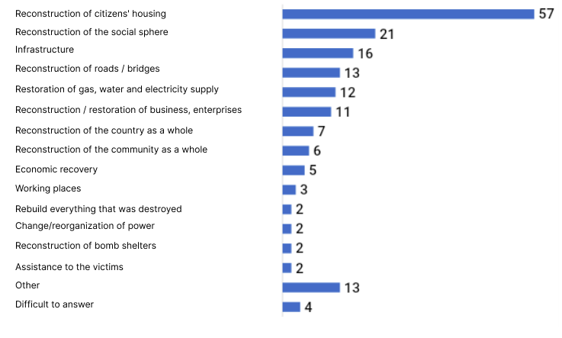
*The sum of responses does not equal 100%, as respondents could indicate several answer options.
Among the answers to the closed question (with suggested answer options) regarding which areas need to be restored in the first place, a conditional top-4 was recorded (respondents from the "community residents" category could choose up to 3 answer options):
- Housing of citizens (68%) – this answer option again occupies a leading position.
- Social sphere (63%).
- Objects of critical infrastructure (49%).
- Communications (gas, water, electricity, etc.) (40%).
Housing of citizens and objects of the social sphere were noted somewhat more often by women than by men. Also, respondents from the Borodyansk and Kiinsk communities chose the option "residential housing" somewhat more often than the others, "social sphere" - participants from the Dymersk community, "objects of critical infrastructure" - surveyed from the Chernihiv and Ivanivsk communities, "communications ( gas, water -, electricity supply, etc. ) - participants from the Irpin and Novobilou communities.
Areas that need to be restored / rebuilt first, N = 600, %*
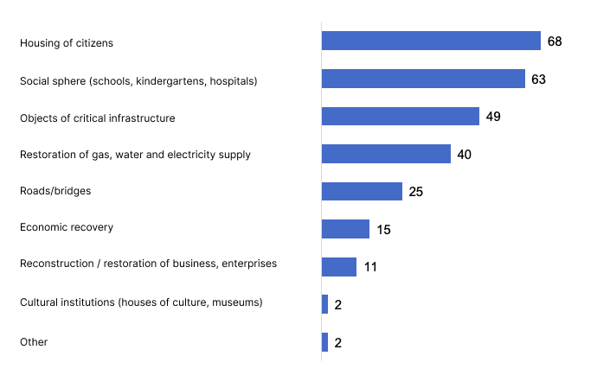
*The sum of the answers does not equal 100%, as the respondents could indicate up to 3 answer options.

In contrast to key informants from the category of "representatives of local government, business, NGOs / BF", respondents from the category of "residents of communities" preferred the approach of "as much as possible to build new instead of damaged" - this option was supported by 55% of respondents. 32% of the survey participants noted that they support the opposite approach to reconstruction – "rebuild everything damaged as much as possible" (women chose this option somewhat more often); 13% could not determine the answer to this question.
Approach to reconstruction supported, N = 600, %
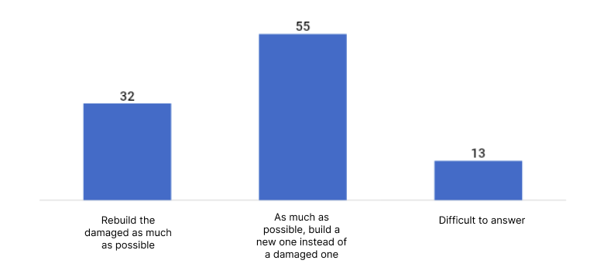
The vast majority of respondents (68%) noted that reconstruction / restoration should take place gradually, as far as possible - this answer is the most common for all categories of informants, both qualitative and quantitative components. 18% of respondents noted that reconstruction/restoration should take place only after the end of the war; 13% – immediately, right now; 1% - could not decide on the answer to this question.
How the restoration / reconstruction of the country or community should take place, N = 600, %
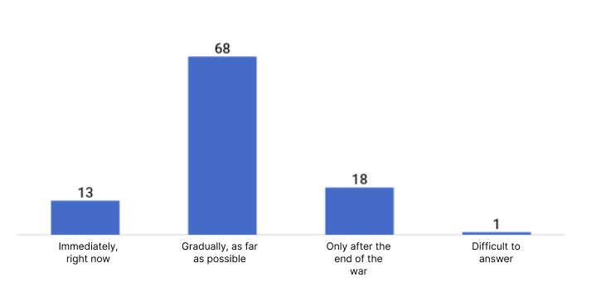
67% of the respondents noted that it is not appropriate to rebuild some objects, men gave this answer somewhat more often. 27% of survey participants indicated that it is advisable to rebuild all objects, this answer was given somewhat more often by women.
Is it advisable to rebuild all the objects that were damaged, N = 600, %
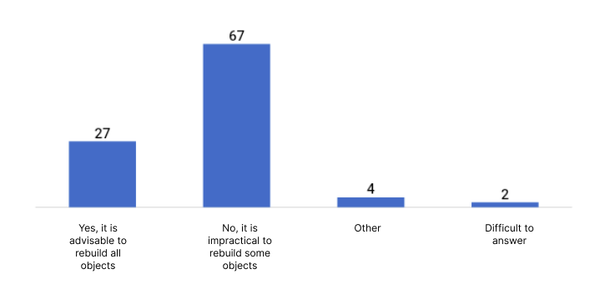
Respondents who believe that it is not expedient to restore/rebuild part of the objects, among such objects more often noted the following (conditional top-3):
- Cultural institutions (22%).
- Objects in which there is generally no urgent need (20%).
- Objects that are completely destroyed (14%).
Objects that are not advisable to rebuild, N = 427, %*
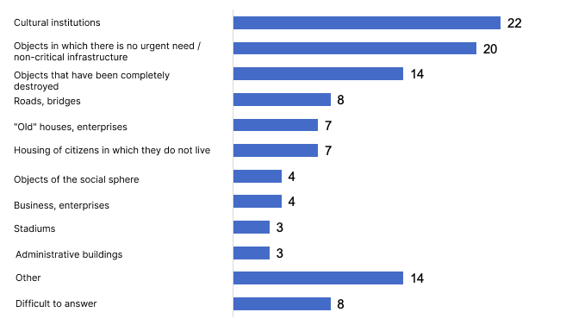
*The sum of responses does not equal 100%, as respondents could indicate several answer options.
**Among the option "Other", the following were mentioned more often: infrastructure (without clarification), shops, non-residential premises / offices / warehouses, facilities in border areas, entertainment facilities, etc.

The main obstacles to reconstruction. Manifestations of corruption in the process of reconstruction / restoration.
The vast majority of key informants from the category of "community residents" identified corruption as the main obstacle on the way to reconstruction/restoration (besides war/shelling) - this was the answer given by 82% of respondents. At the same time, 45% of respondents noted a lack of finances among the obstacles to the recovery of the country/community (women, respondents aged 18-35 and respondents from the Chernihiv region gave this answer somewhat more often); 26% – the need to spend on providing for the military (respondents aged 55 and older gave this answer somewhat more often than others); 25% - lack of personnel in the construction industry (somewhat more often this answer was given by respondents from the communities of Chernihiv region); 24% - lack of a comprehensive reconstruction strategy (respondents aged 18-35 and interviewed from the communities of the Kyiv region gave this answer somewhat more often than others).
The main obstacles and difficulties on the way to the reconstruction / restoration of the country / community, except directly from the war (shelling), N = 600, %*
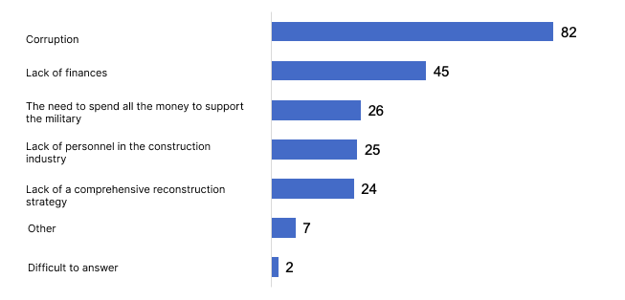
*The sum of answers does not equal 100%, as respondents could indicate up to 3 answer options.
**Among the "Other" option, the following were mentioned more often: inappropriate use of funds in general, insufficient qualification of government representatives, lack of proper communication between all participants in the reconstruction process, etc.

Corruption was noted as the biggest obstacle on the way to recovery / reconstruction of the country, this thesis is confirmed once again by the distribution of answers to questions about the relevance of the problem of corruption in the process of recovery / reconstruction, so 65% of respondents consider the problem of corruption to be very relevant, another 25% - rather relevant.
Assessment of the relevance of the problem of corruption in the process of recovery / reconstruction, N = 600, %
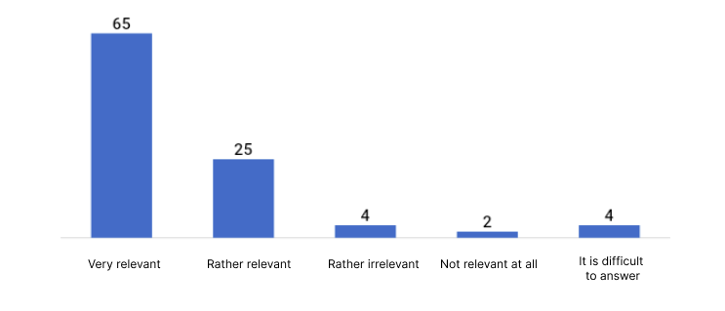
Among the potential manifestations of corruption, all proposed hypothetical options received almost the same number of responses - from 62% or more. With a small margin, the option "overestimation of the cost of construction materials" is in the lead - 69% of respondents noted exactly this option (also this option was noted somewhat more often by the surveyed communities of Chernihiv Oblast than Kyiv Oblast).
How corruption manifests itself in the process of reconstruction / restoration, N = 600, %*
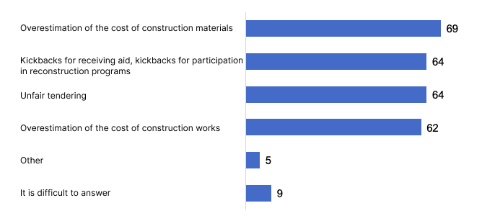
*The sum of the answers does not equal 100%, as the respondents could indicate several answer options.
The problem of corruption, which is noted as relevant in other studies as well, actualized the need to find out who exactly the respondents, residents of the communities included in the study, would trust to dispose of / distribute funds for restoration / reconstruction. Yes, 66% of respondents trust the disposition/distribution of funds for restoration/reconstruction to international public organizations and charitable foundations – this is the most popular answer. A fairly large part of the respondents are ready to entrust the distribution of funds for reconstruction to representatives of local authorities (39%) and to Ukrainian public organizations and charitable foundations (21%). The option "local government of the community" was chosen somewhat more often by respondents from the communities of the Chernihiv region than from the Kyiv region.
If we look at the trends according to the option "local government of the community" at the community level, this option was chosen more often by those interviewed from the Makariv, Kiyin, Chernihiv, and Novobilou communities; less often - interviewed from Borodyansk, Irpinsk, Dymersk communities.
Who should manage and allocate funds for reconstruction, who is most trusted, N = 600, %*
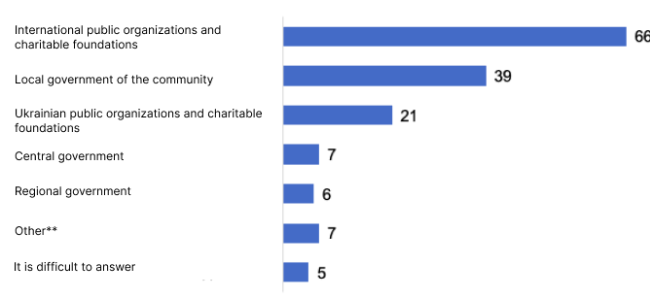
*The sum of responses does not equal 100%, as respondents could indicate up to 2 answer options.
**Among the "Other" option, the following were mentioned more often: international observers, independent control from the public, lack of trust in all.

Assessment of the existence of a defined reconstruction / restoration strategy. The level of readiness to participate in the development of a strategy for the reconstruction of the country / community.
A third of the survey participants (33%) from the "community residents" category noted that there is no strategy for rebuilding/restoration (respondents aged 36-54 gave this answer more often than others).
At the same time, 24% of respondents indicated that there is a reconstruction strategy at the country level (respondents aged 18-35 gave this answer somewhat more often than others); 16% – at the level of a separate community; 13% each - at all levels / at the level of the region; 12% could not decide on the answer to this question.
Is there a defined recovery / rebuilding strategy, N = 600, %*
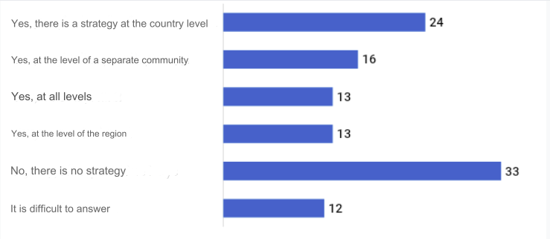
*The sum of responses does not equal 100%, as respondents could indicate several answer options.

A fairly high level of readiness to participate in the development of a recovery / rebuilding strategy was recorded among respondents , residents of the communities of Kyiv and Chernihiv regions included in the study, as follows:
- 59% of respondents are ready to take part in online voting and choose the best reconstruction/restoration projects.
- 39% of respondents are ready to join the discussion of the strategy in an online format (somewhat more often, respondents from the communities of the Kyiv region noted).
- 29% of respondents are ready to participate in the discussion of the strategy live (men indicated it somewhat more often).
- 21% of respondents are ready to offer their ideas (respondents aged 18-35 years indicated somewhat more often).
Only 23% of respondents are not ready to participate in the development of a recovery / rebuilding strategy (this response was more often noted by respondents aged 55 and older); 1% - could not decide on the answer to this question.
Are you ready to participate in any way in the development of a community / country reconstruction strategy, N = 600, %*
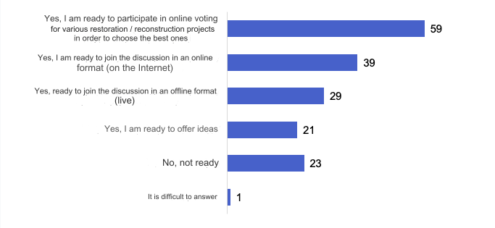
*The sum of the answers does not equal 100%, as the respondents could indicate several answer options.

Evaluation of reconstruction initiatives and measures that have already been implemented in communities.
Respondents from the category "community residents" were asked to indicate the objects that have already been rebuilt / restored in their communities, the following most common answers to this question were recorded (conditional top-8):
- Residential buildings (64%) were mentioned more often than others by respondents from the Irpinsk, Makarivsk, Kiinsk, Chernihiv, and Ivanivsk communities.
- Bridges (55%) were mentioned more often than others by respondents from Gostomelska, Irpinska, Kyselivska communities.
- Schools / lyceums / gymnasiums (54%) were mentioned more often than others by respondents from the Irpinsk, Borodyansk, Kyinsk, and Ivanivsk communities.
- Gas, water, and electricity supply (41%) – respondents from Gostomelska, Irpinska, Makarivska, Chernihivska, Novobilouska communities noted more often than others.
- Hospitals, FAPs (36%) were mentioned more often than others by respondents from Gostomelska, Irpinska, Makarivska, Chernihiv, and Ivanivka communities.
- Kindergartens (35%) were mentioned more often than others by respondents from the Irpin, Borodyan, Kiyin, and Chernihiv communities.
- Business/enterprises (shops, coffee shops, factories, etc.) (34%) – respondents from Gostomelska, Irpinska, Borodyanska, and Makarivska communities noted more often than others.
- Roads (29%) were mentioned more often than others by respondents from Gostomelska, Irpinska, and Dymerska communities.
Which objects have already been rebuilt in the community after damage, N = 600, %*
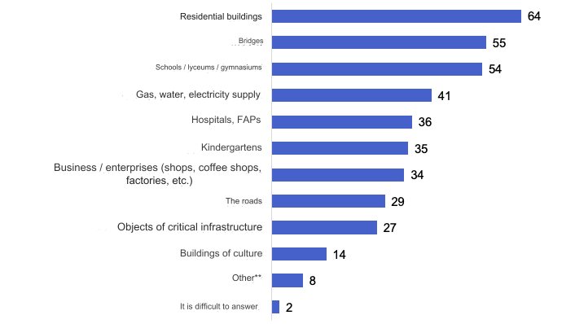
*The sum of responses does not equal 100%, as respondents could indicate several answer options.
**Among the "Other" option, the following were more often mentioned: administrative buildings of local councils, bomb shelters, playgrounds, temporary housing (cars), rehabilitation centers, buildings of TsNAPs, etc.

To an open question (without suggested answer options) - At whose expense was the restoration / reconstruction of various community facilities? - 39% of respondents could not provide an answer. At the same time, 35% of the participants noted that the restoration took place with the funds of various public organizations and charitable foundations, but they do not remember the specific name. Respondents could indicate several sources of funds for the reconstruction of their community's facilities (therefore, the sum of answers to this question does not equal 100%), as follows: 12% of respondents indicated that the reconstruction was financed by the local budget; 9% – for state funds; 7% – for funds from various countries, the following countries were most often mentioned: Denmark, Lithuania, Latvia, Germany, the Netherlands, Norway, the USA, Poland, France, Japan, Canada, Switzerland, Finland, Hungary; 4% - with the funds of the state program isRecovery; 2% - at the expense of the regional authorities.
From 2% to 5% of the answers were collected by the following organizations, whose funds were used for reconstruction, according to the respondents: Rokada, UN, Red Cross, UNICEF. Up to 2% of responses were received by the following organizations, whose funds were used for the reconstruction, according to the respondents: NEFCO, To Ukraine with love, Acted, UNDP, NRC, Buffett Foundation, Dobrobat, NEW WAY, IOM, ZOA, United24, Caritas, DRC, Man in Need, UNESCO, sister cities from other countries, Western investments in general, business funds, Gem, "Because we can", USAID, Women's Consortium
Individual respondents also mentioned the following organizations/institutions/persons whose funds were used to restore their communities: Oxfam, Cobblestone Freeway Foundation, Oleksandr Pankeev, Help Ukraine, Leroy Merlin Foundation, Desna Foundation, Vidnovy Dim Foundation, Energy Efficiency Fund, International Protestant Churches, BF "Narodna domozoma", DTEK, Epicenter, Onur, Shops with own funds (ATB, Fora, Novus), Housing and hope for children, For a clear sky, Kyiv Bridge Construction Company, OKKO, Lithuanian sponsors, President Zelenskyi gave his prize, the Shmyhal project, the Lithuanian-Ukrainian project, the League of Laughter, aid from Prytula, Dutch Christian organizations, Ocean of Hope, Polish Humanitarian Action, Kharkiv Legal Group, The HALO Trust demining, Veteran HAB, Prytula fund, Partnership "For a strong Ukraine" , "Miyamoto" Organization, Polish-Ukrainian Cooperation Foundation (PAUSI), Women's Fund of Ukraine from the United Nations, Canadian firm, Sokar, SOS Children's Villages , Adra, Hungarian Economic Service, Ukrzaliznytsia (windows), Vasylevsky Foundation (Vasylevsky-Smaglyuk Olga 94 district ), the Fund for the Reconstruction of Kyiv Region, the Fund for Liquidation of the Consequences of Military Aggression, the Petro Poroshenko Foundation, the Center for Social and Psychological Support, Churches from the USA, the International Medical Corps, individual patrons from various countries (names not specified).
In general, it can be assumed that the respondents have rather insufficient information about the sources of funds for the restoration / reconstruction of objects in their communities, or are not interested in this information, do not remember the names of institutions and organizations.
The level of success of implemented reconstruction projects is quite high according to the respondents, so 7% of survey participants called the implementation of reconstruction / restoration projects "completely successful", 64% - "rather successful", 20% - "rather unsuccessful", only 4% - "completely unsuccessful" ", 5% could not decide on the answer to this question. If we analyze the trends by communities, it should be noted that respondents from Irpinska, Kyinska, Ivanivska, and Novobilouska communities gave more positive assessments of the success of implemented reconstruction/restoration projects; somewhat less often - respondents from Gostomelska, Borodyanska, Kyselivska communities.

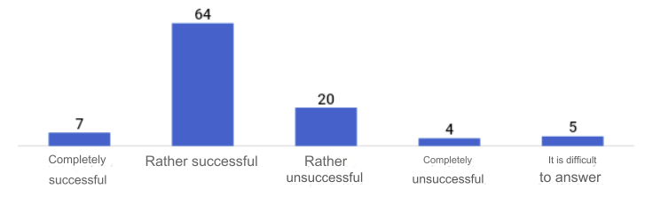

Evaluation of the level of success of reconstruction / restoration projects, N = 600, %

Respondents were also asked about the most powerful institutions and organizations in the process of restoration/reconstruction. The question was also open, it was possible to name several answer options (therefore the total number of answers does not equal 100%), spontaneous answers of respondents were collected, which were then systematized and coded, thus the following distribution of answers was recorded: 71% of respondents could not decide on the answer regarding , which institutions / organizations are the most powerful in terms of recovery / reconstruction; 11% of participants indicated that charitable foundations and public organizations were the most powerful, but did not specify specific names; 3% of respondents indicated that the most powerful state program is Reconstruction; 2% – the local budget of the community; 1% – the state and state funds; 0.5% – regional council and its funds; 3% - various countries that allocated funds for restoration / reconstruction. The table below shows the received data on specific organizations that a certain percentage of respondents noted as the most powerful in terms of recovery / reconstruction.
Organization | % | Organization | %
UNICEF | 4.0% | Buffett Foundation | 0.9%
Red Cross | 2.8% | Dobrobat | 0.9%
DRC | 1.8% | NEW WAY | 0.8%
NRC | 1.6% | Caritas | 0.8%
Rokada | 1.5% | A man is in trouble | 0.7%
UN | 1.3% | UNDP | 0.5%
ZOA | 1.2% | Acted | 0.4%
United24 | 1.0% | NEFCO (NEFCO) | 0.3%

Individual respondents also noted the following organizations, which in their opinion are the most powerful in terms of recovery / reconstruction: Oxfam, BF "Bo mogoryo", BF "Dakh-Chernigiv", Jam, BF "Vasylevsky", Cobblestone Freeway Foundation, Oleksandr Pankeev, KAN Development, Kyivmiskbud, Intergalbut, Motorway (bridges, roads), DETEC, Gas Service, Construction Company "Continent Group", SOS Children's Towns, eOselya, With Love for Ukraine, Kyiv University and Kyiv Polytechnic (students), Future in the Palms, IOM .​ ​Zelenska, Fund for the Elimination of the Consequences of Armed Aggression, Serhiy Prytula Fund, Kyiv Region Reconstruction Fund, Shmygal project, UNESCO.

Respondents noted international charitable foundations and public organizations as the most effective in terms of restoration / reconstruction in communities : 35% - very effective, 50% - rather effective, only 3% - rather and not at all effective, 12% - could not assess. The conditional second position in terms of efficiency is occupied by Ukrainian national charitable foundations and public organizations; the third - representatives of local authorities (the lowest efficiency indicators regarding the level of efficiency of local authorities in relation to the restoration / rebuilding of the community were recorded among respondents from Gostomelska, Borodyanska, Dymerska communities; the highest - from Irpinska, Makarivska, Kiyinska, Chernihivska, Ivanivska, Novobilouska communities).
Evaluation of the level of effectiveness of organizations / institutions regarding restoration / reconstruction in the community, N = 600, %

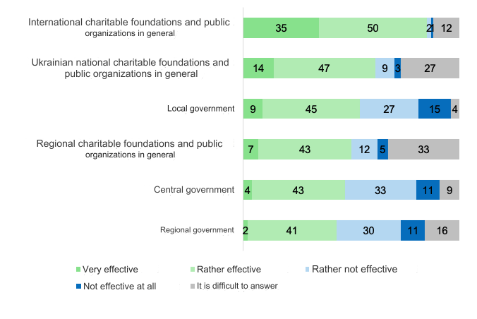

Current needs of communities.
Among the objects in need of priority restoration / reconstruction, 60% of respondents indicated residential buildings, 27% - roads, 17% - schools / lyceums / gymnasiums, 12% - critical infrastructure objects, 11% - kindergartens, 9% - business/enterprises, 9% - hospitals, public health facilities, 7% - bridges, 6% - gas, water, electricity supply, only 4% - cultural centers.
Objects currently in need of priority restoration in the community, N = 600, %*
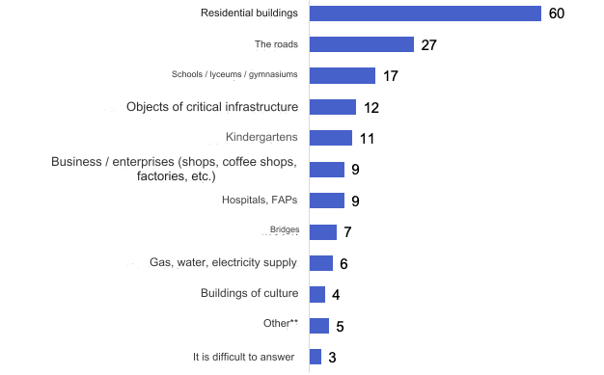
*The sum of responses does not equal 100%, as respondents could indicate up to 2 answer options.
**Among the "Other" option, bomb shelters and intercity transport were most often noted, some respondents also noted a pharmacy, a library, road lighting, a post office, and a church.

The table below shows a conditional rating of urgent needs for each individual community from 1 (the first place in terms of relevance) to 11 (the lowest position in the needs rating), x – if not specified, there may be several positions in one place, if they scored the same percentages.

What should be rebuilt / restored first | All of them | Gostomelska village | Irpinska city | Borodyansk village | Dymer village | Makarivska village | Kiinska village | Chernihiv city | Kiselivska village | Ivanovska village | Novobilouska village
Residential buildings | 1 | 1 | 1 | 1 | 1 | 1 | 1 | 1 | 1 | 1 | 1
The roads | 2 | 3 | 2 | 2 | 1 | 4 | 2 | 2 | 2 | 2 | 2
Schools / lyceums / gymnasiums | 3 | 2 | 4 | 3 | 6 | 2 | 6 | 3 | 4 | 6 | 3
Objects of critical infrastructure | 4 | 6 | 2 | 5 | 3 | 3 | 5 | 2 | 8 | 8 | 7
Kindergartens | 5 | 4 | 5 | 4 | 7 | 1 | 7 | 7 | 9 | 9 | 8
Hospitals, FAPs | 6 | 9 | 7 | 6 | 6 | 5 | 4 | 4 | 3 | 5 | 7
Business / enterprises (shops, coffee shops, factories, etc.) | 7 | 5 | 4 | 5 | 4 | 6 | 8 | 5 | 9 | 4 | 6
Bridges | 8 | h | h | h | 5 | 6 | 3 | 7 | 10 | 3 | 4
Gas, water, electricity supply | 9 | 7 | 6 | 6 | 2 | 8 | h | 6 | 6 | h | 9
Buildings of culture | 10 | h | 3 | h | h | 7 | h | h | 6 | 7 | 5
Other | 11 | 8 | h | 5 | 3 | 7 | 9 | 8 | 5 | 7 | 9

Damage to respondents' property. Assessment of what has already been rebuilt / restored.
63% of respondents noted that as a result of the full-scale invasion of the Russian Federation, their housing (private house or apartment) was damaged, 7% – business premises. 35% of survey participants noted that no property was damaged.
Was your family's real estate/property damaged as a result of the full-scale invasion of the Russian Federation, N = 600, %*
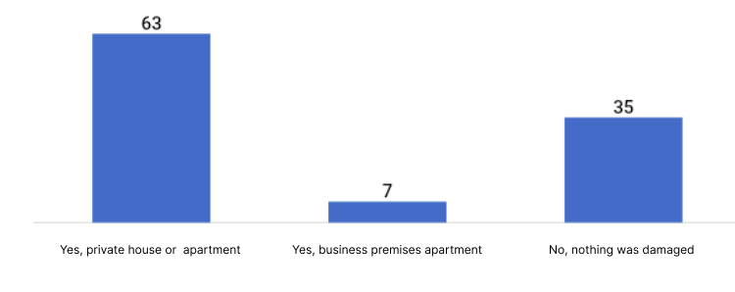
*The sum of responses does not equal 100%, as respondents could indicate several answer options.
The table below shows data on respondents' property damage by community, which can be used to assess general trends in property damage among survey participants in each individual community.
Were there any damages: | All of them | Gostomelska village | Irpinska city | Borodyansk village | Dymer village | Makarivska village | Kiinska village | Chernihiv city | Kiselivska village | Ivanovska village | Novobilouska village
Yes, a private house or apartment | 63% | 88% | 87% | 73% | 33% | 60% | 78% | 51% | 37% | 91% | 39%
Yes, business premises | 7% | 11% | 6% | 10% | 9% | 6% | 10% | 9% | 3% | 0% | 2%
No, nothing was damaged | 35% | 12% | 11% | 27% | 61% | 37% | 18% | 45% | 63% | 9% | 61%
*The sum of responses does not equal 100%, as respondents could indicate several answer options.

Among all respondents, 39% indicated that they received assistance for restoration / rebuilding, if we count for those whose property was damaged, it is worth noting that 60% of participants received one or another assistance for restoration / reconstruction.
Did your family directly receive assistance for the restoration / reconstruction of damaged property, any assistance, not necessarily monetary, N = 600, %
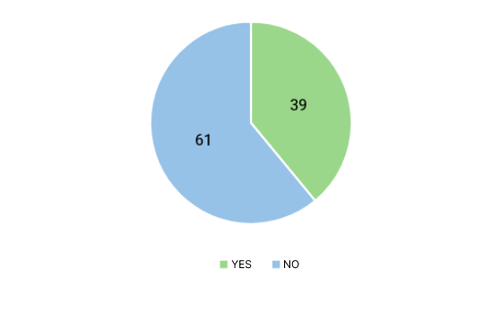

The respondents who received it noted money as the most common option for obtaining assistance for restoration / reconstruction, in second place - turnkey works (36%), in third place - construction materials (33%).
The format of receiving assistance for restoration / reconstruction among those who received this assistance, N = 233, %*
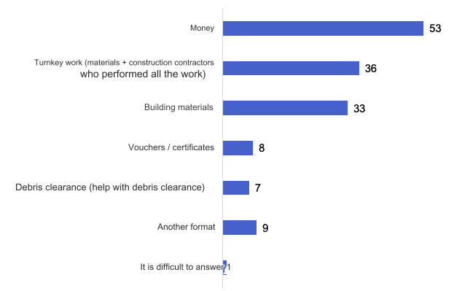
*The sum of responses does not equal 100%, as respondents could indicate several answer options.
** Among the "Other" option, the following were mentioned more often: installation of windows / doors, apartment rental / room rental in a modular town, construction services.

The table below shows the distribution of aid formats by community, which shows the main trends in aid formats in each individual community.

Help format | All of them | Gostomelska village | Irpinska city | Borodyansk village | Dymer village | Makarivska | Kiinska village | Chernihiv city | Kiselivska village | Ivanovska village | Novobilouska village
Money | 53% | 41% | 32% | 51% | 23% | 41% | 67% | 54% | 81% | 70% | 71%
Turnkey work (materials + construction contractors who performed all the work) | 36% | 32% | 52% | 40% | 48% | 40% | 52% | 12% | 16% | 32% | 15%
Building materials | 33% | 37% | 19% | 34% | 44% | 38% | 29% | 27% | 19% | 50% | 17%
Vouchers / certificates | 8% | 11% | 8% | 0% | 7% | 10% | 8% | 16% | 0% | 8% | 8%
Debris clearance (help with debris clearance) | 7% | 9% | 7% | 0% | 14% | 7% | 7% | 16% | 7% | 2% | 0%
Another format | 9% | 8% | 10% | 10% | 15% | 4% | 10% | 9% | 13% | 5% | 22%
Difficult to answer | 0% | 0% | 4% | 0% | 0% | 0% | 0% | 0% | 0% | 0% | 0%
*The sum of the answers does not equal 100%, as the respondents could indicate several answer options.

Answering an open question (with no suggested answer options), 23% of respondents among those who received assistance for the restoration / reconstruction of damaged housing / real estate noted that they used the program isRecovery, 18% - received funds from charitable funds and public organizations, 13% - received funds from the local budget of the community, 12% - received assistance from the Red Cross. The table below also lists the names of the institutions/organizations from which the respondents received assistance.
Institutions / organizations from which respondents received aid for reconstruction / restoration, N = 233 (among those who received aid), %*
Name of the institution / organization | %
isRecovery (state program) | 23
Funds of charitable foundations and public organizations without specification | 18
Funds from the local budget of the community | 13
Red Cross | 12
DRC | 6
UN | 6
ZOA | 5
State funds without specification | 5
Rokada | 5
Caritas | 4
Help from different countries (Denmark, France, Poland) | 4
NRC | 2
Regional government funds | 2
IOM | 2
A man is in trouble | 2
Acted | 1
United24 | 1
UNICEF | 1
NEW WAY | 1
State grants for business recovery | 1
Other** | 14
Difficult to answer | 18
*The sum of the answers does not equal 100%, as the respondents could indicate several answer options.
**Among the "Other" option, the following were noted: Cobblestone Freeway Foundation, Oleksandr Pankeev, Global Communities, Anika, Baptist Church, BF "Bo we can", BF "Dakh-Chernihiv", BF "Adra", BF "Desna", GO "Budyumo Ukraine Together", Leroy Merlyen Store, Silpo Store, "Miyamoto" Organization, "New Home" Program, the Mayor of the community helped with organization - she came with representatives of the foundations in person, Students of Kyiv Polytechnic and Kyiv Shevchenko University, "Father's House" Church, Ukrzaliznytsia, Foundation Novinsky, Poroshenko Foundation, UNESCO.

A high level of satisfaction with the assistance received by the respondents for recovery / rebuilding was recorded, so 48% of the participants were completely satisfied, another 42% were rather satisfied, only 9% were rather or not at all satisfied, 1% could not decide on the answer to this question.
Level of satisfaction with recovery/reconstruction assistance received, N = 233 (among those who received assistance), %
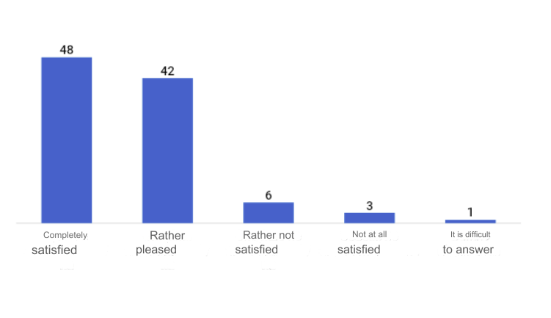

Sources of information on recovery / rebuilding.
40% of survey participants, residents included in the community research, noted that residents of their community take part in decision-making, what exactly needs to be restored / rebuilt, at the same time, 41% of respondents noted that residents do not participate in these processes, 19% - could not decide on the answer to this question . Respondents from Kiinska, Kiselivska, and Ivanivska communities noted the answer "yes, they participate" somewhat more often.
Do community residents participate in decision-making, what exactly needs to be restored / rebuilt, N = 600, %
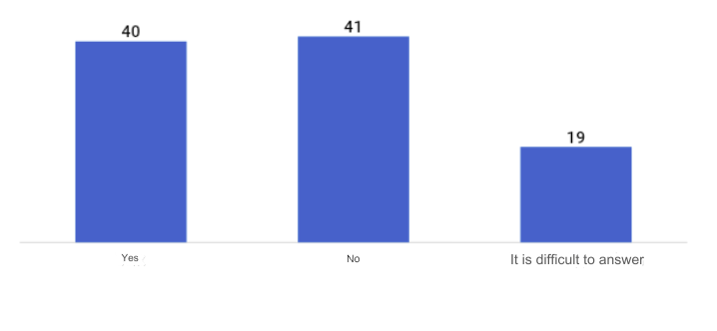

The following top-5 sources of information regarding what has already been rebuilt and what is planned to be rebuilt / restored have been recorded:
- Local groups in Telegram, Viber, Facebook (not from local authorities) (32%).
- Facebook, Instagram, Twitter of local authorities (30%).
- Information from relatives, friends, colleagues, acquaintances (27%).
- Telegram of local authorities (24%).
- I see it personally (19%).

Sources of information regarding what has already been rebuilt and what is planned to be rebuilt / restored, N = 600, %*
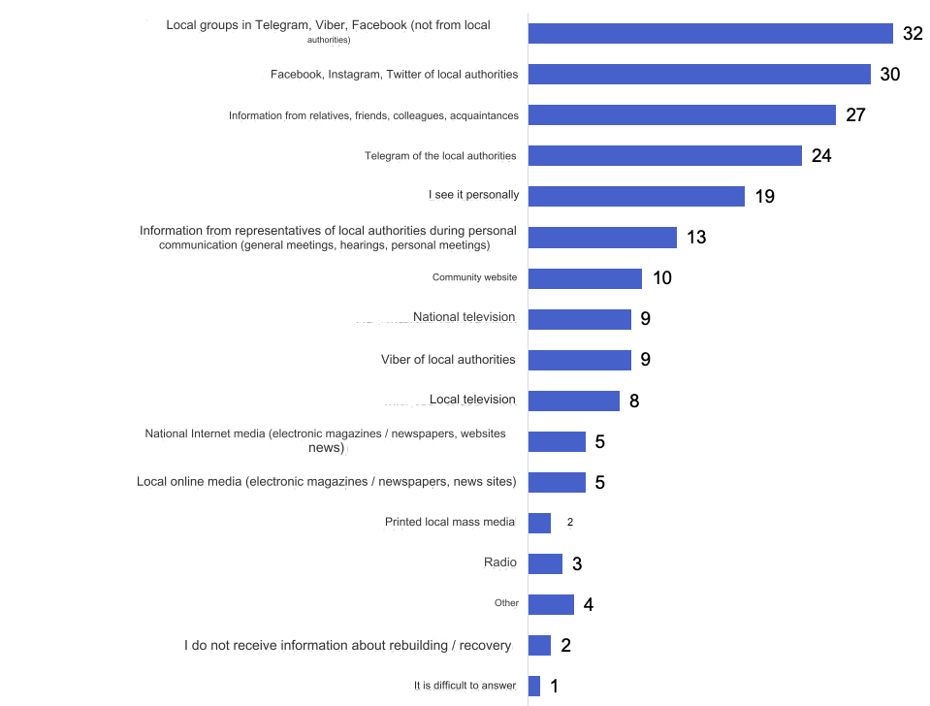
*The sum of the answers does not equal 100%, as the respondents could indicate several answer options.

The opinions of the respondents regarding whether the local government sufficiently informs about the process of restoration / rebuilding of the community were divided: 18% of respondents noted that the local government informs quite sufficiently about the process of restoration / reconstruction of the community, 34% - rather enough, 29% - rather not enough, 15 % - not enough at all, 4% - could not decide on the answer.
Respondents from Irpinska, Makarivska, Kiyinska, Chernihivska, Ivanivska, and Novobilou communities more often stated that the information is completely / rather sufficient, while respondents from Gostomelska and Borodyanska communities chose these answers less often than others.

Is the local government sufficiently informed about the process of restoration / reconstruction of the community, N = 600, %
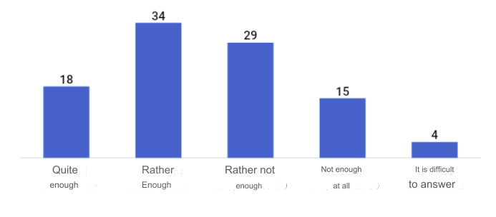

Willingness to participate in the recovery / reconstruction process.
75% of respondents from the category of "residents of communities" are ready to join the process of restoration / reconstruction of the community. Respondents from the Kyinska and Kiselyivska communities gave this answer somewhat more often than others; somewhat less often than others - interviewed from the Irpin community. Also, respondents aged 36-54 gave the answer "yes, I am ready to participate in the recovery/rebuilding process" somewhat more often than others, and, predicted, somewhat less often than others - participants aged 55 and older.
Are they ready to directly participate in the process of restoration / reconstruction of the community, N = 600, %
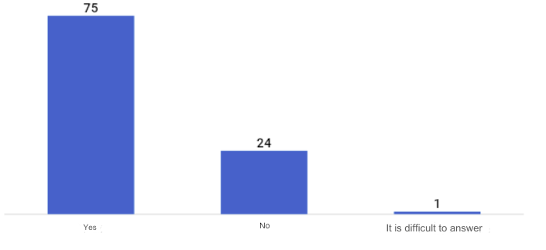

Among the formats in which they are ready to participate in the process of restoration / rebuilding of the community, physical assistance leads (49%). Also, 14% of respondents are ready to participate financially or by discussing projects/plans, voting; 12% - ready to do whatever it takes; 6% – get involved directly in construction; 4% - join the organization of reconstruction / restoration processes in general.
In what format are willing to participate in reconstruction / restoration, N = 448 (among those who are willing to participate), %*
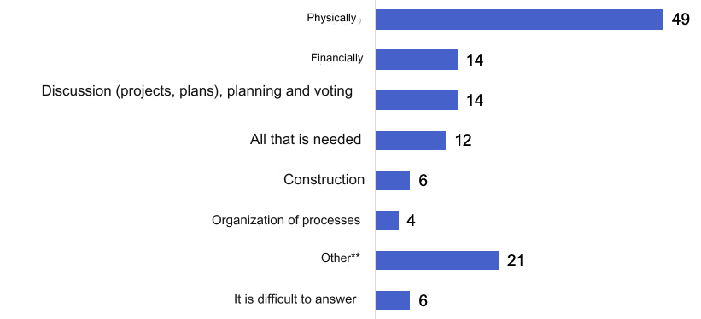

*The sum of responses does not equal 100%, as respondents could indicate several answer options.
**Among the "Other" option, the following were more often mentioned: any forms of volunteering (but without specifying), offering ideas / expressing one's vision, dissemination of information, transport services, any initiatives that coincide with professional activity, etc.

Lack of physical and moral strength (54%), lack of time (32%), as well as the position that they should do this dominate among the reasons for not being ready to join (among those who are not ready to join the process of restoration/rebuilding of the community) authorities and builders (29%). 13% of respondents are not ready to join the rebuilding/restoration processes, as they do not understand what exactly they can do to help.

Reasons for not being ready to participate in recovery / reconstruction processes in the community, N = 146 (among those who are not ready to participate), %*
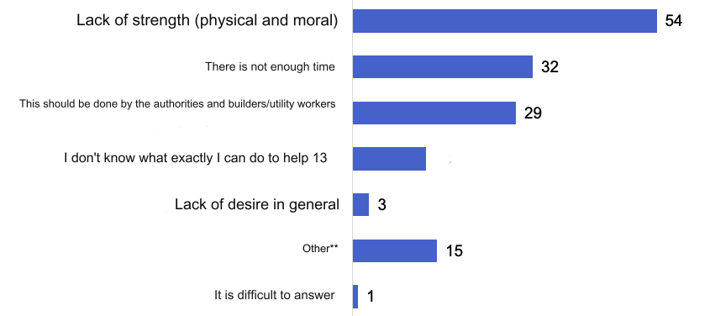
*The sum of responses does not equal 100%, as respondents could indicate several answer options.
**Among the "Other" option, the following were more often mentioned: respectable age and military service.

Portrait of participants.

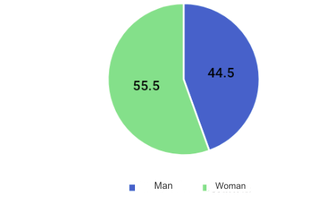
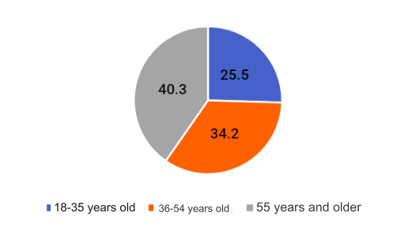
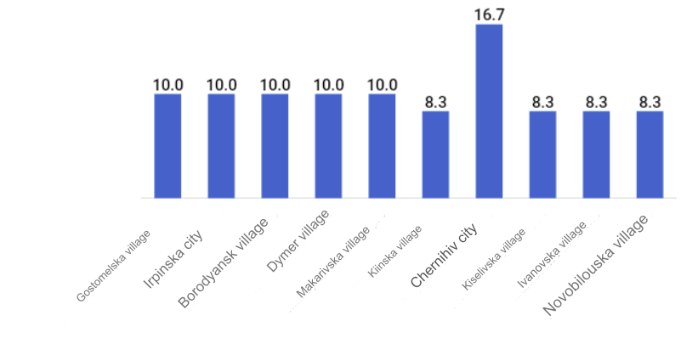

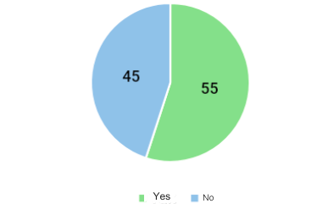
*Women were somewhat more likely than men to report leaving the settlement/community after the start of a full-scale invasion. A smaller share of those who left the settlement among respondents aged 55 and older. Also, it was noted much more often that respondents from the communities of the Kyiv region left the settlement than participants from the communities of the Chernihiv region (72% and 37%, respectively, for a total of 55%).
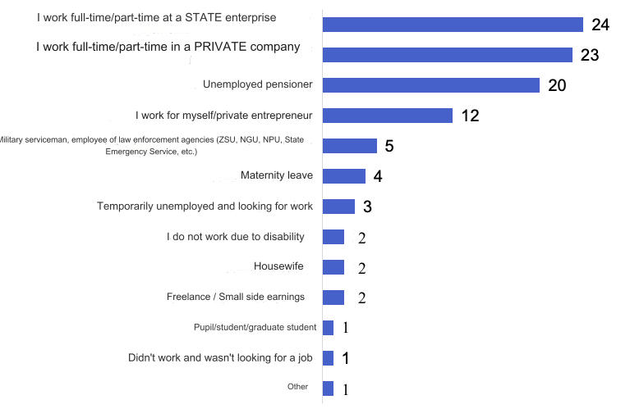

Level of education, N = 600, %
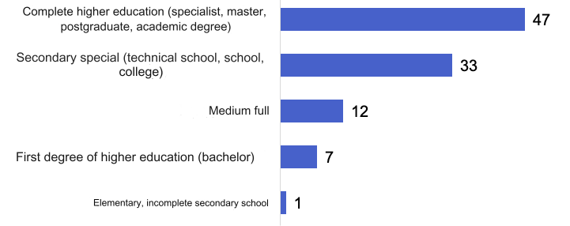
Family status, N = 600, %
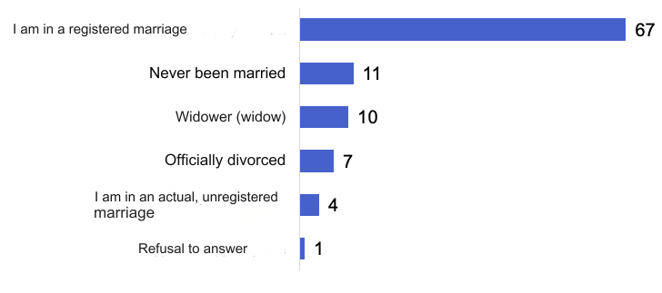
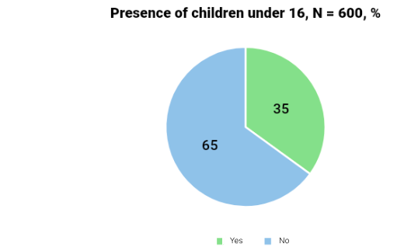
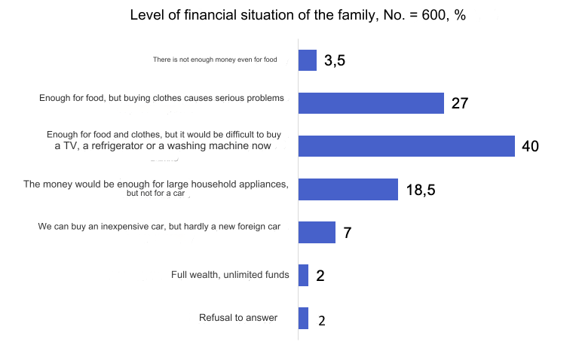

Performers:
Natural person Liana Volodymyrivna Shcherbina (administrator)
The natural person Oleg Yuriyovych Sinayuk (the head of research in the project)
Individual Mykola Anatoliyovych Homanyuk (moderator of the qualitative component of the study)
Natural person Vasyl Ivanovich Nikolenko (transcriber)
Natural person Demchenko Anna Volodymyrivna (manager of public opinion polls (in particular, by phone))

Thank you for your attention!
We wish you good health
and speedy Victory!
We believe and help the Armed Forces of Ukraine!

Statistical collection "Distribution of the permanent population of Ukraine by gender and age" as of January 1, 2022 (newer statistical data are currently not publicly available)

